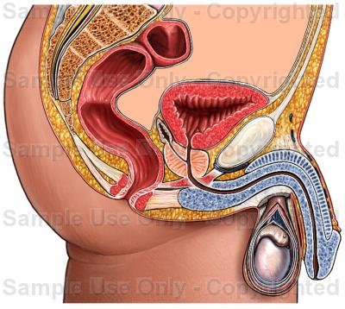

Anatomical organs/functions to know:
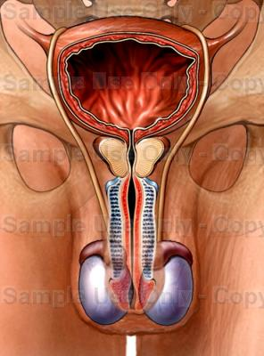
Scrotum-
Testicle-
Epididymis-
Vas Deferens-
Seminal Vesicle -
Prostate Gland -
Cowper’s Gland -
Urethra -
Penis –
Foreskin -
Circumcision –
Castration -
Sperm -
Semen –
Vasectomy -
Male Fertility cycle –
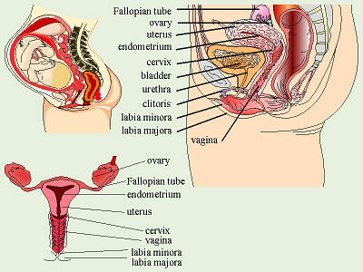

Anatomical Organs/Terms to know
(all listed above)….plus:
Vulva -
ovulation-
egg (ovum)/eggs (ova)
menstruation -
menarche -
menopause -
hysterectomy-
tubal ligation -
F.G.M -
Female fertility cycle -

