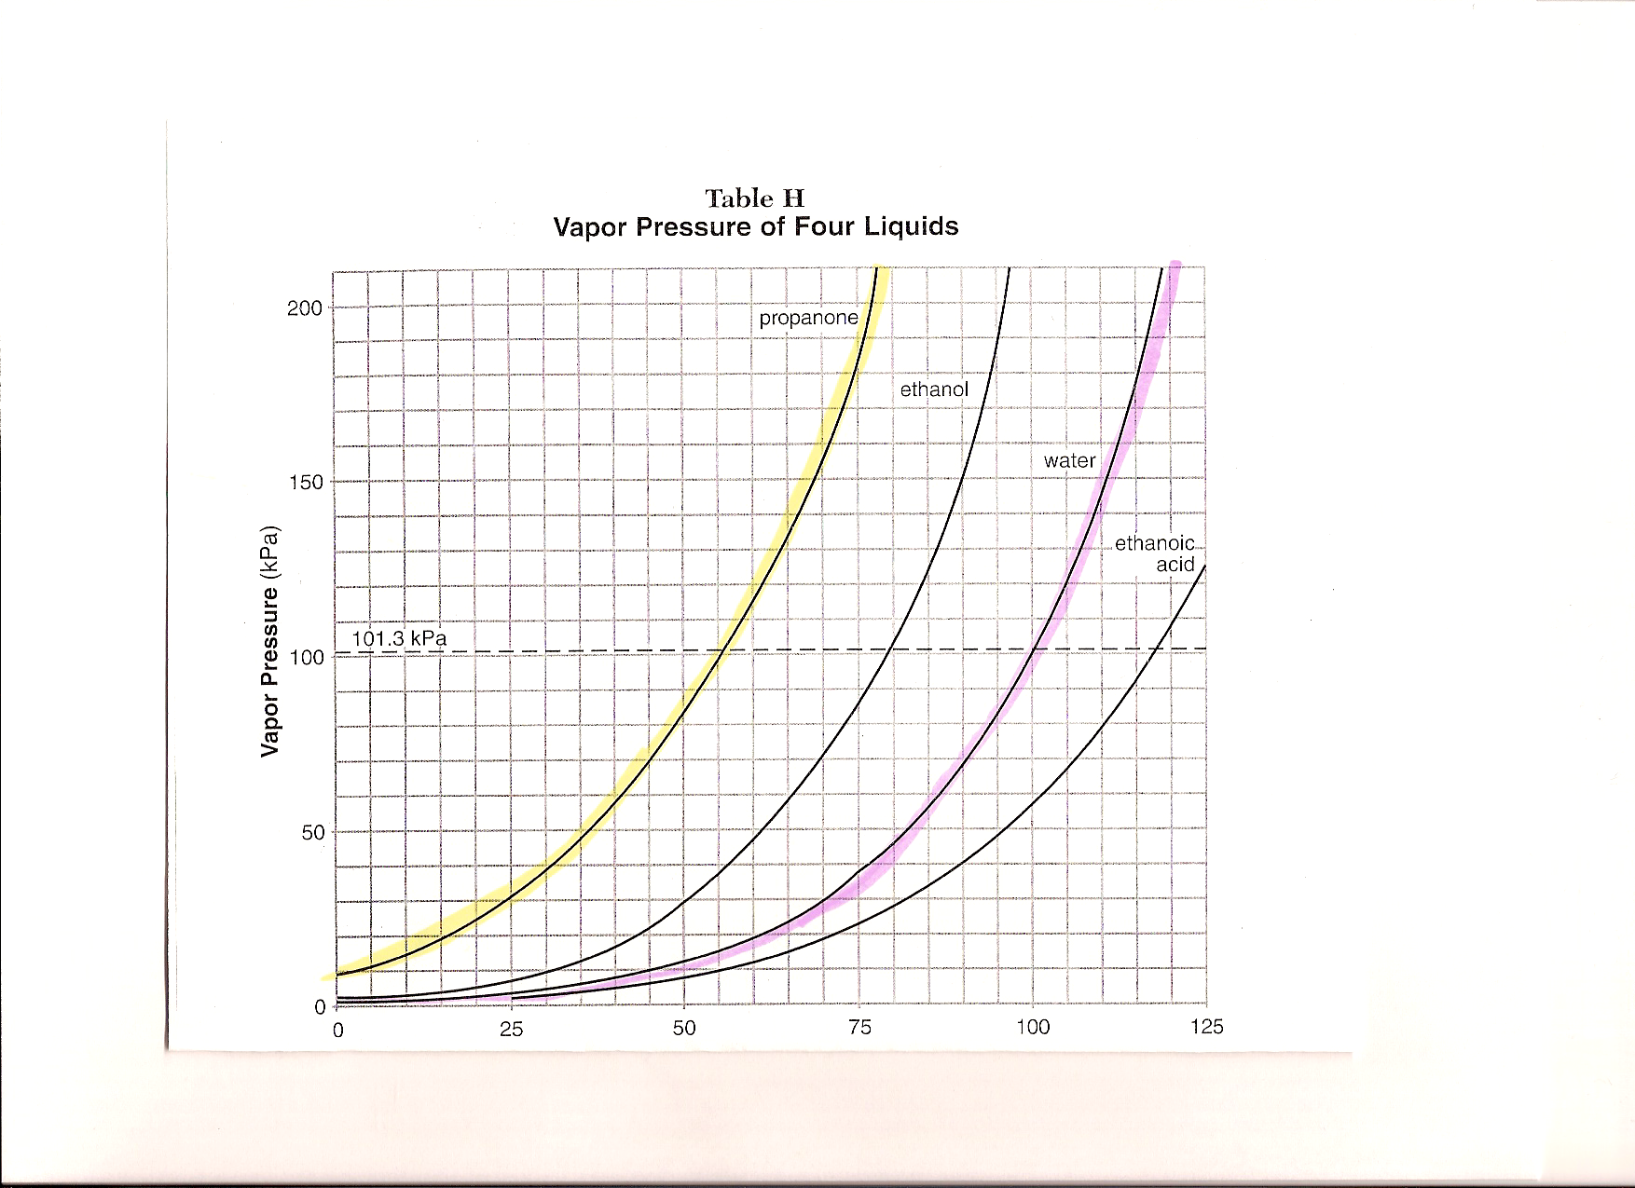

Propanone (75ºC, 180kPa)
Water(115ºC, 180kPa)

Propanone (63ºC,120kPa)
Water (105ºC, 120kPa)

Propanone (45ºC, 70kPa)
Water (45ºC, 70kPa)

Propanone (25ºC, 30kPa)
Water (65ºC, 30kPa)

TEMPERATURE IN (ºC)

SUMMARY: as a liquid is heated, its vapor pressure increases.
- temperature is the only factor affecting vapor pressure.
- The volume of the liquid is not a factor.

