
GRAPHIC DESIGN: SHMERYKOWSKY
DESIGNING AN ALPHABET

AGENDA: Students will develop an ALPHABET based on a particular THEME

DIRECTIONS:
- Choose a THEME (Have fun with it!)
- In the boxes provided, SKETCH out ideas for the ALPHABET
  - EACH letter should EVOKE the message of the theme
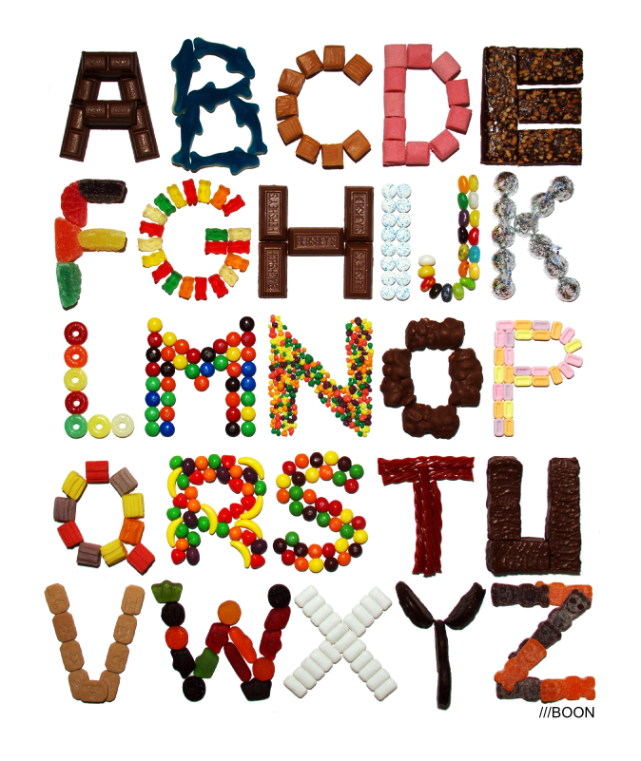
  - The letters are MADE UP of images which are INSPIRED by the theme.
  - NO COLOR REQUIRED YET

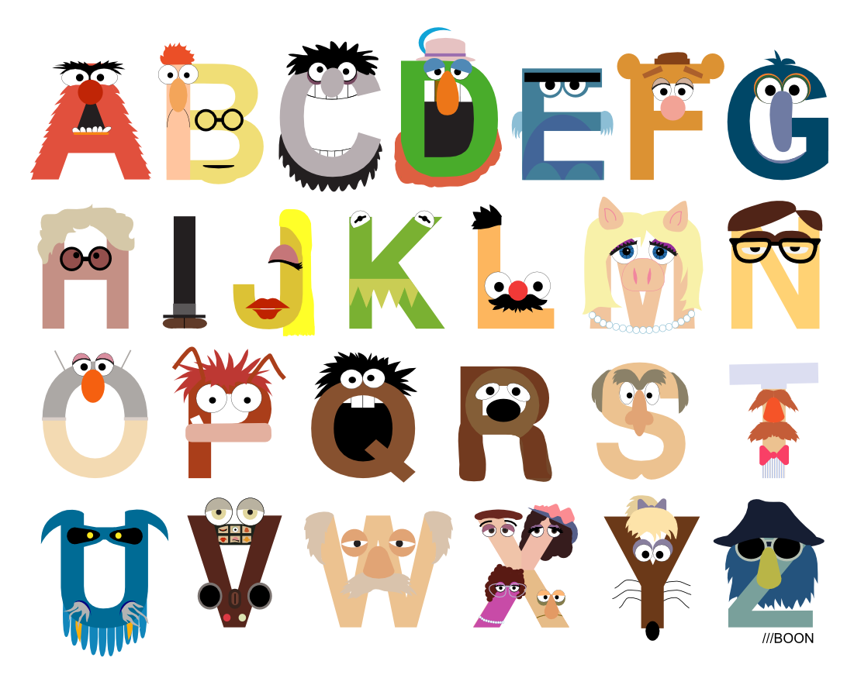
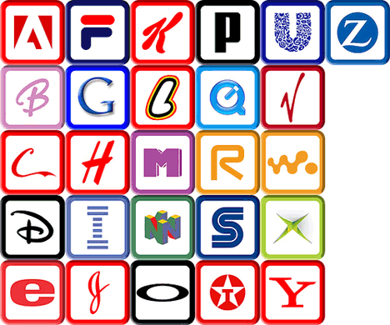
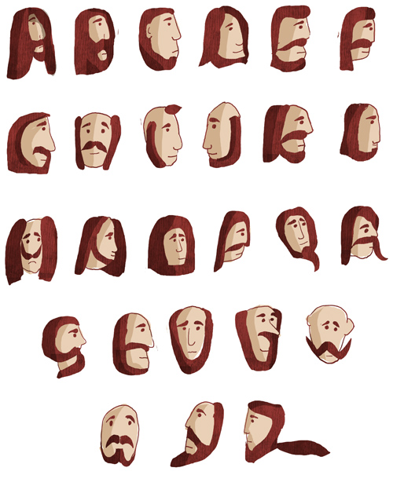
EXAMPLES:

