Advanced Studio in Art II
Shmerykowsky

MAGNIFIED ART USING ELEMENTS AND PRINCIPLES
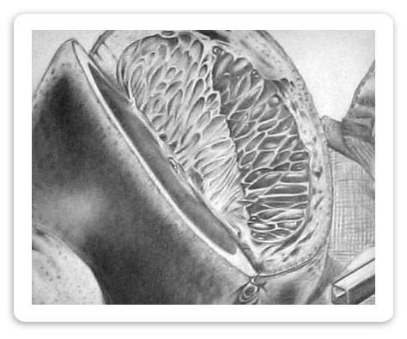
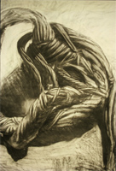
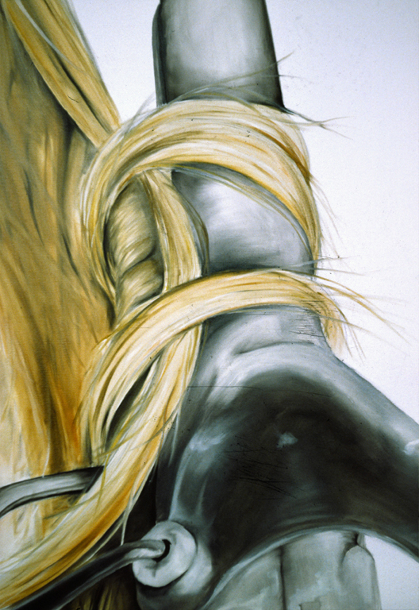
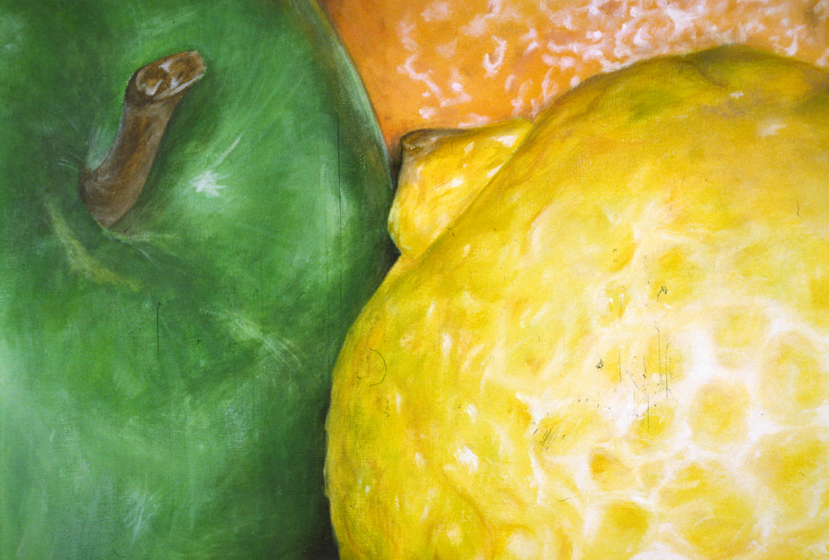

Using the elements (line, shape, form, value, color, space, texture) and principles (unity, variety, balance, contrast, emphasis, rhythm and movement) of design, your task is to create a strong and impacting piece of art. You will select an “ordinary object” and magnify it so it is largely cropped and becomes more interesting and less ordinary. You will work in color. The design must look 3 dimensional, meaning that your objects should be FORMS rather than shapes. There MUST be a light source so there is shading. You will CROP your object(s) on the page so the image is very large, therefore there will be many DETAILS. You will already be using several of the elements, but what principles will you use? (Proportion, movement, rhythm, emphasis, etc)

Homework Requirements:
*Use your BRISTOL BOARD paper.
*You MUST use at least THREE ELEMENTS AND PRINCIPLES in your design.
* You must create a light source in your work! (The objects MUST BE Three-dimensional FORMS not shapes and you need to use sense of VALUE)
*You will use colored pencil.
*You will crop your image so there is a lot of detail.

