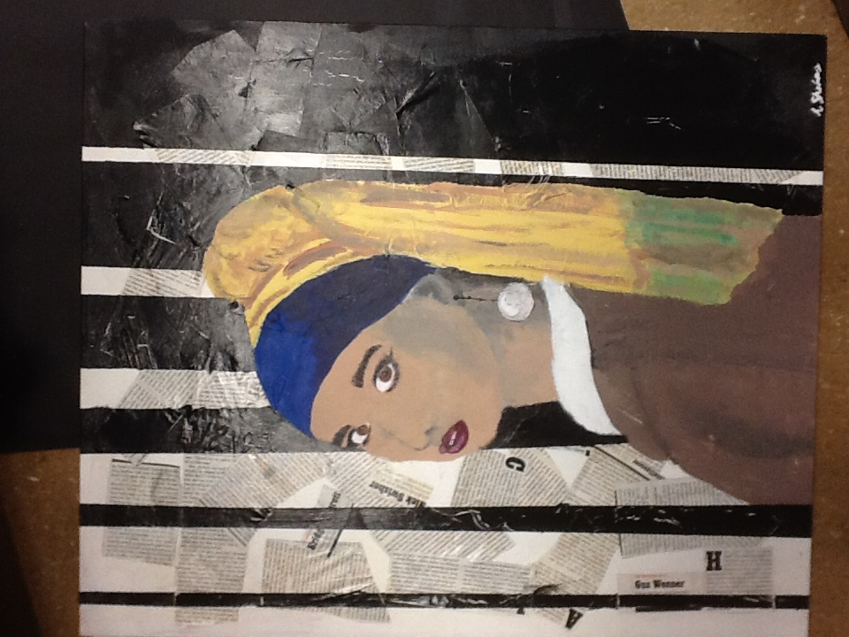
ADV STUDIO IN ART II: SHMERYKOWSKY
HW: Drawing a Modern Art

Agenda:
Students are to create a drawing of themselves based on a Classical Painting.

HW:
Students are to create a drawing of themselves based on a Classical Painting.

DUE_____________________________________________________________

Directions:
- Use any material you want (pencil, paint, collage, photo….)
  - **The HW can be 8x10 inches and larger. (PLEASE nothing smaller than that!)
- Choose a classical painting you’d like to be a part of (For Example, the Mona Lisa)
- Then, depict yourself as if you were the subject of the painting.
- It can be as drastic or subtle as you want.
  - You can use a photo of yourself for reference and include as little or as much of yourself as you want.
  - The image must have BOTH some original classical painting qualities and some aspect of yourself being incorporated.
- Be creative and have fun with it!
- There are limited guidelines. This HW is to express your creative and methods of Art Making.
- If you photograph, use a photoshop program, or require some description to how you made it, please include a short write-up
- PLEASE EMAIL WITH ANY QUESTIONS!
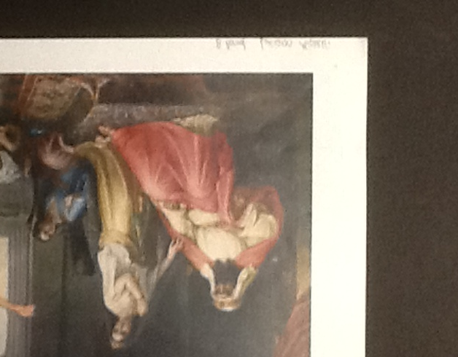
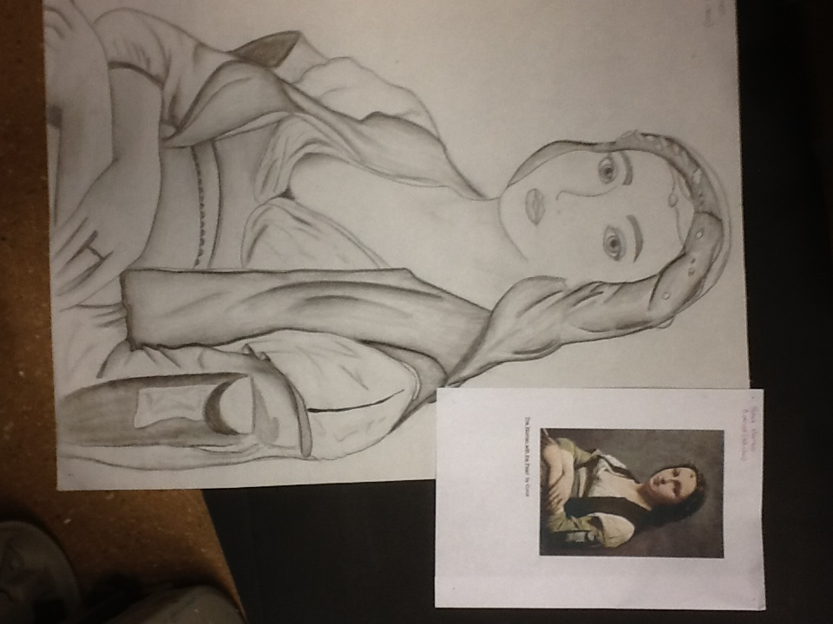

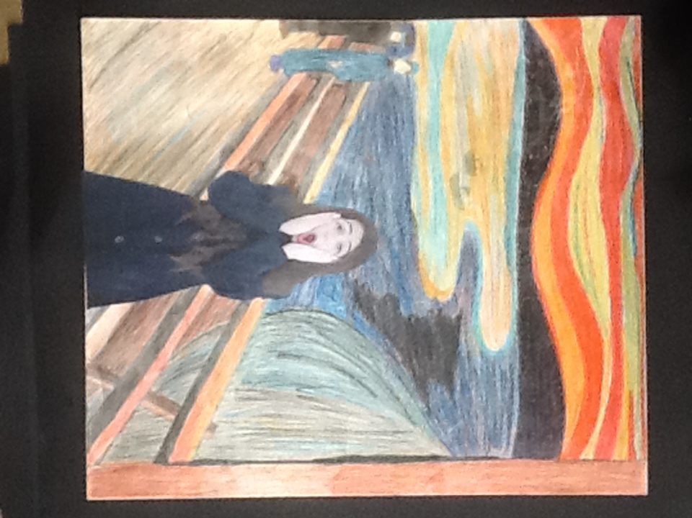

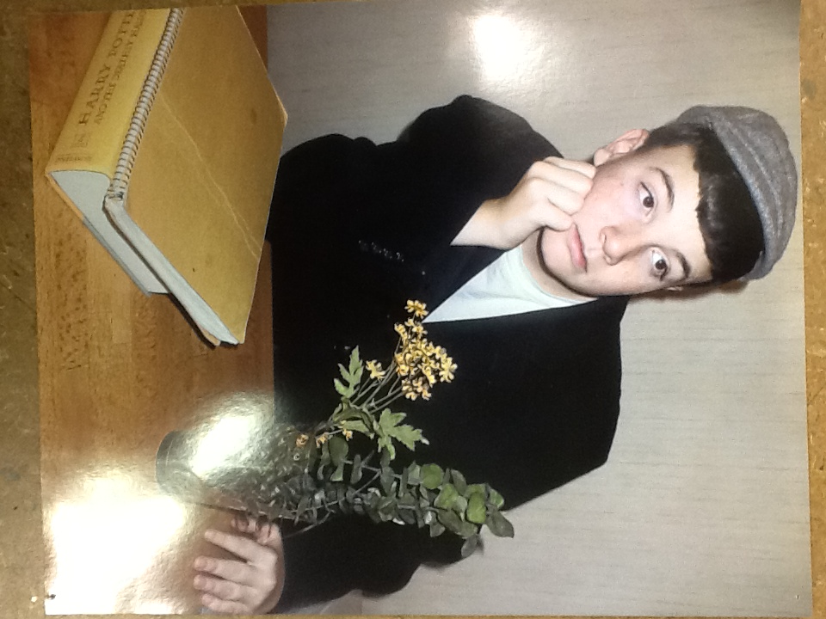
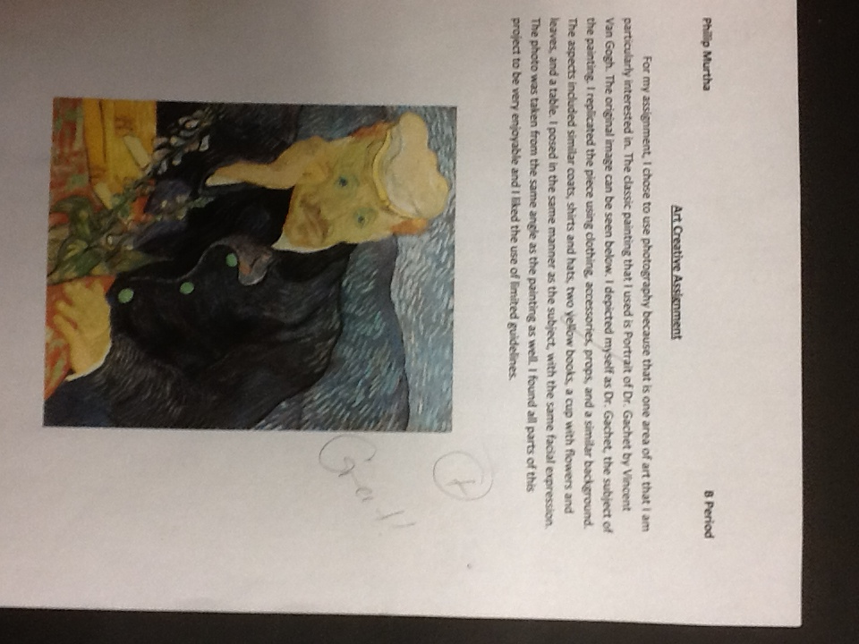

ADDITIONAL EXAMPLES:



