ADV. STUDIO IN ART II: COLOR STILL-LIFE

AGENDA: Now that you have practiced some of your color and drawing skills through your Visual Journals, now let’s apply it again to some observational drawing. (You can incorporate images from your imagination as well, but use PHOTO REFERENCES!)
Set up a little Christmas/ Holiday still-life at home.
KEEP IT SIMPLE! Be sure to have LOTS of color!


- Please do this in your BRISTOL PAD
- Sketch lightly your Christmas/ Holiday composition. DRAW LARGE!!!!
- Add the LIGHTEST colors first. Work with PRESSURE in order to get correct color values.
- Begin adding main colors on top of the colors. Build pressure gradually! (Think about COLORING MIXING!)
- Keep edges soft. Leave lighter areas light.
- Begin to add color to the background
- Look for areas to increase contrast! (the differences between darks and lights)
- Where needed, add complementary colors (red/green, orange/blue and yellow/purple) to enhance the shadows.
- Put in black and purple values towards the end.
- Be CREATIVE and HAVE FUN WITH IT! This will be collected when I see you next. Please take your time, put effort into this and show off those amazing drawing skills of your!

Please email me with ANY questions! ☺


**Examples shown are professional photos, but are great examples of still-lifes.

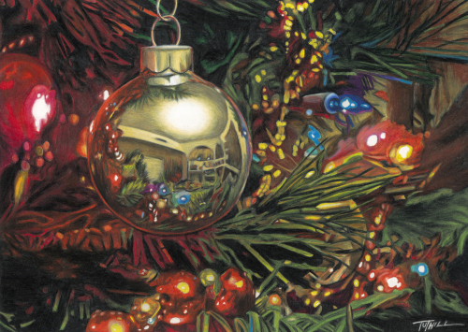
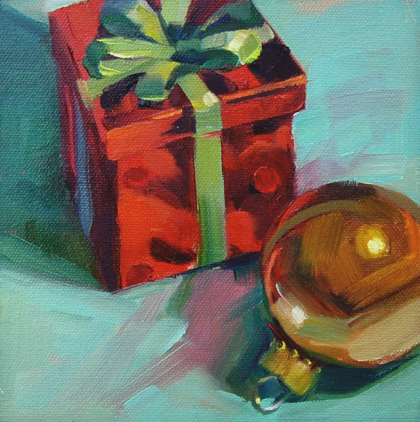
DRAWING EXAMPLES:


