“The Profit” – Worksheet
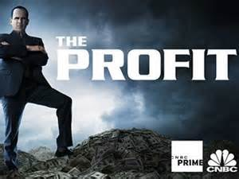

- What is the Name of the Business, where is it located and who is the owner?

- What product/products does this business sell? List two methods by which it sells its product.

- How much Revenue or Income did the business have last year?
- What was the business profit for last year?
- How much debt do they have?
- How is the inventory managed in this business?
- How does it manage Accounts Receivables?
- How does it manage Accounts Payables?
- What is wrong with the Accounting System in this business?
- What is wrong with the management structure of this business?
- How would you describe the business relationship between the “The Profit” and the owner?
- List 5 things “The Profit” will do to fix the business?
- What deal does “The Profit” want to make to keep the business going? Would you make this deal?
- What did you learn about running a business from this episode of “The Profit”?
- If the internet is available, search this business and list one interesting update from this episode.

