Examine the charts below from the same Web page and answer the question that follows each:
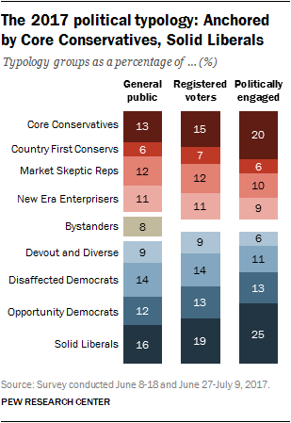
1. What is the purpose of this chart? Is there any correlation in the different groups between their percentage in the general public vs. that of registered voters? Are there any anomalies to this correlation, if it exists?
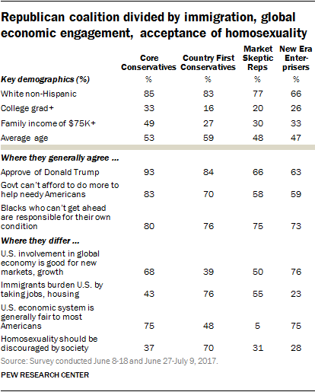
2. From the data presented in this chart and your knowledge of the political spectrum, what contradictions might be present between ideology and expressed political attitudes within the specific groups
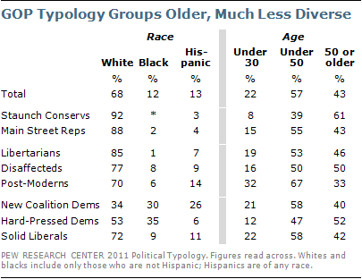
3. What is the purpose of this chart? In what ways do race and age play a role in the typology?
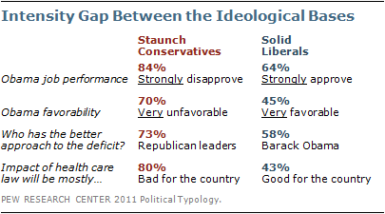
4. What does this data say about how intensely staunch liberals and staunch conservatives feel about President Obama and his policies?
5. Political typology was very important for the results of the 2016 elections. Please visit this site for an activity involving the impact of typology.
The site is on my website (homepage)

