Two Dimensional Design
Ms. Schnurr
Paraline Perspective
Creating Windows in Secondary Planes
To create windows in secondary planes, use the same process as with creating the previous shapes:
- Draw out the primary plane – this will be the window itself
- Identify the working angle – This is already pre-determined. It will only be 90 or 180, and the lines should be cutting into the shape itself.
  - If the window is in the bottom of your shape, the lines will go 90 up.
  - If the window is in the right side of your shape, the lines will go 180 to the left.
- From every vertex, draw lines with that angle. These lines should extend only inside of the shape itself, for what you would see through the window.
- Enclose your shape if the depth of your shape is smaller than your window – draw lines parallel to those in your plane for the window.

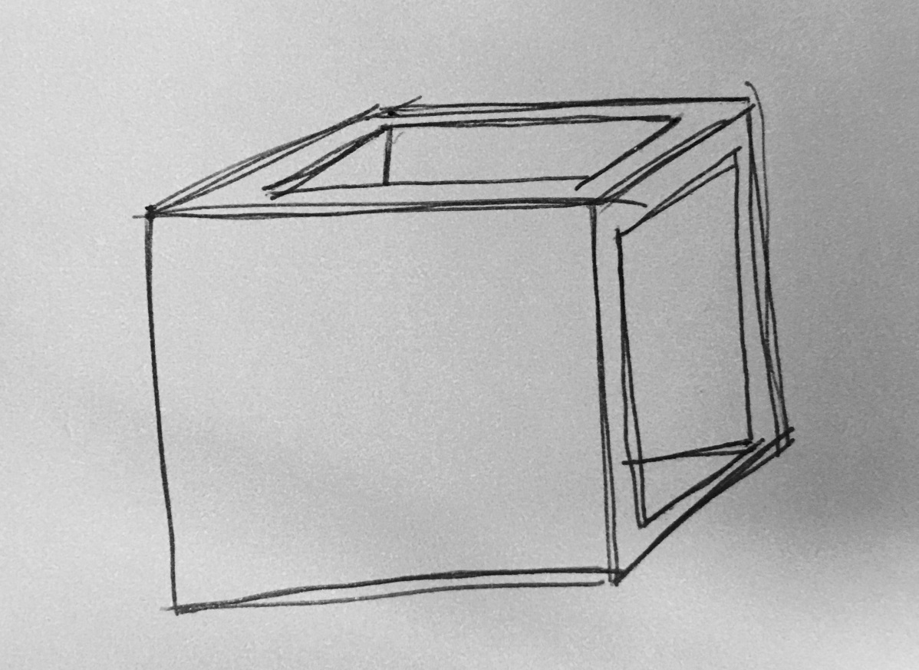

TO CREATE A WINDOW FRAME:
- Draw your window plane in the secondary plane as normal.
- Extend lines from every vertex into your shape
- Enclose your window frame by adding lines parallel to those in your window plane.
- Shade in the surfaces of the window frame.
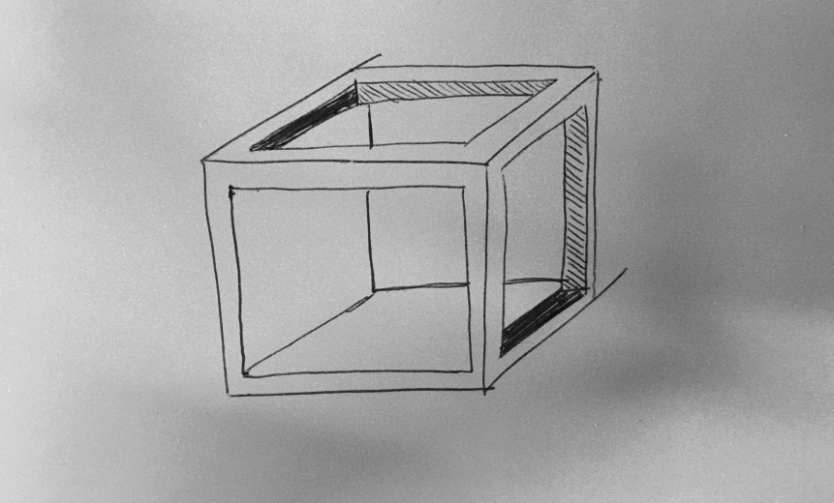
ASSIGNMENT:
- Draw six shapes with 3 windows in every shape.
- Your first shape should be a square or rectangular cube with windows in the primary and secondary planes.
- 3 of these shapes should have window frames for both windows in secondary planes.
- 2 of these should be funky shapes with regular windows
- 2 of these should be regular shapes with funky windows
- 2 can be whatever you want
- Use your triangle and t-square AT ALL TIMES. THIS IS IMPORTANT.
