Measuring with a Microscope Although it is interesting and informative to observe specimens under the microscope, it is often difficult to know the actual size of the object being observed. Magnification causes us to lose the idea of actual size. You cannot hold up a ruler to a paramecium or a plant cell while it is under the microscope. Therefore, size must be measured indirectly-that is it must be compared with the size of something you already know. The diameter of the microscope field seen through the eyepiece is a convenient standard to use. To measure objects under the microscope, a unit called the micron or micrometer (um) is used. One micrometer equals 0.001 millimeter. (1mm = 1000 micrometers). In this investigation, you will learn how to estimate the sizes of objects under the microscope. Procedure 1. Obtain a microscope and a transparent ruler calibrated with millimeters. Examine and identify the millimeter markings along one edge of the ruler. 2. Place the ruler on the stage so that it covers half of the stage opening, as shown in Figure 1. 3. While on Low power (10x), look through the eyepiece. Focus on the edge of the ruler using the coarse adjustment. Adjust the position of the ruler so that the view in the low power field is similar to that in Figure 2. 4. Place the center of one mark at the left side of the field of view. Make sure the edge of the ruler is exactly across the center (diameter) of the field. 5. Note that one millimeter is the distance from the middle of one mark to the middle of the next mark. The diameter of the Low power (10x) field measures one millimeter plus a fraction of another. In the Observations section, record the measurement of the Low power (10x) field diameter in millimeters, expressing the length to the nearest tenth of a millimeter. 6. Determine the Low power (10x) field diameter in micrometers and record in Observations. Remember, 1mm = 1000 micrometers. 7. You cannot measure the diameter of the high power field using the process you just completed, because the high power field diameter is less that 1 millimeter. But, you can obtain the high power field diameter indirectly. Now that you know the low-power field diameter, find the magnifying power of both objectives. Record in Observations. Since the magnification of the objectives is inversely proportional to the field size, you will use this formula:
In Observations, record the high-power field diameter in micrometers. -------------------------------------------------------------------------------------------- **
Record all Observations on the answer document (separate page), with your calculations using the formula in step 7. Then, complete questions #1-5 in the Analysis and Conclusions section, and solve practice problems #1-4 in the Critical Thinking and Application Section.
High power field diameter low-power field diameter (um) x low power magnification = high power magnification

Measuring with a Microscope
HAND THIS PAPER IN AS YOUR LAB!!!
Name__________________ Period _______#_____

Observations:
Measurement of low-power field diameter = _______millimeters (mm).
Measurement of low-power field diameter = _______micrometers (um).
Low-power magnification = ___________
High-power magnification = ___________

Use the formula shown in step 7 of the Procedure to calculate the high-power field diameter. Show Your Calculations.
Analysis and Conclusions
1. How many micrometers are in 1 millimeter?

2. How many micrometers are in 1 meter?

3. What happens to the field of view when you change from low-power magnification to medium-power, to high-power magnification?

4. How many times is the magnification increased when you change from low-power to high-power magnification?

5. How many times is the diameter of a field decreased when you change from low-power to high-power magnification?

Critical Thinking and Application Show Your Calculations!
1. Approximately 500 of a certain type of bacteria can fit across your low-power field of vision. What is the approximate size of 1 bacterium?

2. Approximately 7 of a certain type of protist can fit across your high-power field of vision. What is the approximate size of 1 protist?

3. If a microscope has a low-power magnification of 100X, a high-power magnification of 600X, and a low-power field diameter of 1800 micrometers, what is the high-power field diameter in micrometers?

4. If 20 objects fit across a low-power field of view whose field diameter is 3000 micrometers, what is the approximate size of each object?

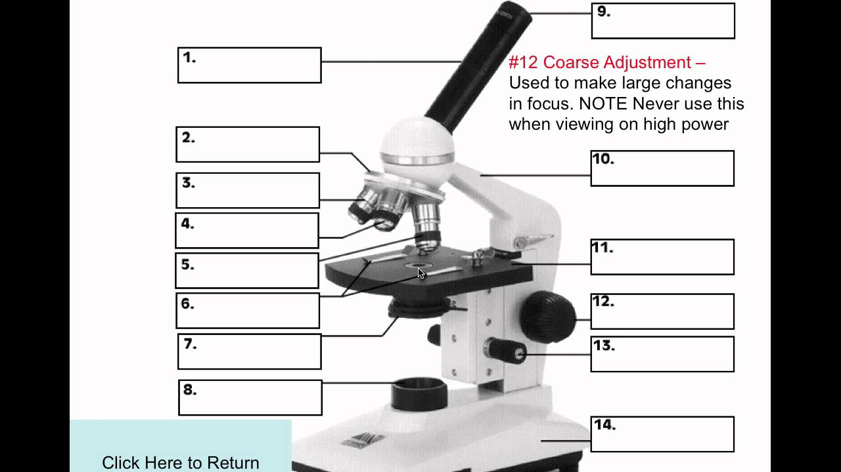

Identify each part and write the name in the box.
Then write the function of each part on the lines below:
Part | function
1
2
3
4
5
6
7
8
9
10
11
12
13
14

