History of Music, Mr. Robert L. Johnston

Jazz/Edward Kennedy “Duke” Ellington (1899-1974)

Aim:

To meet one of the most important figures in American music, “Duke” Ellington.

Instructional Objectives:

At the conclusion of this unit, students will:

- Have met “Duke,” and gained a sense of his musical upbringing.
- Have gained an understanding of what differentiates him from other Jazz composers.
- Have heard a representation of this music, as interpreted by the great Ella Fitzgerald.

Motivation:

Play one of the most famous tunes associated with “Duke” Ellington, Take the “A” Train by Billy Strayhorn, as sung by Ella Fitzgerald and the Ellington Band (6:42)

Development/Procedures:

- Early Life
  - Was born in Washington D.C.
  - One of his grandparents was a former slave
  - Both parents played piano, his mother more popular music, his father more classical
  - Began studying piano at age 7
  - Studs Terkel, in Giants of Jazz, cites, “his casual, offhand manner, his easy grace, and his dapper dress gave him the bearing of a young nobleman.” This is how he earned the nickname “Duke”
  - He was more interested in baseball and pool in his youth
    - In his autobiography, Music is My Mistress, he cites, “"President Roosevelt (Teddy) would come by on his horse sometimes, and stop and watch us play"
  - His early influences were ragtime pianists
    - It was at this point, in his mid to late teens, when he began to take greater interest in music, that he began to study harmony and learn to read music
  - He began playing in and around Washington D.C.
    - According to John Edward Hasse, his first date as a leader earned him 75¢
    - His band played for both white and black audiences, something unique for the time
  - Married when he was 19
    - Had one child, Mercer Ellington, an important figure in his own right
  - Picture

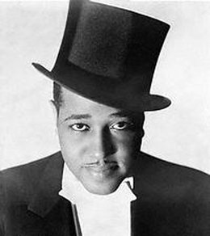
http://www.8notes.com/wiki/images/260px-Duke_Ellington_hat.jpg

- Duke in New York
  - Moved to New York in the 1920’s
    - Played in a band called the Washingtonians
    - East St. Louis Toodle-Oo dates from this time
      - Play (3:39)
      - Note the trumpet playing of Bubber Miley
    - The Washingtonians

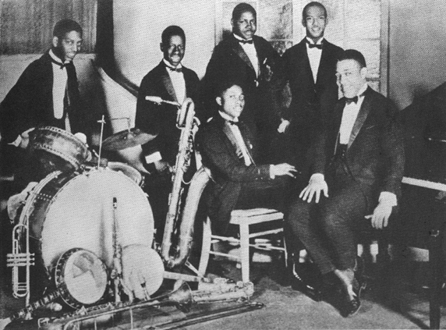
http://www.redhotjazz.com/washinfo.html

  - Ultimately earned a regular booking with his band at Harlem’s Cotton Club
    - This was originally turned down by “King” Oliver
    - Also presented radio broadcasts, earning national exposure
    - Duke Ellington and his Cotton Club Orchestra

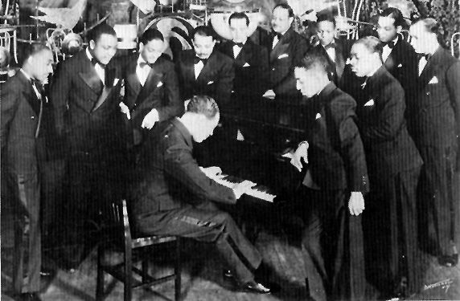
http://www.redhotjazz.com/deccoinfo.html

  - Many call this period “the Golden Age”
  - Stylistically, the band played not only dance music, but also New Orleans style Jazz
  - Tunes from this period include Cotton Tail and In A Sentimental Mood
    - Play Cotton Tail (3:27)
  - It was during this time that Ellington began a business association with Irving Mills who became the band’s manager and publisher
  - By this time, musicians were firmly embedded in the Ellington Orchestra and with Mills running the business of the band, Ellington concentrated on writing
    - Ellington would often write with specific players in mind
    - Many members stayed in the band for decades
  - The final piece of the “Golden Age” was Billy Strayhorn
    - Classically trained, but turned to Jazz due to the prejudices facing him as an African-American
    - A composer and lyricist, Ellington described Strayhorn as, “my right arm, my left arm, all the eyes in the back if my head, my brain waves in his head, and his in mine.”
    - Important Strayhorn tunes include Chelsea Bridge, Take the "A" Train and Lush Life

- Changing Styles and the 1940’s and Beyond
  - Following the Cotton Club, the Band toured extensively throughout the United Sates and Europe
  - The 1930’s saw a shift from New Orleans flavored Jazz and Dance Music to Swing
    - Play It Don’t mean A Thing (If it Ain’t Got That Swing) (4:15)
  - It is this ability of Ellington and his orchestra to change and adapt musical styles that kept the band performing prolifically well past Ellington’s death
  - Aside from his own band, Ellington worked with Max Roach and Charles Mingus, John Coltrane as well as Count Basie
  - Later in his career, Duke wrote religious works, ballets, musicals and larger form works
    - Arranged classical works such as The Nutcracker and Peer Gynt for jazz orchestras
  - Struggled due to new forms such as Be-Bop and Rock & Roll, the decline of the Big Band idiom, and the music industry’s focus on singers such as Frank Sinatra

- Legacy
  - Gunther Schuller said of Ellington, “Ellington composed incessantly to the very last days of his life. Music was indeed his mistress; it was his total life and his commitment to it was incomparable and unalterable. In jazz he was a giant among giants. And in twentieth century music, he may yet one day be recognized as one of the half-dozen greatest masters or our time.”
  - Ella Fitzgerald, at Ellington’s funeral at the Cathedral of St. John the Divine said, “It's a very sad day. A genius has passed.”
  - Duke Ellington swamped by students at Washington Elementary School, Berkeley, 1969

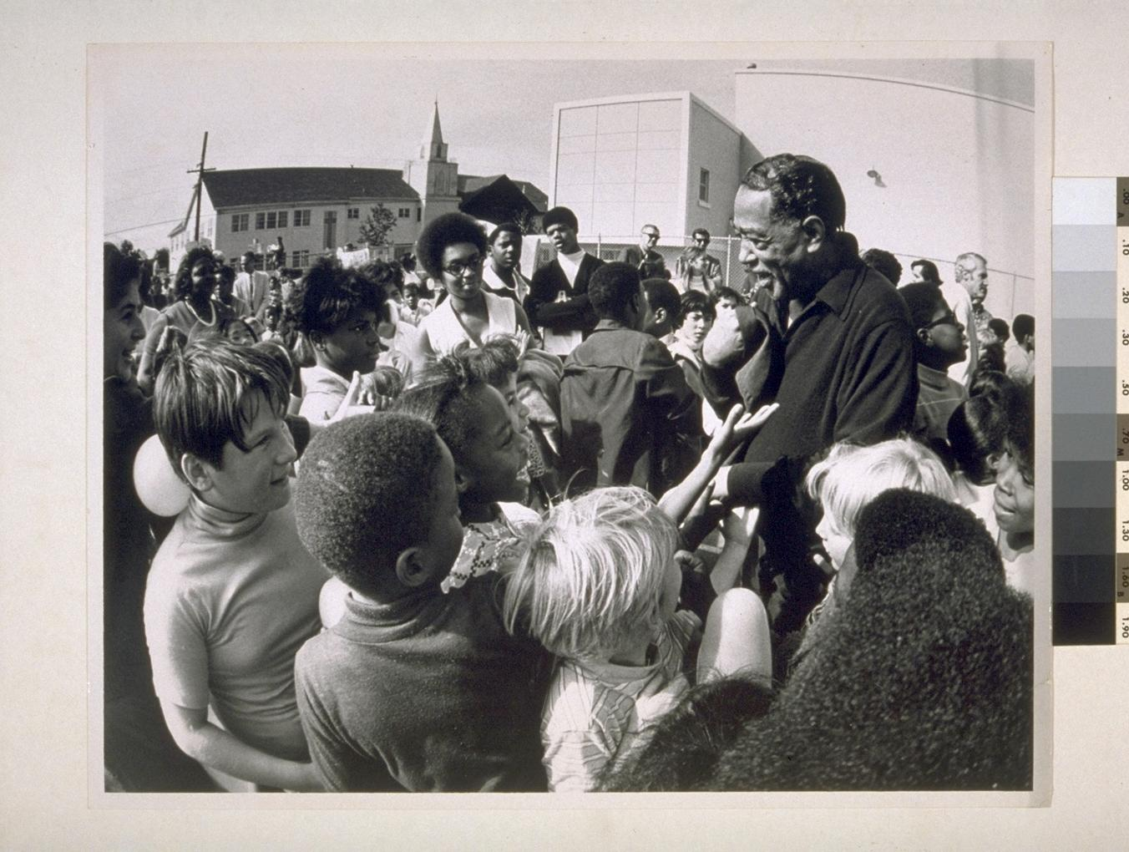
http://sunsite.berkeley.edu/FindingAids/dynaweb/calher/abajbay/figures/I0007474A.jpg

  - If time allows, play Mood Indigo (3:28)
    - In scoring music for his famous jazz orchestra, Duke Ellington wrote for individuals, not instruments. This “Mood Indigo” page features music for his trombone section: Joe “Tricky Sam” Nanton, Lawrence Brown and Juan Tizol.
      - Photo courtesy of the National Museum of American History

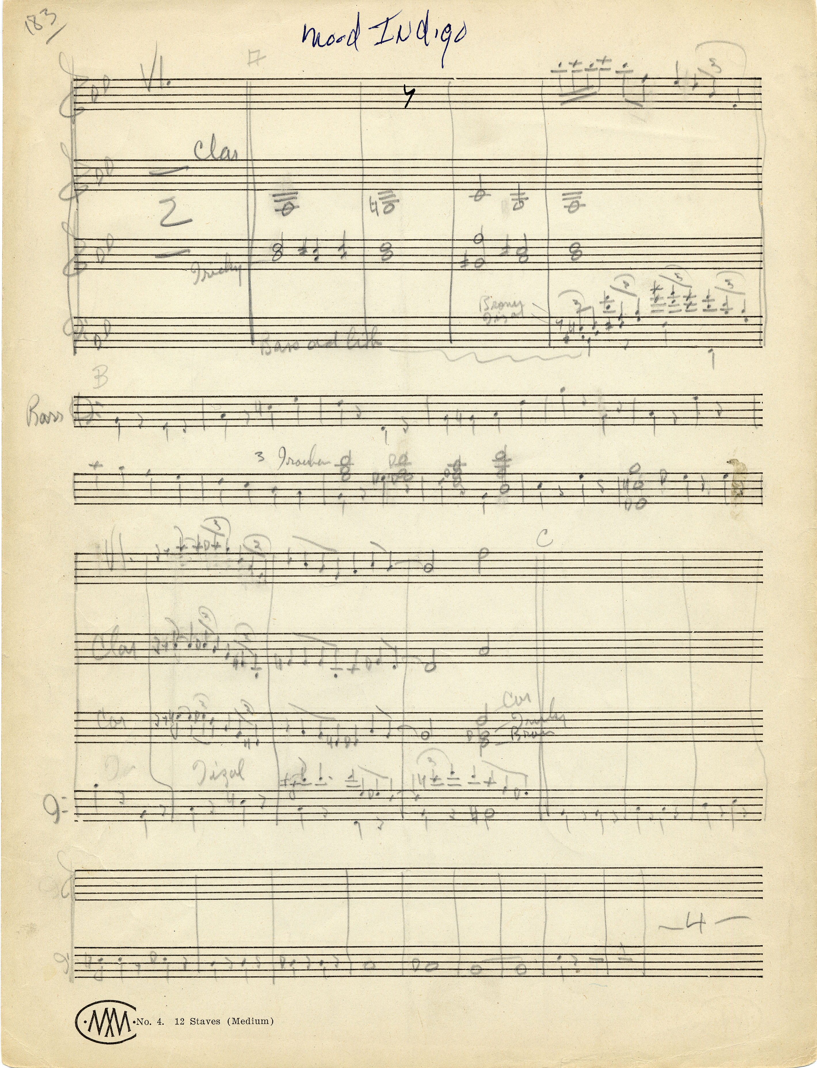
http://newsdesk.si.edu/images_full/images/museums/nmah/treasures/duke_ellington_score.jpg

Materials of Instruction:

Smart Board

Various Recordings

Summary:

Ellington is widely considered one of the great Jazz artists. He himself termed his music “American,” vs. Jazz.

Like so many of the great composers we have studied, we have only scratched the surface. I have left out elements such as the bulk of his later career and the important musicians in his band, and countless other facets.

We have also only listened to tunes from the cannon that are considered standards. Many of these tunes are considered part of the Great American Songbook. Having played a great deal of his larger form works, he is a vital composer who has contributed to the American vernacular in his own unique ways.

Assignment:

Listen to an Ellington or Strayhorn tune and write a short reaction paper citing your impressions of both the musical style and lyrics.

Bibliography:

http://en.wikipedia.org/wiki/Duke_Ellington

http://www.redhotjazz.com/duke.html

http://en.wikipedia.org/wiki/Billy_Strayhorn

http://newsdesk.si.edu/photos/nmah_treasures.htm

The Smithsonian Collection of Classic Jazz, Volume III, (c) 1987, Smithsonian Institution, (p) 1987, CBS records, Inc.

Ella Fitzgerald, The Duke Ellington Song Book from The Complete Ella Fitzgerald Song Books, 1993, Polygram Records

Suggested Reference:

As suggested by http://www.redhotjazz.com/duke.html

Duke Ellington In Person by Mercer Ellington with Stanley Dance, Da Capo Press, 1988

Ellington: The Early Years, Mark Tucker, 1995

Beyond Category : The Life and Genius of Duke Ellington by John Edward Hasse, Wynton Marsalis, 1995, Da Capo Press

The World of Duke Ellington by Stanley Dance, 1981, Da Capo Press

The Duke Ellington Reader by Mark Tucker, 1995, Oxford University Press

Robert L. Johnston

