Ocean Breeze Holiday Festival
Ocean Breeze
Monday 12/30/19

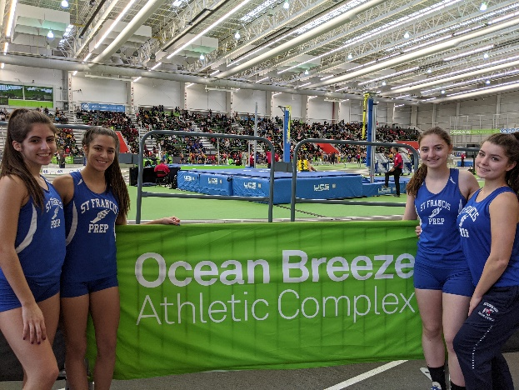
Shuttle Hurdle Relay

Palmeri 9.4
Vasiliadis 9.6
Kenny 9.9
Gonzalez 10.9
39.89 NEW SCHOOL RECORD
4th Place Medals

Freshman 4 x 800

O’Connor 2:53.66 (39.2 41.2 45.6 47.1) (80.5 92.7)
Hughes 2:35.13 (37.0 39.2 39.8 38.7) (76.2 78.5)
Leslie 2:50.90 (36.2 41.2 47.5 46.1) (77.3 93.7)
Morgan 2:37.71 (37.1 39.7 41.9 39.2) (76.8 81.0)
10:57.62 1st Placed Medals

Freshman 4 x 400 Freshman 4 x 200

Muro 72.12 Muro 30.22
Morgan 70.66 Hall 29.20
Hughes 69.40 O’Connor 32.91
Leslie 66.99 Valte 33.62
4:39.20 2nd Place Medals 2:06.65

Varsity 4 x 800 “A” Varsity 4 x 800 “B”

Duffy 2:45.70 (37 39 43 44) Calisi 2:55.64 (38 45 47 43)
Olivieri 2:44.50 (38 41 42 42) Gonzalez 3:02.28 (40 42 52 47)
Mansfield 2:39.78 (35 39 41 43) Vasiliadis 3:06.24 (42 47 50 45)
Vonwerne 3:01.36 (40 45 48 47) Foe 3:03.54 (41 47 47 46)
11:11.37 Medals 12:07.72

