Red Review Book pp. 3-8

Neolithic Revolution → How did agricultural advancements impact society?
Permanent
Settlements
New Social
Classes
New
Technology

ANCIENT CIVILIZATIONS
CIVILIZATIONS | GEOGRAPHY | RELIGION | GOVERNMENT | CONTRIBUTIONS
EGYPT | - Mostly desert  - Nile river serves to irrigate | -Polytheistic  -Amon-Re was the chief god  -Belief in life after death | Egyptian ruler is called Pharaoh | -Science and art  -Mummification – learned about the human body  -Calendar  -Statues
MESOPOTAMIA/  SUMERIA | Fertile Crescent between Tigris and Euphrates Rivers | -Polytheistic  -Built their cities around temples called Ziggurats | -City-states  -Individuals grouped together | -Calendar  -Number system of Cuneiform  -Trade
INDUS RIVER  VALLEY | -Peninsula in the Indian Ocean  -Mountains limited contact with others  -Monsoons – rain for crops | Little is known | -Well planned cities  -Dominated by building on hill | -Most were farmers and plumbers  -Enormous granaries
CHINA | -Grew in river valleys of Huang-He or Yellow Rivers  -Geography isolates the Chinese | -Gods and natural spirits  -Ancestor worship  -Yin-Yang | Shang stated dynasties in China | Written Chinese (4,000 characters)

The CODE of HAMMURRABI was the first Major Collection of Laws

Red Review Book pp. 9-20
MANDATE OF HEAVEN
Old Dynasty
Taxed people too much without benefits
Old Dynasty loses Mandate of Heaven
Problems
-Flood & earthquakes
-Peasant revolts
-Invaders
-Local problems
New Dynasty claims Mandate of Heaven
New Dynasty
-Brings peace
-Restores order

Define Bureaucracy → System of managing government through departments

Classical Greece

Polis
What is it?
City State
Why did they form?
Geography – mountains divide Greece into Valleys

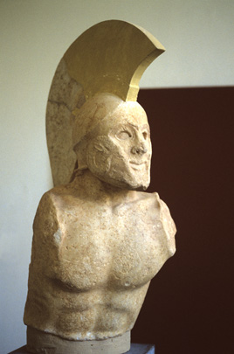
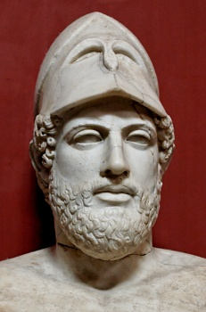
-Limited democracy
-Laws made by assembly and citizens
-Only male citizens in assembly
-Trade with other city-states
-Education for boys
-Women viewed as inferior

-Monarchy with 2 kings
-Military society
-Trade and travel not allowed
-Military trading for all boys
-Girls were trained to be mothers of soldiers
-Women obey men
-Women own property
-Common language
-Shared heroes
-Olympic games
-Same gods and religious beliefs
aTHENS
sparta
Define Direct Democracy → System of government where citizens participate directly rather than through representatives

Red Review Book pp. 9-20

Alexander the Great conquered The Nile Valley, Persia, and parts of India. He spread Hellenic culture through his area of control. Through Alexander’s conquests Hellenistic culture developed.

Hellenistic Contributions

Philosophy | Plays | Art | Science/Math
Philosophers  1) Socrates: Socratic Method  2) Plato: government should control the lives of people. Society is made of 3 classes.  3) Aristotle: strong and good leaders should rule. Learn through reason. | Types of Plays  1) Tragedies: plays that told stories of human conflict  2) Comedies | Human body was shown in its most perfect form. | Archimedes: pulley and level principle.  Aristarchus: earth rotates on its axis and moves around the sun.  Hippocrates: causes of illness and looked for cures.  Pythagoras: Pythagorean Theorem

ROME

Rome Ruled → Senate Upper Class → Patricians Lower Class → Plebeians

Julius Caesar’s death led to the rise of Augustus Caesar who established the Roman Empire. A long peace developed that was known as the Pax Romana.

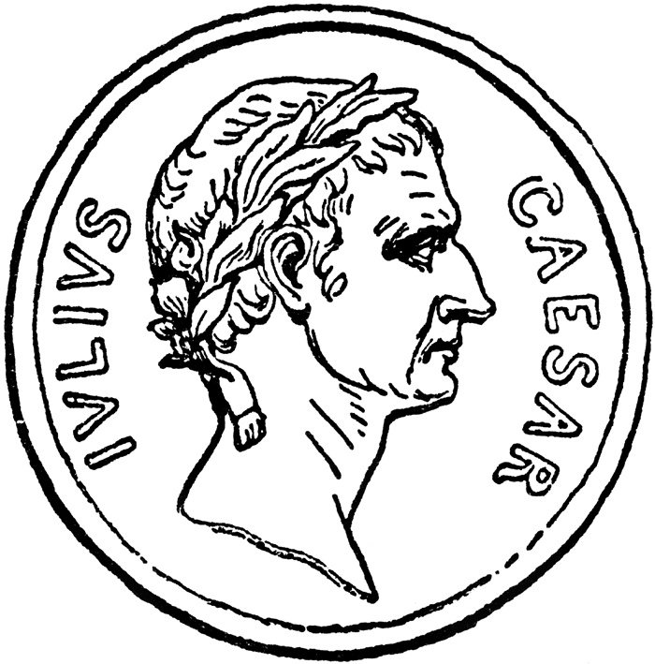
Accomplishments
Law
- Applied to all, stable empire
-Equality under the law
-Basis for modern justice system
Engineering
-Built roads, harbors, bridges, and aqueducts
-Improved architecture
Roads
Created a series of roads to connect the empire which encouraged trade.

The Silk Road was a trade route that connected the Han Dynasty and the Roman empire.

Red Review Book pp. 21-27
What led to the fall?
Political Reasons
Rulers that followed Wudi were unable to control powerful warlords in outlying areas.
Social Reasons
-Peasants were oppressed
-Foreign invaders
Economic Reasons
-Some rulers did not maintain canals and roads, so the economy suffered
-High taxes led to revolts

The Han Dynasty fell…

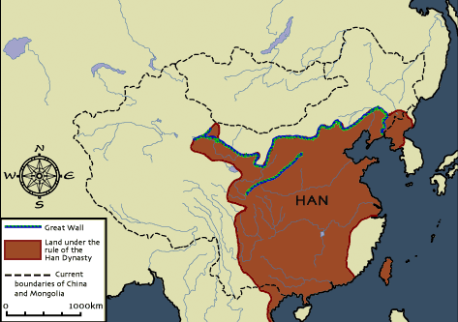

What led to the fall?
Political Reasons
Overexpansion divided the Empire in half
Social Reasons
-Too many cultures
-Foreign invaders
Economic Reasons
High Taxes

The Roman Empire fell…

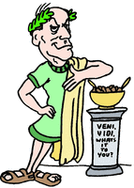

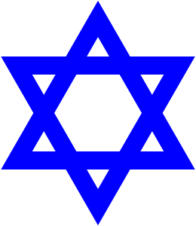
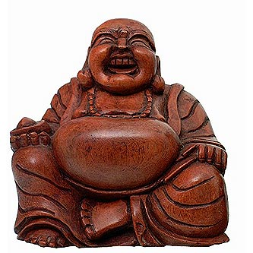
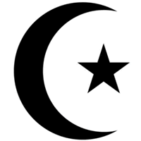
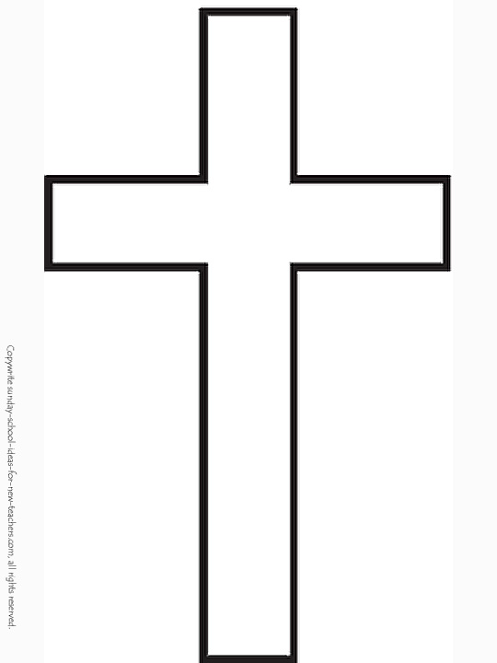
Red Review Book pp. 21-27

Belief Systems/ Religions

System | Location | Major Belief 1 | Major Belief 2 | Misc.
ANIMISM | -Shang, China  -African Societies | Followers believe they are impacted by spirits of living and non-living things. | Prayer is important because it is away to influence the gods. | Belief in Spirits!
HINDUISM | -Indus River Valleys  -India | Reincarnation is rebirth of the soul in a new body. | Why does Karma and Dharma matter?  Following them brings a person closer to a union with Braham. | Define: Caste System  Social classes into which people are born and out of which they cannot move during a lifetime.
BUDDHISM | -China  -India | List 4 Noble Truths  1) All life is suffering  2) Suffering is caused by desires for things that are illusions  3) The way to eliminate suffering is to eliminate desire  4) Follow the 8 Fold Path | Buddha is called the Enlightened one because  -He was unable to mediate to find his answer.  -While meditating under a tree, he found the answer to the meaning of human suffering. | How doe it compare to Hinduism?  Buddhists accept Karma, Dharma, and reincarnation. They reject the Caste System, many Hindu gods and rituals.
CONFUCIANISM | China | List 5 Relationships  1) Superior Ruler → Inferior Subject  2) Husband → Wife  3 Father → Son  4) Elder Brother → Younger Brother  5) Friend → Friend | Why is education important?  Helps to advance society | Define Filial Piety  Respect for parents
JUDAISM | Nomadic Group | Define Monotheism  Belief in one God | What are the 10 Commandment?  Laws describing how people should behave toward God and each other. | Sacred text is the Torah
CHRISTIANTIY | -Palestine  -Europe | Define Monotheism  Belief in one God | Who was Jesus?  Messiah – savoir sent from God | Sacred text is the Bible
ISLAM | Arabia | List 5 Pillars of Islam  1) Faith in one God  2) Fast during Ramadan  3) Daily Prayer  4) Help for the poor  5) Visit Mecca | Who was Mohammad?  Prophet who spread the message of Islam. | Sacred text is the Qur’an (or Koran)

Red Review Book pp. 40-47

Tang and Song Dynasties
Most Chinese farmers who lived in small villages

-Some became very rich, but lower in status because riches come from work done by other people.
-Some bough land and educated, so a son could the gentry
Wealthy
Landowners
Gentry
Merchants
Peasants
Describe each level of society

What was the role of women in China? What was porcelain?
Held great authority A hard, shiny pottery
Byzantine Empire
Eastern half of the Roman Empire that lasted until 1453

What was the capital of the Byzantine Empire? Constantinople
Justinian’s Code  -“Body of Civil Law”  -Collection of the Ancient Laws of Rome | Orthodox Christian Church  -Eastern Orthodox Christians  -Ruled y Patriarchs  -Priests could marry  What was the Great Schism?  1054 – the split between Orthodox Christians in the East and Roman Catholics in the West | Preservation of Greco-Roman Culture  -Preserved Roman law and engineering  -Preserved Greek science, philosophy, art and literature
Cyrillic Alphabet
Brought to Russia via missionaries and is still used today.
Orthodox Christianity
Brought the Orthodox faith via missionaries. Close Church-State relationship.
Autocratic Rule
Czar is the Russian word for Caesar.
Effects on Russia

Red Review Book pp. 48-53
Islam Spread
Asia
Mainly spread through trade and was huge in India.
Europe
Muslims conquered parts of Spain and Sicily in the early 700s during a weak European period.
Africa
Muslims armies invaded North Africa and converts. Two eventually work together to conquer Spain.

Islamic Civilization

DIFFERENCES
Sunnis  -Caliph should be chosen by Muslim leaders  -Do not view Caliphs as religious authority | Shiites  -Only descendants of the prophet Muhammad  -Can be chose by Muslim leaders  -Only descendants can be successful because they would be divinely inspired

List 5 Achievements of Islam’s Golden Age
- Art (beautiful writing, Byzantine domes, and arches, paintings in non-religious art)
- Literature and Philosophy (Qur’an, oral poetry, collected stories from others)
- Math and Science (developed algebra, observed Earth turning and its circumference)
- Economics (trade, manufacturing, agriculture)
- Medical (set up hospitals, doctors had to pass difficult tests, studied diseases, wrote medical books)

What are three characteristics of a “Golden Age”?
- Emphasis on learning
- Achievements in the arts and sciences
- Flourishing economies based on trade

Red Review Book pp. 54-63
Middle Ages
Charlemagne was a Frankish King who helped spread Christianity over Europe after the fall of the Roman Empire.

THE MIDDLE AGES HAD TREE IMPORTANT ELEMENTS

POLITICAL
FEUDALISM
ECONOMIC
MANORALISM
SOCIAL
CATHOLIC CHURCH
How did the Church assert authority over rulers?
Threatened ex-communication

The Catholic Church was a unifying force in a time of political instability after the fall of the Roman Empire.

Owned
State
Owed Responsibility to the King State
Belonged to the Lords
Serfs are bound to the Lord, cannot leave without permission
King
Lords
Knights
Peasants
Serfs
How were manors self-sufficient?
Serfs completed labor in turn for goods.
What was chivalry?
Code of Conduct
How were these groups different?
Serfs were bound to the Lord and Peasants were not.

The Crusades: Histories most successful failure
Effects

1) Trade increased
2) Popes and Kings became more powerful
3) Renting Land helps to free serfs
4) Europeans become interested in traveling
5) People learned about cultures
Reasons for Crusades

1) Increase in Pope Urban’s power and to reunite the Church
2) Christians believed this would ensure that there sins were forgiven
3) Nobles: gained wealth and land
4) Chance for travel and excitement
5) Serfs hoped to escape oppression
Europeans failed to conquer the Holy Land

Red Review Book pp. 72-75
JAPAN
Describe Japan’s geography:
Chain of mountainous islands. Part of the Ring of Fire – susceptible to tidal waves.
Impact of geography:
Land is difficult to form. Most of the population lives in river valleys or on the coast. Blocks political units.
Shintoism
-Uniquely Japanese religion that stresses love of nature
-Shrines are located in places of natural beauty.
List two ways in which Japan was influenced by Korea or China
1) Upper Class imported cultural traditions and ideas from China
2) Koreans brought Buddhism and writing from China.

Geography

Religion

Cultural Diffusion

High Rank
Actual Ruler
Large Landowners
Warriors – loyal to Daimyo
¾ of the population were peasants. Peasants and artisans were granted protection for their service.
Low status, but eventually gained more influence
Emperor
SHOGUN
Samurai
Peasants & Artisans
Daimyo
Merchants
Define Bushido
The way of the warrior
Feudalism
Why was Shogun in caps?
He has all the power
Why were merchants below peasants?
Merchants didn’t do their own work

The Tokugawa Shogunate closed Japan from the outside world. This is asked every year on the regents so know it!

Red Review Book pp. 76-79
MONGOLS

Genghis Khan conquered the largest land empire ever in the history of the world in one life time. The Mongols conquered areas of Eastern Europe, The Middle East, and Central Asia. His armies were made up of skilled raiders, fighters, and rulers. Kublai Khan, grandson of Genghis started the Yuan Dynasty in China. He hired Marco Polo an Italian merchant. Pax Mongolia was a Gold Age if Mongol Rule.
Mongol’s lasting effect upon Russia
Isolation
Absolutist
Government

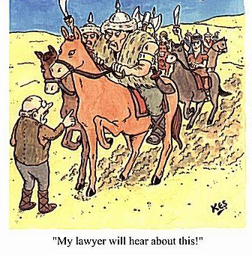

Red Review Book pp. 80-83

The famous Chinese explored Zheng He traveled to Southeast Asia, the Coast of India, East Africa, and the Arabian Peninsula. After his explorations the Chinese decided that no other civilization was as superior as theirs. They decided to isolate themselves and limit foreign contact with others.
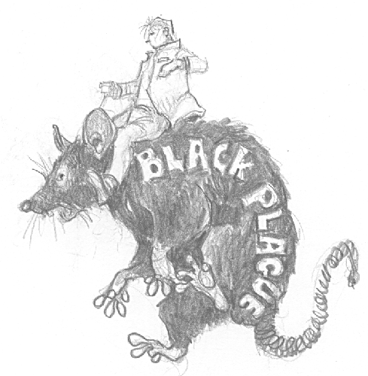
The Bubonic Plague spread from China to Europe, Asia, and North America.
Why is the rat the animal chose to represent the Black Death?
It carried the disease through crowded urban centers.

Population Losses
-35 million Chinese died
-7,000 people died per day in Capco
-⅓ of the European population died
Economic Decline
-Farm and industrial population declines
-People demanded higher wages and prices rose
-Peasants revolted over wage caps

Social and Political Change
-Feudalism declines
-Monarchies gain power and build powerful nations

Confusion and Disorder
-People question their faith and turned to magic and witchcraft
-Some blamed Jews and thousands are murdered

EFFECTS OF THE PLAGUE

Red Review Book pp. 84-91

List two factors that led to the Commercial Revolution

1) Expansion of trade
2) Growth of Cities
Commercial Revolution

LED TO

Rise of Towns
What is a guild?
Trade Association that exits to protect members of the same craft
List 3 New Businesses
1) Banking

2) Insurance

3) Stock Companies

The Renaissance: A rebirth of Greek and Roman ideals that focused on Human ability, potential, and achievement.

List 3 qualities of HUMANISM → 1. Curious about life/ the present
2. Emphasis on the individual 3. Examine worldly subjects

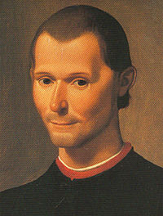
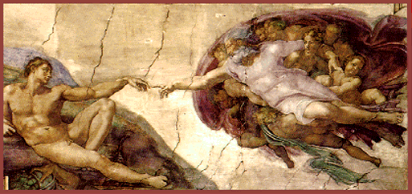
I wrote that the end justified the means. Who am I?
Niccolo Machiavelli
The Sistine Chapel by Michelangelo

List 3 Artists
1) Leonardo Da Vinci

2) Raphael

3) Michelangelo
List 3 Artists
1) Mona Lisa

2) The Madonna

3) The David

List 4 Writers
1) Dante

2) Cervantes

3) Shakespeare

4) Machiavelli
List 4 Writers
1) The Divine Comedy

2) Don Quixote

3) Romeo and Juliet

4) The Prince

Red Review Book pp. 84-91
Johann Gutenberg invented the Printing Press.
List 3 Effects of the Printing Press
Books became more available | Literacy Increases | Ideas spread rapidly

The Protestant Reformation
Causes of the Protestant Reformation
Long Term
1) Renaissance

2) Strong Monarchs

3) Problems in the Church – became more worldly
Short Term
1) Indulgences were sold in Germany
2) Luther wrote the 95 Theses
3) Luther translated the Bible into German
4) Printing press helped spread ideas
5) Reformers called for change
The Protestant Reformation had many leaders. Two of the most important of them were

1) Martin Luther

2) John Calvin

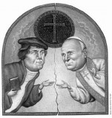

EFFECTS OF THE PROTESTANT REFORMATION

Short Term
1) Peasants revolted

2) Lutheran, Calvinists, Anglican, and other Protestant churches founded

3) Holy Roman emperor weakened
Long Term
1) Loss of religious unity in Western Europe

2) Religious wars broke out for over 100 years

3) Catholic Reformation

4) Inquisition became stronger

5) Many Jews forced out of Eastern Europe

Red Review Book pp. 84-91

What was the Counter Revolution? What was its purpose?
A reform movement taking place within the Roman Catholic Church. The purpose was to strengthen the Catholic Church and to keep Catholics from converting to Protestantism.

Nation States

France fought England in the Hundred Years War. The French became inspired by Joan of Arc and won the war after she was burnt at the stake y the English. Weakened Nobles allowed the Kings to consolidate power.

England did not develop into a limited monarchy because:

  - English common law → law is the same for all people

  - Magna Carta → charter that placed limitation on royal power

  - Parliament → Representative Assembly who control taxes

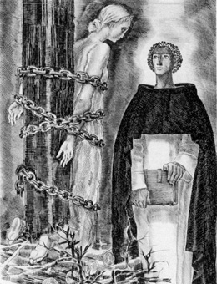
Joan of Arc
Why did the French King not pay my ransom?
Why can I not win a war?

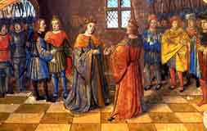

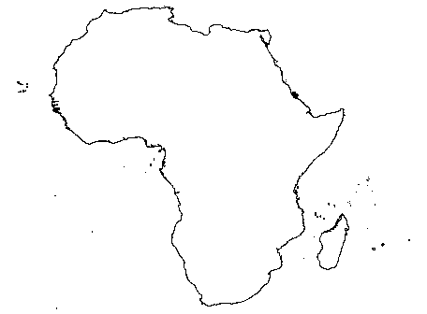
Red Review Book pp. 92-96

African Geography

List 3 Climates of Africa | Fore each explain how it can help or hurt Africans
- Savanna  - Desert  - Rainforest | - Supports farming  - Creates a barrier  - Provides fertile farmland

West African Kingdoms
Ghana, Mali, and Songhai guarded the gold for salt trade.
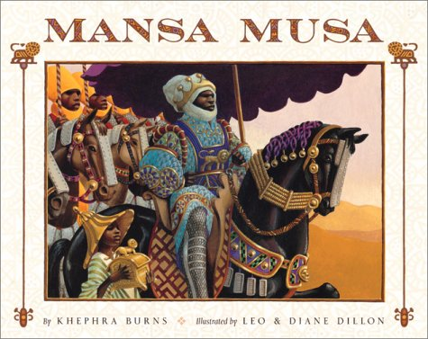
My Hajji is on of the most famous in history
1. Growth of Islam
2. Mali extended its borders and dominated West Africa. Timbuktu becomes a center of living.
Effects of his rule
Hint: meeting of camel and canoe

EAST AFRICA

In West Africa, vast empires developed. In East Africa a variety of city-states developed. Trade was so extensive between Africans and Arabs that a new language Swahili developed.

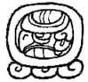
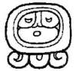
Red Review Book pp. 106-111
Latin America (Mesoamerica)

 | OLMECS | MAYAS | AZTECS | INCAS
WHERE FOUND | Gulf Coast of Mexico | Southern Mexico | Central Mexico | Andes Mountains in Peru and Chile
POLITCAL STRUCTURE  (government) | Influenced Mayans, Aztecs, and Incas in areas that included:  1. Trade  2. Religion: were very religious  3. Architecture: Pyramid-shaped temples | Each city has its own ruling chief followed by Nobles. | The entire Empire was ruled by a single Emperor. | Centralized government ruled by an Emperor.
ROLE OF RELIGION |  | Significant priests occupied an exalted place. | Important to them. Honored the Sun god. Built a huge pyramid to honor sun god. Practiced Human Sacrifices on the largest scale. | Affects of daily life
ROLE OF RELIGION |  | SUN GOD IS THE MOST IMPORTANT OF ALL GODS
ACHIEVEMENTS |  | 1. Architecture: pyramid temples and palaces  2. Agriculture: cleared rain forest and built raised fields for farming.  3. Learning and Science: 365 day calendar, concept of zero, and hieroglyphics. | 1. Learning and Science: accurate calendars, recorded history, medicine, and dentistry.  2. Architecture and Engineering: temple pyramids.  3. Agriculture: chinampas | 1. Engineering: roads, bridges, and canals, and terrace farming.  2. Communication: quipus  3. Performed surgery and used herbs as antiseptics.
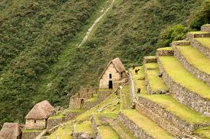
Terrace Farming

Red Review Book pp. 112-117
Why did China choose to isolate themselves from trade in 1433?
Exploration was costly. They believed they had the best civilization and had no need to explore.

How did geography contribute to Chinese isolation?
Mountains, Gobi Desert, and the ocean separated them.
CHINA IMPACTS THE WEST AND ASIA

List the many ways China had influence the following areas
KOREA  -Porcelain  -Writing  -Sometimes took control | WESTERN EUROPE  -Trade  -Introduces new weapons  -Gun and gun powder | JAPAN  -Introduced Buddhism (Zen Buddhism)  -Technology | SOUTHEAST ASIA  -Influenced by trade  -Confucian thought

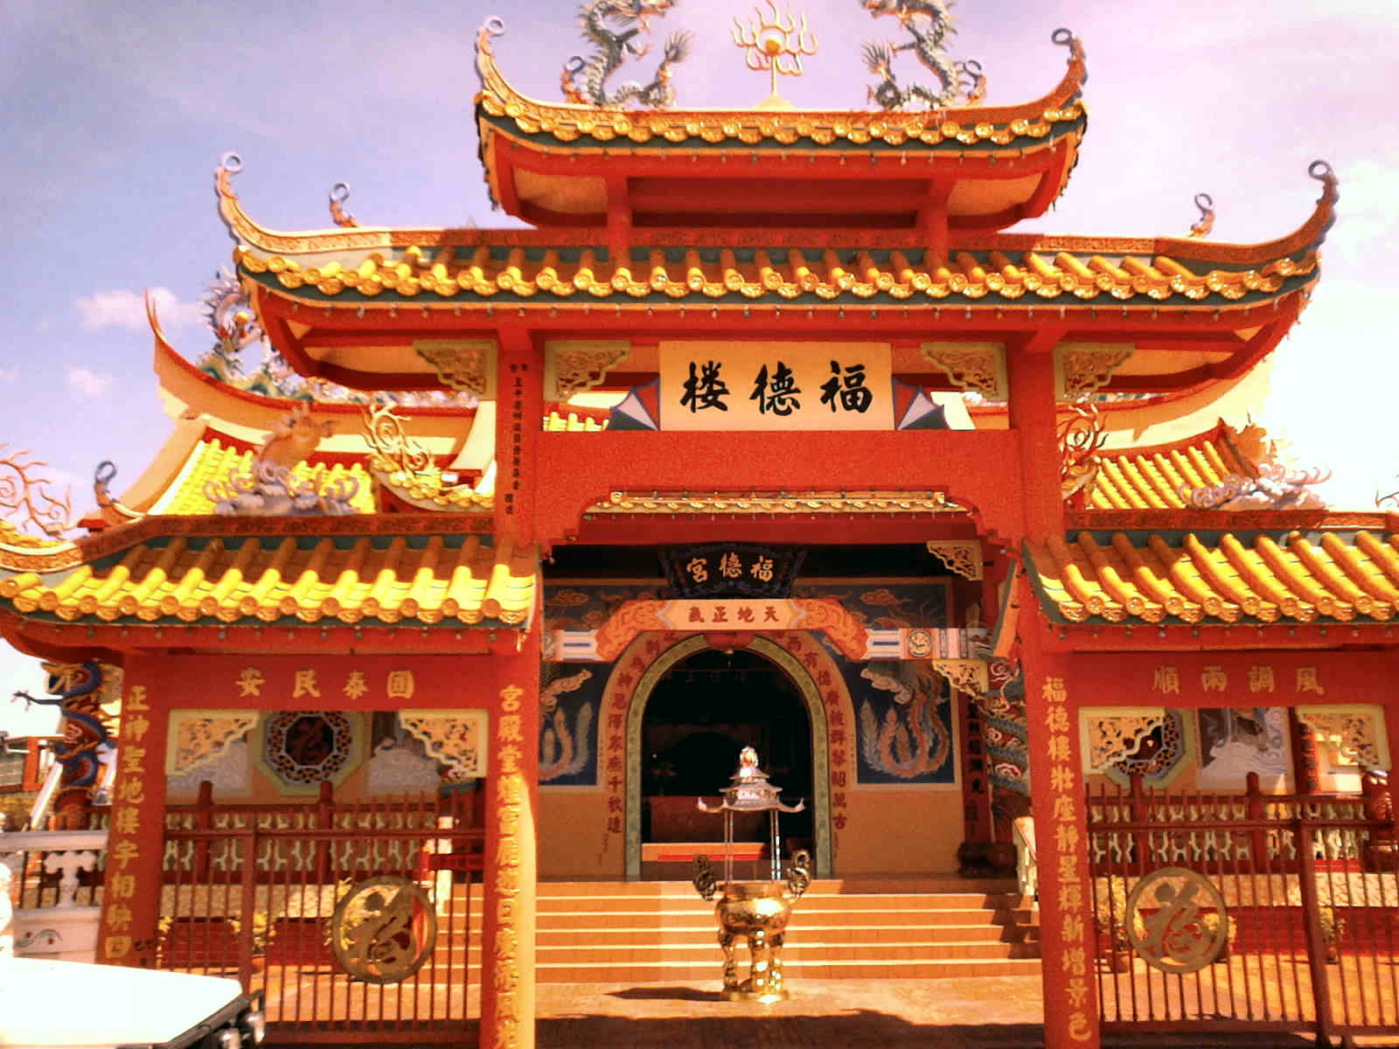

Red Review Book pp. 116-118
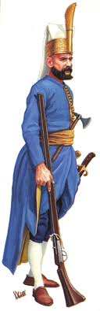
Capital City: Istanbul

Religion: Muslim

Successful because of: New military technology
Absolute Ruler SULEMAN
2 Things He Did
1. Strengthened Government

2. Improved Economy
How did cultural diversity and nationalism impact the Ottoman Empire?
-Made Islam a dominate cultural force
-Non-Muslims were organized into groups called Millets
-Janissaries: young boys converted to Islam and trained for military service
How did Europe contribute to Ottoman decline?
-They were cut out of global trade
-European military and commercial technology surpasses the Ottoman’s
-Commercial Revolution in Europe
Janissary
THE OTTOMAN EMPIRE

Red Review Book pp. 119-125

THE AGE OF EXPLORATION → IMPERIALISM

European trade with Asia was controlled by Portugal and Spain. Spain and Portugal wanted direct access because they wanted spices to be less expensive.

Three Advancements  - Printing Press  - Gun Powder  - Naval Technology | How they were useful for exploration  - New ideas about geography are printed  - Cannons out of ships  - They were able to sail any which way

EXPLORERS
Vasco da Gama

-Portuguese
-Sailed around Africa
-Established an all-water route to Asia
Christopher Columbus

In 1492, he sailed for the Americas

Ferdinand Magellan
Completed the first circumnavigation of the world

Conquistadors | Who did he conquer? | Reasons for Success
HERDANDO CORTES | The Aztecs | 1. Use of Technology that the Americas were not familiar with  2. Disease  3. Allies among the native groups who disliked the Aztecs and Incas
FRANCISCO PIZARRO | The Incas

Red Review Book pp. 119-125
Peninsulares: Europeans born in Spain
Creoles: Europeans descent, born in the colonies
Mestizos/Mulattos: A mix of European & Native American or African
African & Native American

How does the hierarchy reflect Eurocentrism? Europeans held the most power
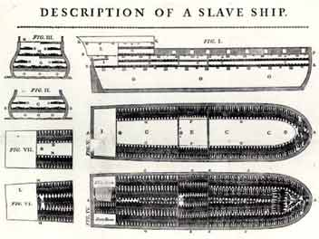
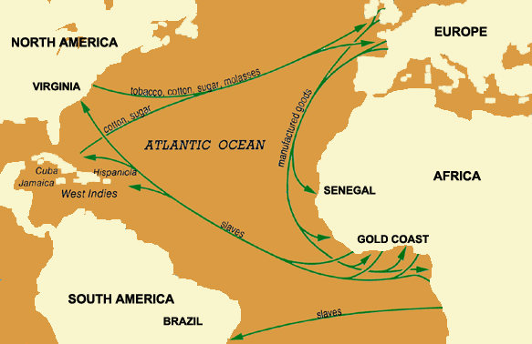
THE SLAVE TRADE
Causes: What did the Europeans need?

Labor to satisfy the shortage that existed on plantations
Effects: List 2 negatives of the slave trade
1. Local Wars Developed in Africa. African political structures were undermined
2. African societies were deprived of talented, strong, intelligent people. Some African states disappeared.
This ship was sued to take slaves on Middle Passage across the Atlantic Ocean.
This trade route was known as the Triangular Trade.

Red Review Book pp. 119-125

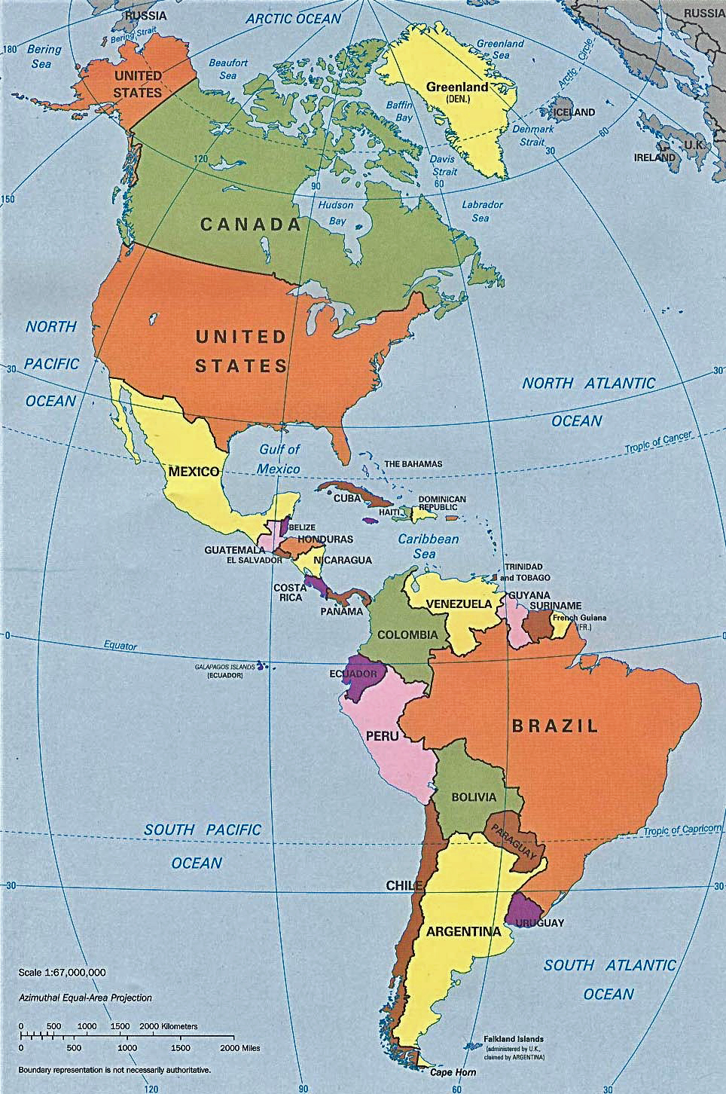
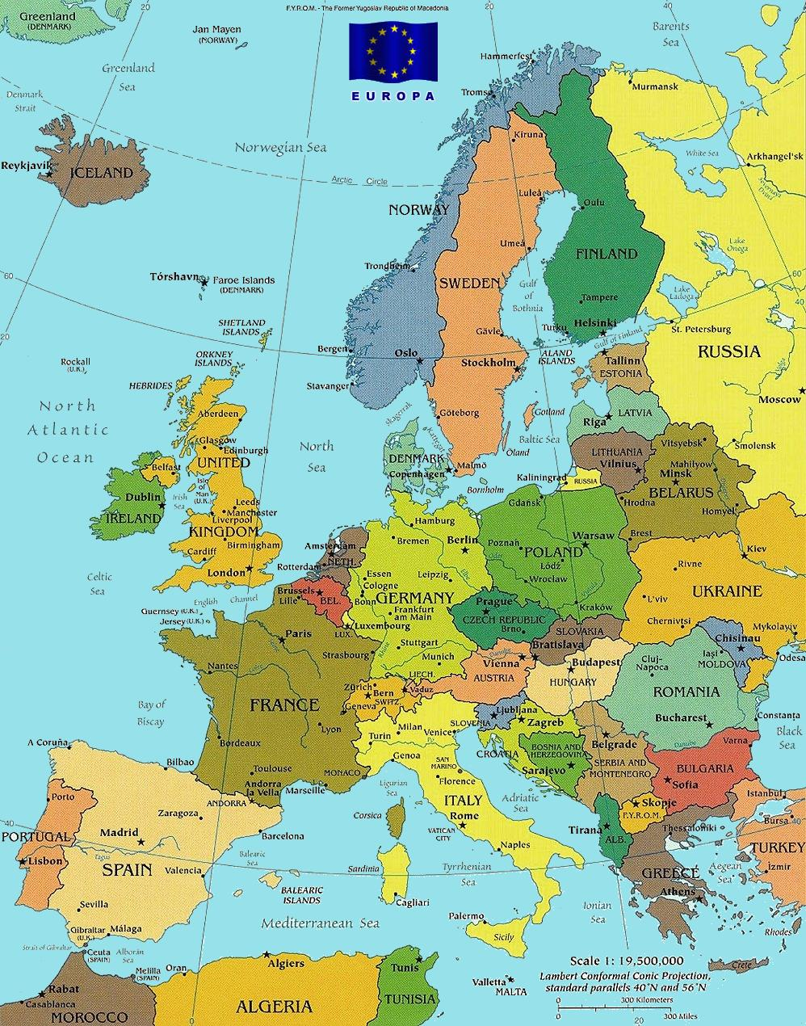
The Columbian Exchange
This is an example of Global Exchange (Cultural Diffusion).

Goods from the Americas

Maize, potatoes, beans, pumpkins, pineapple, avocado, and quinine
Define MERCANTILISM: building national wealth by exporting more than you can import.
COLONY
What is sent to the parent country? Raw Goods
PARENT COUNTRY
What is sent to the colony? Finished Product
Goods from Europe

Wheat, sugar, banana, rice, grape, horse, pig, small pox, typhus, and measles

What profession probably grew in wealth during this time?
The Slave Trade

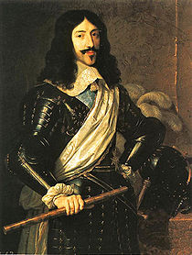
Red Review Book pp. 125-130
It’s good to be King.

The Age of Absolutism

COUNTRY | MONARCH | FACTS
INDIA | Akbar | Ruled during the early 1500’s
SPAIN | Charles V | Did not complete anything special
SPAIN | Philip II | Promoted the Divine Right theory. This theory stated that a ruler’s authority comes directly from God.
FRANCE | Louis XIII | Who is Cardinal Richelieu?  Chief Minister
FRANCE | Louis XIV  The Sun King | List 2 things he did to improve France:  - Highly disciplined army  - Expanded bureaucracy  How did his wars impact France negatively?  They cost a lot of money and caused national debt.
RUSSIA | Peter the Great | Westernization is…  Becoming more modern like Western Germany.  WARM WATER PORT!!!
RUSSIA | Catherine the Great | (See Peter the Great)  Centralized Power

Define Limited Monarchy
A government in which a legislative body that limits the monarch’s power
GLORIOUS REVOLUTION
No Absolutism in England
List 4 Elements of the English Bill of Rights
1. King must work regularly with parliament
2. The king must give the House of Commons financial control
3. Abolished excessive fines and cruel and unusual punishment
4. Affirmed Habeas Corpus - meaning that no person could be held in jail without first being charged with a crime


Red Review Book pp. 140-143
How did the Renaissance spark the Scientific Revolution?
It questioned old ideas about the world.

SCIENTIST | ACCOMPLISHMENTS
Copernicus | Heliocentric Model
Galileo | Heliocentric Model – challenges church
Newton | Gravity and nature follows laws

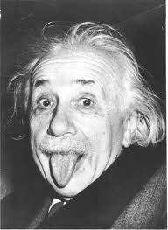
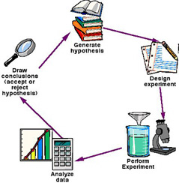
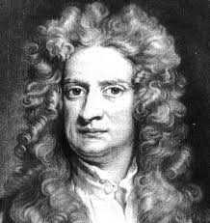
The Scientific Revolution emphasized reason to solve problems.
Do you really know the impact of the Scientific Revolution? OK then, PROVE IT!!!

- How did the Scientific Revolution change the way Europeans looked the world?
World followed laws or rules.

- How did the Scientific Revolution reflect the values of the ancient Greeks?
It encouraged reason and logic.

- How did the Scientific Revolution lead to the Enlightenment?
It allowed people to think of challenging society.

Red Review Book pp. 140-143

The Enlightenment changed the world. Enlightenment thinkers used reason and logic and applied it to government structure, purpose, and administration.

ENLIGHTENMENT THINKER | BELIEFS
John Locke | Natural Rights: Rights that all humans are born with.  List 3 Natural Rights:  Life, Liberty, and Property  How was Hobbes different from Locke?  Hobbes believed a government provides a peaceful, orderly society Locke said people had the right to overthrow government if they didn’t protect their rights.
Montesquieu | The three branches of government are the judicial, legislative, and executive. They are separated to prevent tyranny. A system of checks and balances should be created to be sure no branch acquires too much power.
Voltaire | Pushed for freedom of speech and religious toleration.
Rousseau | Wrote a book called The Social Contract. He believed the general will worked for the common good.

Impact of the Enlightenment
Censorship
The government and church leaders tried to suppress the Enlightenment ideas. Many writers were thrown into prison, and their books were burned and banned.
What did Theresa, Joseph II, and Catherine the Great all have in common?
They were Enlightened Despots – absolute rulers who used Enlightenment ideas.
Ideas Implemented in America
-Democratic and nationalistic feelings
-Sense of Individualism, belief in freedom, and equality
-Declaration of Independence


Red Review Book pp. 144-151
FRANCE
Revolutions
What event is illustrated by each picture?

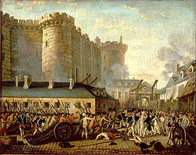
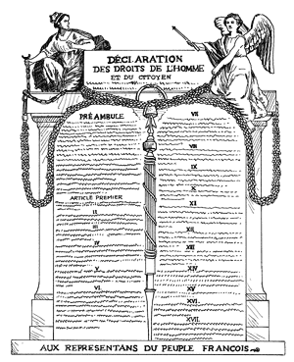
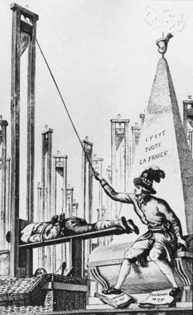
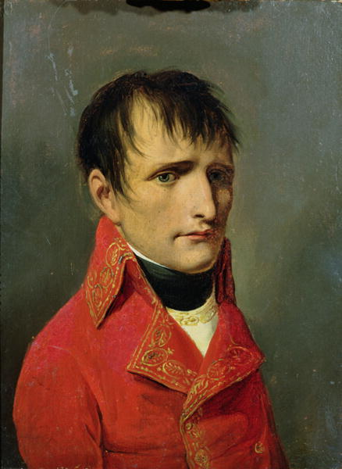
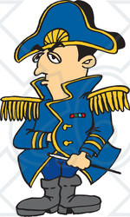
The Storming of the Bastille
The Declaration of the Rights of Man
Napoleon Bonaparte Rose to Power
The Reign of Terror
Explain my code. The Napoleonic code was a legal code that included many Enlightenment ideas, such as the legal equality of citizens and religious toleration.
Because of my greatness, the greatness of French people, and the greatness of French culture, the rest of Europe became jealous. My ability to conquer helped spark one of the most important movements in the modern world. It is known as nationalism, or the love ones country.
List 2 Revolutions that inspired those in Latin America:
French Revolution
American Revolution
Latin America
Who was Toussaint L’Ovuverture?
Helped Haiti gain independence

Who was Simon Bolivar?
Called the “Liberator” and became one of the greatest Latin American nationalist leaders. He won independence for Venezuela, Colombia (New Granada), Ecuador, Peru, and Bolivia.

CAUSES OF THE FRENCH REVOLUTION
POLITICAL  -Absolute Monarchy  -English & American  Revolutions  -Magna Carta  -Parliament | SOCIAL  -Social Inequality  (3 Estates)  -The Enlightenment | ECONOMIC  -Economic  Injustices  -Tax burden fell  an the 3 estates  -Food prices  rose  -People were hungry  and demanding bread

Red Review Book pp. 152-157
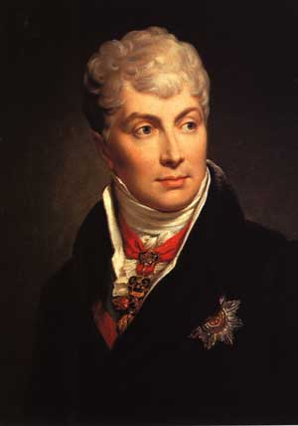
Revolutions
I led the Congress of Vienna. Who am I and where am I from?
Prince Clemens von Metternich of Austria

GOALS | ACTION
To prevent France from going to war again | Strengthen countries around France:  -Add Belgium and Luxembourg to Holland to create the King from of the Netherlands  -Give Prussia lands along the Rhine River  -Allow Austria to take control of Italy again
To return Europe to the way it was before 1792, before Napoleon | Give power back to the monarchs of Europe
To protect the new system and maintain peace | Create the Concert of Europe, an organization to maintain peace in Europe

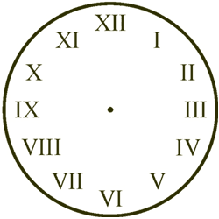
Wanted to turn the back the clock to 1789

Red Review Book pp. 158-162

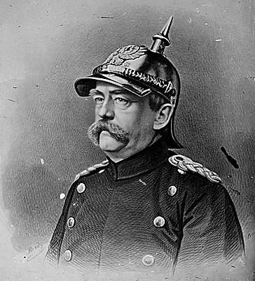
NATIONALISM
When people realize they share a common ancestry, heritage, and language, and culture, nationalism acts as a magnet.
ITALY
Giuseppe Mazzini: formed the Young Italy National movement in 1831, but he was exiled for his views. His writings and speeches provided inspiration to the nationalist movement.
Giuseppe Garibaldi: was a soldier who led forces that won control of Southern Italy and helped it to unite it with the North.
Count Camillo di Cavour: prime minister of the Italian state of Sardinia. Shrewdly formed alliances with France and later Prussia. He used diplomacy and war to drive Austrian power from Italy.
As chancellor of Prussia, I Otto von Bismarck led to the unification of Germany. I believed that only through “Blood and Iron” could Germany be unified. I also love hats with points.

Indian National Congress
1885
-aka Congress Party
-Formed by Nationalist Leaders in India
-Made of Hindu professionals and business leaders
-Wanted equal opportunity to serve in government of India, greater democracy, westernization, and self-rule.

Muslim League
1906
-Formed to protect their won rights and interests
-Wanted a separate Muslim State
INDIA
When people in an empire are ethnically different, nationalism can act as a bomb.
OTTOMAN EMPIRE
Who were the young Turks?
They wanted to strengthen the Ottoman Empire and end the threat of Western Imperialism. In 1908, they overthrew the Sultan.
What was the Armenian Massacre?
Muslim Turks turned against Christian Armenians because they accused them of plotting with Russia against the Ottoman Empire. Over a million Armenians died in 25 years.
BALKANS

Why were they known as the “Powder Keg of Europe?”
Pan-Slavism Movement and Serbian nationalism caused tension. Crisis after crisis broke out on the Balkan Peninsula. Tensions soon exploded into WWI.

Define Zionism: a movement devoted to rebuilding a Jewish State in Palestine.

Red Review Book pp. 163-169
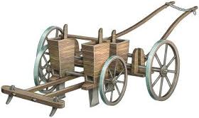
The Agricultural Revolution:
increased production of food
introduction of mechanization

The Industrial Revolution

List 4 causes and explain them
1. Geography – Britain had iron ore and coal needed for industrialization. They also had harbors for trade. Rivers were used for sources of power and transportation.
2. Population Growth – more available workers. Enclosure Movement resulted in fewer laborers needed. People moved into the city to work in factories.
3. Capital for Investment – The British has money to invest in mines, railroads, and factories.
4. Energy and Technology – Britain had water wheels in the 1700’s to power new machines. They had coal for steam engines.

Define Factory: sheds, which brought workers and machines together in one place.
Mass Production: goods being produced in huge quantities at lower cost.

EFFECTS OF THE INDUSTRIAL REVOLUTION
Improved Transportation
Explain
-Roads and canals ere built and improved.
-The steam engine locomotive was invented. Railroads grew.
-Steam engines powered ships at sea.
Laissez-Faire Economics
Define and Explain
- Businesses should be allowed to operate free of government regulations.
-Adam Smith promoted Laissez-Faire in his book The Wealth of Nations.

What did business owners gain from selling stock in their companies?
Each stockholder owned part of a company. Stockholders allowed businesses to form corporations and expand into many areas.
Describe the living and working conditions of the early industrial cities
-Men, women, and children worked 12 to 16 hours a day.
-Mass production led to boring work.
-Machines were dangerous.

How was class structure reformed by industrialization?
-Upper class: very rich industrial and business families
-Upper middle class: business people and professionals (doctors and lawyers)
-Lower middle class: teachers, office workers, clerks, and shopowners
-Factory workers and peasants: lived and worked in over crowded cities.

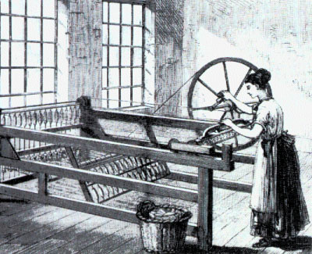

Red Review Book pp. 163-169
New Philosophies and Ideals in Politics and the Arts
What is liberalism?
Strong belief in individual rights to liberty, equality, and property
What is conservatism?
Set of beliefs held by classes who had been in power previously
The Arts

What is Utopian Socialism?
Sought to create self-sufficient communities, where all property and work be shared. All would have equal wealth.

What is Marxism? (Communism)
-History was a class struggle between wealthy capitalists and the working class, or proletariat
-In order to make profits, the capitalists took advantage of the proletariat
-The proletariat would eventually rise up and overthrow the capitalist system, creating its own society
-The proletariat society would take control of the mans of production and establish a classless, communist society, in which wealth and power would be equally shared

What is Social Darwinism?
-Natural Selection
-Successful business people were successful because they were naturally more “fit” to succeed than others
-War allowed stronger nations to weed out weaker nations
-Encouraged racism and imperialism

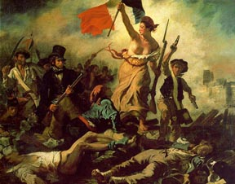
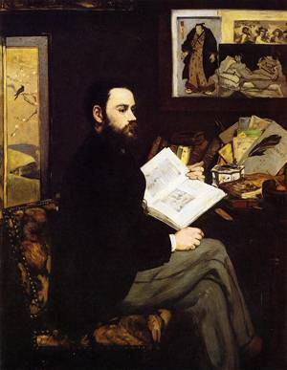
Romanticism
-Appealed to emotions rather than to reason
-Rebellion against the Enlightenment
Realism
-Showed the harsh side of life – poverty, cruel working conditions
-Charles Dickens (writer)
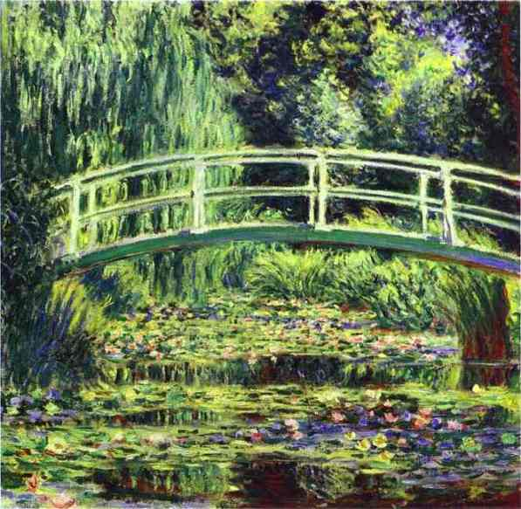
Impressionism

Red Review Book pp. 170-172
The Modernization of Japan
What foreign policy did the Tokugawa practice?

Isolationism
Who was Commodore Matthew Perry and what did he do?
An American who sailed to Japan with a letter from the United States President asking for Japan to open its ports to trade. Japan was impressed by the Americans strength and signed the treaty of Kanagawa that ended Japan’s isolation.
The Treaty of Kanagawa opened Japan for trade. This angered some people in Japan. The shogun was overthrown and the Emperor was restored into power. This was known as the Meiji Restoration. By borrowing and modeling ideas from the West, Japan was able to modernize.

List 4 ideas that were borrowed from the West:
Government
Economics
Technology
Customs

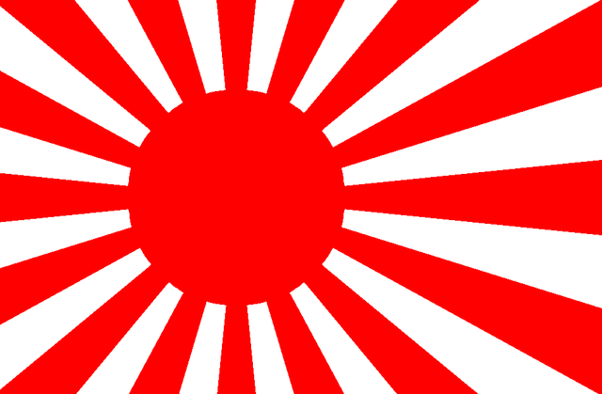
Japanese Imperialism
Sino-Japanese War
Why did they begin to fight?
Japan fought China over land in Korea

Who won?
Japan
Russo-Japanese War
What territory was gained?
Korea and parts of Manchuria

Russian was humiliated

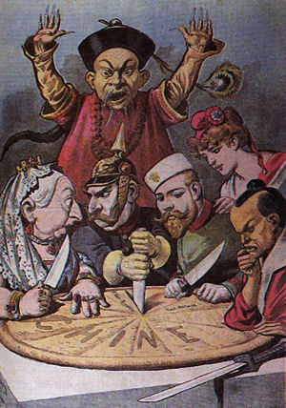
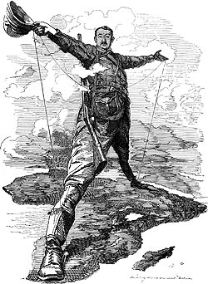
Red Review Book pp. 173-178
IMPERIALISM
CAUSES

ECONONMY  -Needs for natural resources  -Need for new market  -Place for growing population to settle  -Place to invest profits | POLITICS & THE MILITARY  -Bases for trade and navy ships  -Power and security of global empire  -Spirit of nationalism | SOCIETY  -Wish to spread Christianity  -Wish to share Western civilization  -Belief that Western ways were the best | SCIENCE & INVENTION  -New weapons  -New medicine  -Improved ships

INDIA | What European country controlled India?  Great Britain  Explain what led to the Sepoy Mutiny  The British angered the Sepoys by demanded that the soldiers follow rules that were against their religious beliefs.  What were the effects?  Positives: New roads and railroads, telegraph and postal system unite India. Irrigation systems improve farming. New laws means justice for all classes, British schools offer education, customs that threaten human rights are ended.  Negatives: Indian resources go to Great Britain, British-made goods replace local goods, farms grow cash crops rather than food crops, Indians go hungry, top jobs go to the British, Indians are treated as inferior, Great Britain tries to replace Indian culture with Western ways.
AFRICA | How did the Berlin Conference illustrate Eurocentrism?  Europeans set up rules for colonizing Africa. They divided up Africa with little regard for the people that lived there. By 1920, most of the continent was under European rule.  What was the Boer War? Who fought?  Great Britain decided to annex the Boer republics. The Boers resisted and war began (1899-1902). The British won and in 1910 they formed the Union of South Africa.  What was the result of the Zulu resistance?  The superior weaponry of the British crushed the Zulu resistance.
CHINA  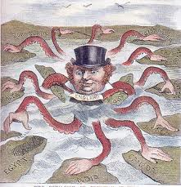 | Who was selling Opium to the Chinese which led to the Opium War?  The British  How did Europeans benefit from the Treaty of Nanjing?  China paid Great Britain war costs, opened ports to British trade, gave Hong Kong to Britain, and granted British citizens extraterritoriality. Other nations forced China to sign unequal treaties.  What is a Sphere of Influence?  Areas in which an outside power claimed exclusive trade privileges.  What did the Boxers lose?  Armies from Japan and Western nations crushed uprisings.  Three goals of Sun Yixian?  - To end foreign domination  - To form a representative government  - To create economic security for the Chinese people

Red Review Book p. 178
List 7 short-term effects of imperialism on the colonies. Tell if each one is positive or negative. Explain your answer. | 1. Large numbers of Asians and African came under foreign rule.  2. Local economies became dependant on industrialization.  3. Some nations introduced changes to meet imperialist challenges.  4. Individuals and groups resisted European domination.  5. Western cultures spread to new nations.  6. Traditional political unites were disrupted or destroyed.  7. Famines occurred in lands where farmers grew export crops for imperialist nations in place of food for local use.
List 4 long-term effects of imperialism on the colonies. Tell if each one is positive or negative.  Explain your answer. | 1. Western culture continued to influence much of the world.  2. Transportation, education, and medical care were improved.  3. Resistance to imperial rule evolved into nationalist movements.  4. Many economies became dependent on single cash crops grown for export.
How was the WEST impacted by imperialism?
List 4 effects:
- The West discovered new crops, foods, and other products
- Westerners were introduced to new cultural influences
- Competition for empires created and increased conflict between imperial powers. These conflicts sometimes led to war.
- The industrial nations controlled a new global economy.

How were Europeans nations able to dominate non-European areas?
The strong central governments and thriving economic of industrialized nations gave them the confidence to expand through imperialism. The Europeans had military power.

Red Review Book pp. 190-195
WWI
Explain each cause of WWI
Explain how the “Power Keg of Europe” explodes
-Serbia felt nationalistic and wanted control of Bosnia-Herzegovina
-Austria-Hungary opposed Serbia
-Serbia attacked the Ottoman Empire
-June 28th, 1914 – The Archduke Francis Ferdinand of Austria-Hungary and his wife were assassinated in Sarajevo by Garvilo Princip, a radical Slavic nationalist.
-Austria-Hungary declares war on Serbia
WWI

M
A
I
N
Militarism – the glorification of military power. Led to fear and suspicion.
Alliance Systems – Nations agreed to defend each other. Two important alliances: Triple Alliance (Italy, Germany, Austria-Hungary) & Triple Entente (France, Russia, Great Britain)
Imperialism – Great Britain, France, and Germany competed for colonial and economic power.
Nationalism
-France
-Germany
-Pan-Slavism

Central Powers | Allied Powers
- Germany  - Austria-Hungary  - The Ottoman Empire | - Great Britain  - France  - Russia  *Italy and USA eventually join

Explain how each of these technological innovations impacted the war.
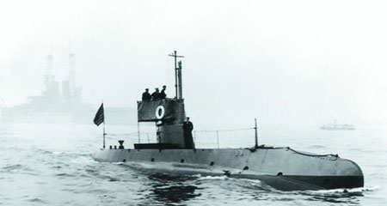
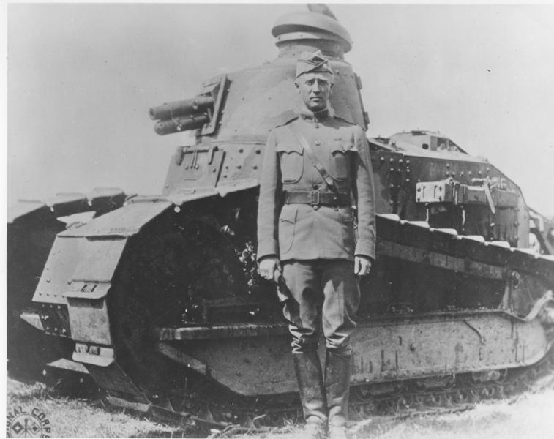
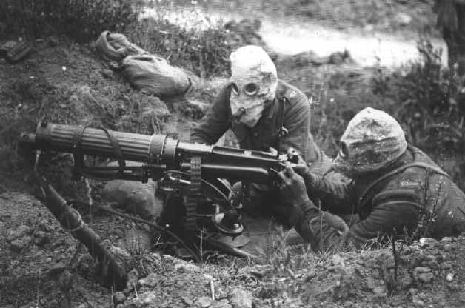
Submarine: under water ships that launce torpedoes or bombs. Germany tried to destroy Allied ships and causes the US to enter the war
Tank: armored vehicles and protected advancing troops.
Airplane: propeller planes equipped with machine guns and bombs.

Poison Gas: caused choking, blinding, or skin blisters. Poison gas was placed in enemy trenches which killed disabled troops.

Red Review Book pp. 196-201
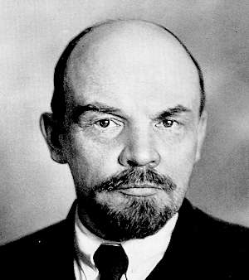
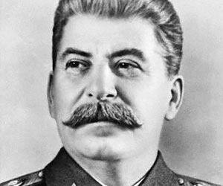
RUSSIAN REVOLUTION
Long-Term Causes → explain each
1. Low spirits after defeat in 1904 war with Japan
2. Poverty and bad working conditions
3. Corrupt government
4. Persecution of minority groups
5. “Bloody Sunday” Killings

What was Bloody Sunday?
Peaceful protestors marched. Troops shot the protesters. People lost faith and trust in the Czar.
Bolshevik Revolution
Who was their leader?
Vladimir Lenin
What philosophy did they follow?
Communism
(Karl Marx)
What promise did Lenin make to the people of Russia?
“Peace, Land, and Bread”
Why did Lenin pull out of WWI at any price?
To make peace with Germany so he could deal with the enemies at home.
What was the NEP? How was it a step back from Communism?
The government still controlled banks, large industry, and foreign. Some privately owned businesses were still allowed.
Who is this man?
Joseph Stalin
What was the Great Purge?
Stalin accused thousands of people of crimes against the government. Many were executed.
Lenin Died
Define:
Totalitarian Rule: A one-party dictatorship that attempts to regulate every aspect of the lives of the citizens
Command Economy: a system in which government officials make all basic decisions
Five-Year Plan: purpose to build industry and increase farm output. Emphasis was placed on heavy industry, while consumer goods were neglected.
Collectives: state-own farms which were large farms owned and operated by peasants as a group

Why did Stalin starve his people?
Some peasants continued to resist by growing just enough grain to feed themselves. The government seized all the grain from some of those communities.

Red Review Book pp. 202-209

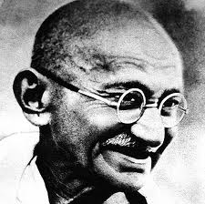
TREATY OF VERSAILLES punished Germany and ended WWI.
1. Territory losses – land was taken from Germany. Some of it was used to make Poland. Lost colonies too. Alsace and Lorraine was returned to France.
2. Military Restriction – Germany’s army and navy were reduced.
3. War guilt – Germany had to accept full responsibility for the war and pay reparations.
What was the League of Nations? Who did not join?
A group of more than 40 countries that hoped to settle problems through negotiation, not war. The US didn’t join, even though it was created by US President Wilson.
Many national movements developed across the world. Kemal Atatürk wanted to modernize Turkey. Iran also sought to modernize through their new leader Reza Khan. Arab nationalism developed after European promises were broken. Many people believed that the only way to free themselves from foreign control was through unity among Arab areas known as Pan-Arabism.
My name is Mohandas Gandhi. I led the Indian independence movements for years. I believe in using Civil Disobedience, which involved boycotts and break laws that we thought were unjust.
CHINA WAS IN A CIVIL WAR BETWEEN THE NATIONALISTS AND COMMUNISTS.

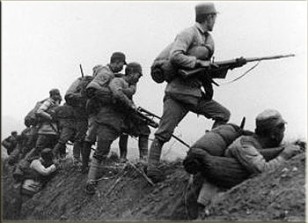
GREAT DEPRESSION

How did the Great Depression impact the world?

-American investors pulled money out of Europe
-Placed high tariffs on imported goods
-Nations who depended on the US saw their economies collapse
-Unemployment
-People lost faith in democracy and capitalism

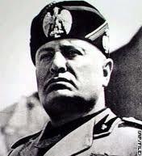
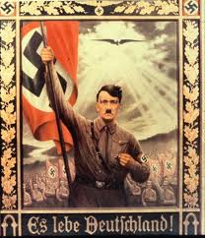
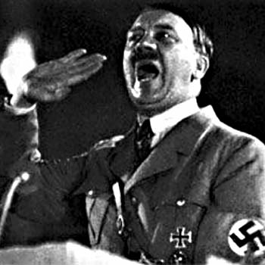
Red Review Book pp. 202-209
Elements of Fascism
1. Censorship and government control of news
2. Extreme nationalism
3. State control of economy
4. Strict discipline
5. Rule by dictator
6. Blind loyalty to leader
7. Use of violence and terror
8. Strong military
I am the fascist leader of Italy Mussolini. I will not allow any outside threat to ruin Italy. In Fascism the goals of the state (nation) are above the goals of any individual right.
Who is the man to the right?
Adolf Hitler

What did he promise to provide to the people of Germany?
To provide jobs and rebuild German pride

What is the poster an example of?
Propaganda
The true people that are holding back are the Jews!!! I hate them!!!
What led to Japanese militarism in the 1930’s?
Unhappiness over loss of traditions, loss of foreign markets due to the Great Depression, unemployment, poverty among peasants, feelings of nationalism, and demand for expansion of Japanese Empire.

What resulted from their militarism?
1931- attack on Chinese province of Manchuria, withdrawal from the League of Nations, anti-Western feelings, end of many democratic freedoms, renewed practice of traditions, increased honor for emperor, renewed expansion, and efforts to control China.

Red Review Book pp. 210-215

COUNTRIES BECOME AGGRESSIVE IN THE HOPES OF BECOMING POWERFUL
JAPAN | ITALY | GERMANY
What area of China did Japan invade?  Manchuria  What was the rape of Nanjing?  Japan’s brutal invasion of the Chinese main land. The Japanese set up a puppet government. | Why was Italy able to defeat Ethiopia?  Italy’s weapons were strong – armored vehicles, aircraft, and poison gas. The League of Nations agreed to stop selling weapons to Italy, but the agreement was not honored by all nations. | Areas taken by Hitler:  - Poland  - Rhineland, France  - Austria  - Sudetenland, Czechoslovakia
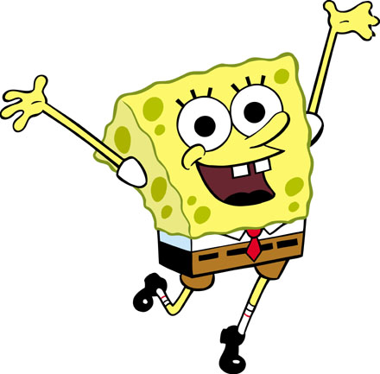
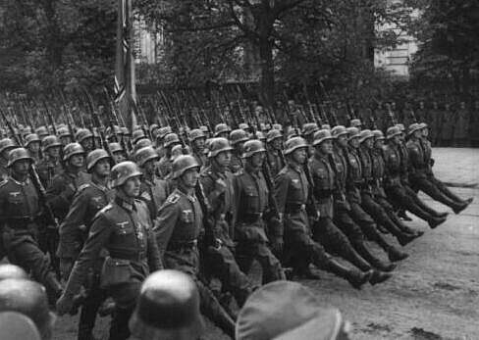
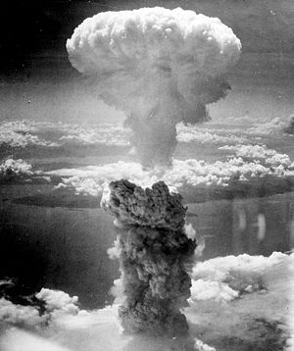
Define Appeasement
Policy of giving into an aggressor’s demands in order to keep the peace
AXIS
1. Germany

2. Italy

3. Japan
ALLIES
1. France

2. Great Britain

3. USA

4. Soviet Union

5. China
Define Blitzkrieg
Lightning War
How did it help Germany early in the war?
Germany conquered Poland and overran Norway, Denmark, the Netherlands, and Poland
End of the War

What 2 important decisions were made at the Yalta Conference?
Germany would be divided temporarily and controlled by the British, French, American, and Soviet forces.
Stalin would oversee the creation of new governments in Eastern Europe.

How did the war in the Pacific end?
The United States Dropped atomic bombs on Japan.

What areas were the atomic bombs dropped?
Hiroshima and Nagasaki

Red Review Book pp. 202-215
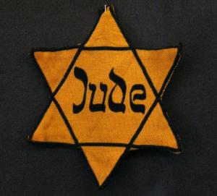
WARTIME ATROCITIES
The Holocaust
Define Genocide
Deliberate attempt to destroy an entire religious or ethnic group
What happened on Kristallnacht?
(Night of the Broken Glass)
Nov. 8, 1938 – organized violence began. Jewish synagogues, businesses, cemeteries, homes, and schools were destroyed. 30,000 Jews were arrested.
What was a concentration camp?
Jews were starved, shot, forced to do labor, or gassed.
Example: Auschwitz
Bataan Death March
What happened?
In the Philippines, Japanese soldiers forced American and Filipino prisoners of war on a march up the Bataan peninsula. Prisoners were beaten, stabbed, or shot.

IMPACT OF WWII
Occupied Nations
-Western Nations occupied West Germany and Japan
-Soviet forces occupied East Germany and most of Eastern Europe
Human Loss
-More than 6 million Jews died
-75 million died in WWII
-Europe had 38 million dead
-Soviets had 22 million dead

War Crimes Trial
-22 Nazi leaders were tried at the Nuremberg Trials
-Some were imprisoned or executed
-Trials were also held in Italy or Japan
The United Nations
-Purpose is to provide a place to discuss world problems and develop solutions
-Two Main Bodies
1. General Assembly: representatives from all member nations
2. Security Council: 15 member nations (US, Russia, France, Great Britain, and China)
Economic Losses
-Cities were in ruins from aerial bombardment
-The economies of war torn countries took many years to recover

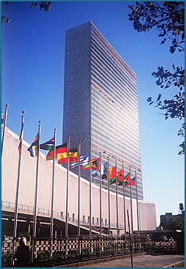

United Nations Building
Red Review Book pp. 226-232
Japan
Mac Arthur drafts a New Constitution
-Constitutional monarchy that limited the power of the Emperor
-Japan would not use was a political weapon
-Democratic Government: Representatives were elected to the Diet (Japanese Parliament)
-Women gained the right to vote
-Basic rights (freedom of assembly and press) were guaranteed
Germany
-West Germany: Nazi party outlawed. Germans wrote a federal constitution that set up a democratic government
-Wanted to make sure the Holocaust would never happen again
-Asylum
How were these countries transformed?
As a result of WWII, The United States and The Soviet Union emerged as the world’s leading superpowers. The ideological conflict between these two nations is known as the Cold War.
The Berlin Airlift
1948
-Stalin closed land routes to Berlin so the Allies couldn’t enter
-Western powers created an airlift that brought food and supplies to Berlin
-Finally, the Soviets ended the Blockade
Marshall Plan
1947
A massive economic aid package designed to strengthen democratic governments and lessen the appeal of communism. Millions of dollars sent to Western Europe. Stalin forbade Eastern European countries from accepting aid.
Truman Doctrine
1947
An economic and military program designed to help other nations resist Soviet aggression and communism.

POST WWII

The Rival Alliances were NATO and The Warsaw Pact.

Red Review Book pp. 226-232

Select 3 areas of the world impacted by the Cold War. Describe a Cold War conflict in each area.
List the areas chosen | List nations involved with the conflict | Describe the Conflict
AREA #1  East Asia | United States and Vietnam | Vietnam War: Americans tried to prevent Ho Chi Minh from uniting Vietnam under communist rule. Vietnam won and in 1975 they United Kingdom.
AREA #2  Middle  East | Arab States (Egypt) and Israel | Abdel Nasser was ruler of the Arab State of Israel. Ended Western power in Egypt. He received support from the Soviet Union. Egypt fought 2 wars with Israel that had American support.
AREA #3  Latin  America | Cuba and the United States | Fidel Castro turned Cuba into a communist state and turned to the Soviet Union for support. The United States tried to invade Cuba and placed a trade embargo on Cuba. This angered Cuba, so they drew closer to the Soviets.

What was the goal of nonaligned nations?

-They were the nations that chose not to ally with either side in the Cold War. They remained neutral.
-India, Yugoslavia, and many African nations
-Their goals were to make economic progress and avoid conflict in the Cold War

Red Review Book pp. 233-237
$$ Economic Issuses World Wide $$

What is a developing nation? Nation with limited resources that faces obstacles in achieving modern industrial economies
List 4 Developing Nations: 1. India 2. Egypt 3. Belize 4. Malawi
List 3 Common Goals: 1. Building Industry 2. Improving Agriculture 3. Controlling Population
INDIA: Explain how the Indian Government has tried to solve the problems listed below.
#1 Inadequate food production
Crop output was increased with new types of seeds, chemical fertilizers, and improved irrigation
#2 Lack of power resources
Dams were built to produce hydroelectric power

List positive and negatives of the Aswan Dam
EGYPT:+
Controlled the Nile River and provided 2 million acres of additional farmland
-
Increased the saltiness of the Nile and caused the soil of the Nile Delta to erode

LATIN AMERICA

List and describe 3 problems troubling many Latin American nations today

- Debt Crisis: Latin American nations had to borrow money to build industry. Money went to paying off interest, not building industry.
- Population Explosion: created an economic burden.
- Agriculture: had to grow staple crops to feed their population.

Africa: list one problem under each heading below.
Economics  -Failed socialist and mixed economy problems  -Cash crops instead of food  -Lack of funding for moral development | Population/ Poverty  -Population explosion  -Widespread hunger | Politics  -Power-hungry, greedy leaders  -Military takeovers  -Harsh dictators  -Ethnic and regional conflicts  -Civil War | Environment  -Too much or too little rain  -Poor soil  -Tropical disease  -Desert climate
What is OPEC? What is its goal?
Organization of Petroleum Exporting Countries (1960)
Goal: to control the oil industry by setting production levels and prices.

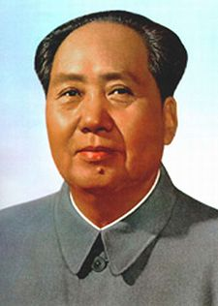
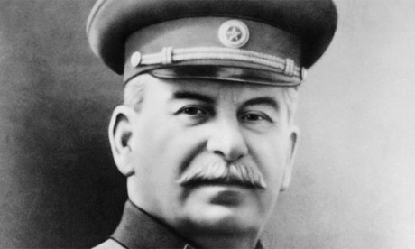
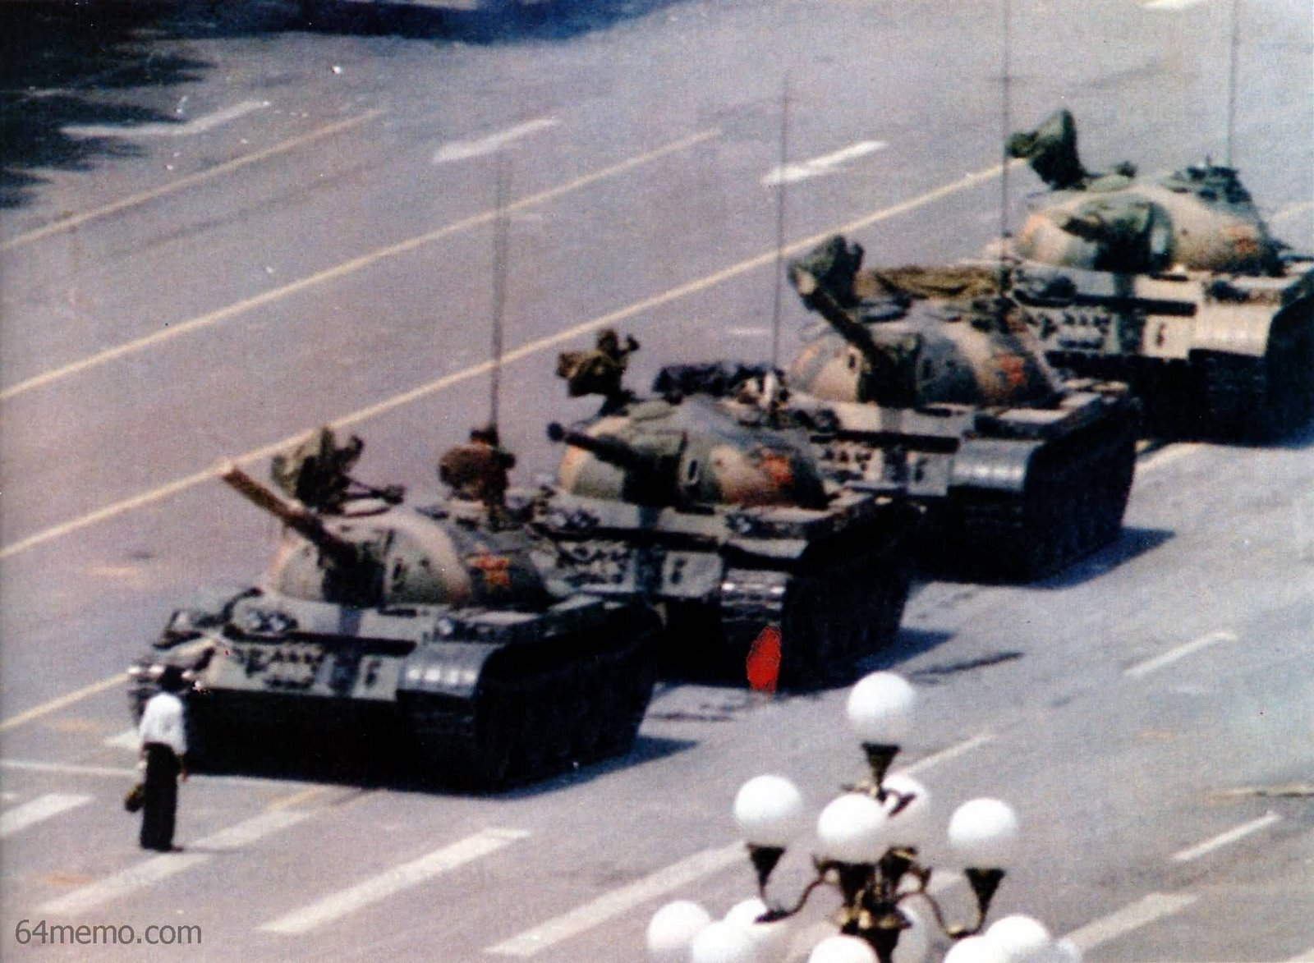
Red Review Book pp. 238-241

CHINESE COMMUNIST
REVOLUTION
Who was Mao Zedong?
Communist leader of China

What was the Long March?
Mao fled the Nationalist forces with 100,000 followers on a 6,000 mile march. They battled for the control of China and Mao won.
List 5 reasons for Communist Success during the Chinese Civil War
1. Mao won the support of the huge peasant population on China by promising to give land to the peasants.
2. Won the support of women by rejecting the inequalities of the traditional Confucian society.
3. Mao’s army made good use of hit-and-run guerilla warfare.
4. Many people opposed the Nationalist government, which they saw as corrupt.
5. Come felt the Nationalist had allowed foreigners to dominate China.
Mao made several changes
What was the goal of the Great Leap Forward?
The goal was to o increase agricultural productions and industrial output. He created communes – groups of people who lived and worked together and held property in common.
What was the Cultural Revolution? Who were the red guards?
Cultural Revolution: to renew people’s loyalty to communism and to establish a more equitable society.
Red Guards: students who attacked professors, government officials, and factory managers.
How did the role of women change in China?
Women won equality under the law. They worked along men on farms and factories.
Which of my programs were similar to Mao’s?
Five-Year Plans and Collectivization
List Deng Xiaoping’s four modernizations
Farming
Industry
Science and Technology
Defense
What event is illustrated in this picture?
Tiananmen Square – demonstrators in Beijing demanded freedom and rights. Troops came to stop them and killed many.

Red Review Book pp. 242-248
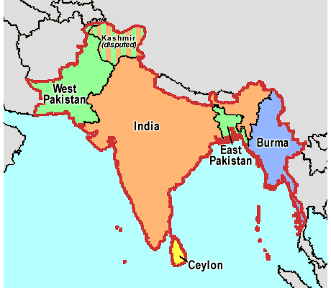
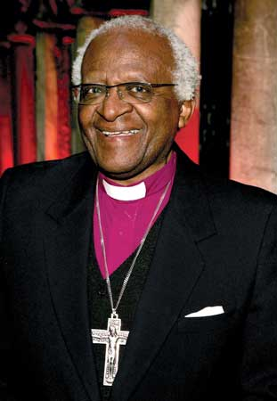
Why did these areas break from India?
Muslims wanted a Muslim state. British officials drew borders to create Muslim Pakistan.
What name does East Pakistan have today?
Bangladesh
Explain how India has dealt with the following problems:

1. Caste System
-Handy campaigned to end harsh treatment of the caste called Untouchables
-Indian constitution banned discrimination against the Untouchables
-Government set aside jobs and places in universities for Untouchables

2. Status of Women
They gained the right to vote, divorce, and to inherit property

3. Sikh Separatism
Sikh separatists expressed their demands. Indira Gandhi (Prime Minister) sent troops. Many Sikhs died.
What did Kwame Nkrumah and Jomo Kenyatta have in common?
They gained independence to Ghana and Kenya respectively. They became Prime Ministers of the new nations.
What problems has tribalism caused in Africa?
It led to civil war. Larger ethnic groups fought for power.
Define Apartheid – separation of the races

Explain how each of the people below contributed to the end of apartheid

Nelson Mandela – he was an important leader to the Anti-Apartheid Movement. He was sentenced to prison.

Desmond Tutu – an Anglican Bishop and civil rights leader. He convinced foreign nations and businesses to limit trade and investment in segregated South Africa.

F.W. de Klerk – became President of South Africa. He legalized the Anti-Apartheid Movement, or the African National Congress (ANC), repealed segregation laws, and released Nelson Mandela from prison.
I lobbied the world to help end apartheid!

Who was Ho Chi Minh?

He was the communist leader of the Vietminh and declared Vietnam free from France.

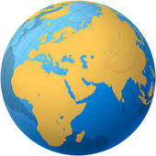
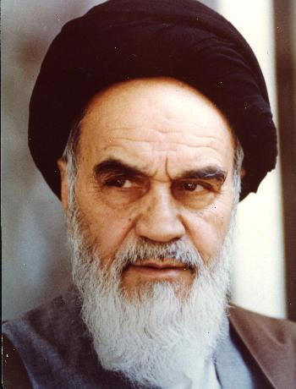
Red Review Book pp. 249-254
Why was Israel created?
Jews wanted a Jewish state separate from Palestine.

What was the goal of the Palestine Liberation Organization (PLO)?
Self-rule for the Palestinians

What was the intifada?
Uprisings by young Palestinians who lived in Israeli occupied West Bank and Gaza. They used civil disobedience.
How did the Camp David Accords promote peaces in the Middle East?

Israel returned the Sinai Peninsula to Egypt in exchange for Egypt’s recognition of Israel’s right to exist.
The Middle East is important to the world because it is an important source of oil, homo to three world religions, and it is the crossroads of trade between Egypt, Africa, and Europe.
My name is Ayatollah Khomeini and I helped overthrow the Shah of Iran. I started an Islamic Republic (Theocracy), or a government bases upon religion. I am an Islamic Fundamentalist. One of the changes I made when I took power was to take away rights from women.
What was the focus of Iran-Iraq War?
Saddam Hussein seized control of a border between Iraq and Iran. They both attacked oil reserves in the Persian Gulf.

How did the Persian Gulf War begin?
Iraq invaded Kuwait and seized its oil fields. The United States saw Iraq as a threat. Iraq refused to withdraw, so the war began. The United States won.
Why have people of the Middle East turned to Islamic Fundamentalism?
Muslims opposed Westernization and wanted to apply Islamic principles to the problems in their nations.

Red Review Book pp. 255-259

COLLAPSE OF THE SOVIET UNION
Causes
1. Leadership of Mikhail Gorbachev
2. Openness to democratic ideas (glasnosts)
3. Reshaping of economy and government (perestroika)
4. Economic problems
5. Freedom movement in Eastern Europe
BREAK UP OF USSR
Effects
1. Formation of the Commonwealth of Independent States
2. Loss of role as world superpower
3. End of the Cold War
4. Economic Hardships
5. Conflicts between procommunists and pro-democratic groups
6. Minority revolts and civil conflicts

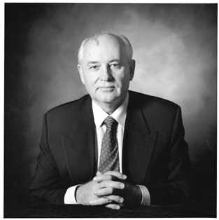
Perestroika: state-run command economy. Its goals were to stimulate economic growth and to make industry more efficient.
Glasnost: openness. Ended censorship and encouraged people to discuss openly the problems in the Soviet Union.
Who was Lech Walesa? What did he accomplish?
He was a Polish leader of Solidarity (an independent trade union). He called for political change.
The fall of the Berlin Wall was a symbolic end to Communist control over Eastern Europe.

Red Review Book pp. 260-263

ARGENTINA | How did Juan Peron gain popularity?  Boosting wages, strengthening labor-unions, and beginning social welfare programs.
GUATEMALA | Define the civil war in Guatemala?  The United States overthrew Jacobo Árbenz because he threatened United States business. The military and landowners gained power. Civil War began. Indigenous people suffered the most.
CUBA | Who was Fidel Castro?  A young lawyer who organized a guerilla army and fought against the Cuban leader Fulgencio Batista. He established a communist dictatorship in Europe (1959).  Why was Cuba affected by the collapse of the Soviet Union?  Cuba’s economy suffered.
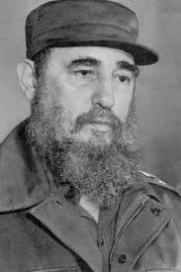
NICARAGUA | What type of political system did the Sandinistas establish?  Made of communists and socialists. I t introduced some reforms and socialized policies.  Name the political group that revolted against the Sandinistas?  The Contras  Why did the US support this counterrevolutionary group?  The United States feared the spread of communism.
MEXICO | How did Mexico benefit from NAFTA?  It allowed free trade among the United States, Canada, and Mexico. Some businesses and investments went to Mexico.

Red Review Book pp. 260-263

Define the Religious Controversy
Violence between the Protestants and Roman Catholics. Until 2005, the Irish Republican Army used violence against the British and Protestant Irish.
NORTHERN IRELAND
What is ethnic cleansing? Who was enforcing that policy?
The Serbs practiced ethnic cleansing, or the act of removing or killing people of a certain ethnic group.
THE BALKANS

Ethnic and Religious Conflict Worldwide
What is causing conflict in the South East Asia?
Muslim and Sikhs said they feel discriminated from the Hindus. East Timor contains mostly Catholic and wanted independence. Muslim extremists (al-Qaeda) didn’t allow it.
INDIA
What happened in Rwanda?
Extreme fighting between ethnic groups: Hutu and Tutsi. It led to genocide. It stopped when a seized control of the government.
AFRICA

