Name:__________________________________ Date:_____________

Period:_____ Hansen

A Walk through U.S. History

In the Beginning:
- First immigrants to North American continent
- Nomadic ancestors of Native American Indians
- Around 15,000 years ago
- Crossed Frozen Bering Strait
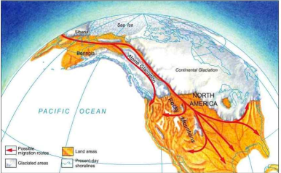

“I believe much trouble and blood would be saved if we opened our hearts more.” ~ Chief Joseph

The First British Settlements:
- Jamestown was the first successful English settlement in North America
- Established on an island in the James River in Virginia in 1607
- Founded by the London Company
- Settlers suffered until learned to grow tobacco to ship back to England
- Second successful English colony was founded at Plymouth Bay in Massachusetts
- Pilgrims
- Strict Protestants who wished to separate from the Church of England
- Before landing, 41 adults on the Mayflower (their ship) signed the Mayflower Compact
- A written agreement
- Established rules and laws for colony by majority rule
- Early example of self-government in colonies
“…frame, such just and equal Laws… for the General good of the Colony”
~ Mayflower Compact
More Examples of “Democratic” Traditions in British Colonial America:
- Magna Carta of 1215
- Yes, a document from the Middle Ages in England, but…
- King promised not to imprison nobles or townspeople except according to the laws of the land
- Limited the power of the king
- Yes, a Parliament in England but …
- Representative legislature
- Established the idea of consent of the governed (people vote)
- Examples of Colonial Self-Government
- Mayflower Compact
- Established a colonial government deriving power from consent of governed
- House of Burgesses
- Colonial Virginia
- Elected representatives helped govern colony
- New England Town Meetings
- People expressed concerns; made decisions for the town
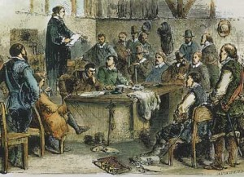“I know not what course others may take, but as for me, give me liberty, or give me death.”~ Patrick Henry

Geography of Thirteen Colonies:
New England:
- Massachusetts, New Hampshire, Rhode Island, Connecticut
- Rocky Soil
- Harbors
- Abundant Forests
Middle Colonies:
- New York, New Jersey, Pennsylvania, Delaware
- Fertile Soil but small farms
- Harbors
The South:
- Maryland, Virginia, North Carolina, South Carolina, Georgia
- Very Fertile Soil
- Long growing season
- Plantation economy

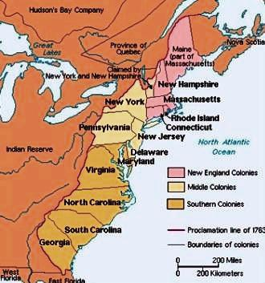
“Geography is an earthly subject, but a heavenly science.”
~ Edmund Burke
A Bit More American Geography:
- Appalachian Mountains
- Thirteen colonies were located east of the Appalachian Mountains
- British issued the Proclamation Line of 1763
- To forbid settlement west of the Appalachian Mountains
- To avoid conflict with Native American Indians
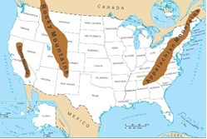
Don’t confuse the Appalachian and the Rocky Mountains!
- Appalachian in the East
- Rockies in the West
- Rocky Mountains made westward expansion difficult
- Mountains are never easy to cross!
The Great Plains:
- Acquired as a result of the Louisiana Purchase
- Grasslands or flat lands with grasses
- From the Mississippi River to the Rocky Mountains
- Farming and herding
- Breadbasket or grain-basket of the nation
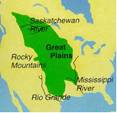
Mississippi River
- United States gained full control of the Mississippi River as a result of Louisiana Purchase
- Flows to port of New Orleans and Gulf of Mexico
- Important river for trade
- Farmers in the Ohio River Valley benefitted – could transport goods to the port of New Orleans to the Gulf of Mexico
Colonial America:
Indentured Servant:
- Signed a contract to work for a period of time in exchange for passage to North America
Mercantilism:
- Belief that colonies exist for the benefit of the mother country
- Colonies must trade with the mother country
- Colonies must export natural resources or raw materials to the mother country and import the mother country’s finished goods
Salutary Neglect:
- Because England was busy with other pressing issues in the 17th century, largely ignored colonies
- England did not act like a mother country towards 13 colonies at this time
- Colonies given a great amount of economic freedom and self-government
The Middle Passage:
- Plantations in South depended on slave labor from Africa
- The Middle Passage was the slave’s forced journey from Africa to Americas
John Peter Zenger Trial:
- John Peter Zenger published a newspaper
- Critical of colonial governor
- Blamed for criticism and content of newspaper
- But jury concluded that criticisms were factual
- Acquitted – freed from criminal charges
- Great victory for freedom of the press
The Albany Plan of the Union:
- Drafted by Benjamin Franklin
- Proposed that colonies unite in a permanent union for defense in dealing with growing French influence in Ohio Valley
- Although the Plan failed, it introduced the concept of a federal plan of representative government and colonial cooperation
The French and Indian War:
- Britain versus France (1754-1763)
- Part of a larger battle over colonies
- Native American allies on both sides
- Britain won and gained Canada
- But Britain incurred a great debt (war is costly!)
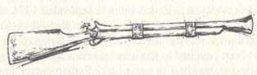
Causes of the Revolution or the End of Salutary Neglect:
- To help pay off their war debt, the British Parliament imposed new taxes on the colonies
- The Stamp Act (1765)
- required colonial newspapers, books and documents to carry an official government stamp
- Colonists objected since they were not represented in Parliament
- Parliament repealed tax; replaced it with taxes on paper, glass, and tea
- When the British repealed all taxes except the one on tea, in 1773, a group threw tea off a British ship in Boston harbor (Boston Tea Party)
The Intolerable Acts:
- These British acts punished the colonists for their behavior at the Boston Tea Party
- Boston harbor was closed
- The colonists had to pay for the destroyed tea
- British troops could stay in peoples’ homes (quartering)
The First Continental Congress:
- On a call from Virginia, all the colonies except Georgia sent delegates to a Continental Congress
- Met at Carpenters Hall in Philadelphia on September 5, 1774
- Divided between those who favored resistance and those who advocated conciliation
“I challenge the warmest advocate for reconciliation to show a single advantage that this continent can reap by being connected with Great Britain. I repeat the challenge; not a single advantage is derived. Our corn will fetch its price in any market in Europe, and our imported goods must be paid for buy them where we will.” ~ Thomas Paine
Thomas Paine and Common Sense:
- Pamphlet: Common Sense
- Wrote that it was ridiculous for the American colonies, located on a huge continent, to be governed by a tiny far-off island like Great Britain
- Paine argued that it was “common sense” for the colonies to seek independence
The Declaration of Independence, 1776:
- Influenced by ideas and principles of the European Enlightenment or Age of Reason
- Influenced by John Locke (natural rights to life, liberty, and property) and Montesquieu (separation of powers)
- Influenced by idea of “consent of the governed” or voting
- Government derives or gets its power from the people
- Also included a long list of grievances or complaints against King George III
- Written by Thomas Jefferson
“We hold these truths to be self-evident, that all men are created equal, that they are endowed by their Creator with certain unalienable Rights, that among these are Life, Liberty and the pursuit of Happiness. – That to secure these rights, Governments are instituted among Men, deriving their just powers from the consent of the governed…”
~ Declaration of Independence
- Formally adopted by the Second Continental Congress in Philadelphia on July 4, 1776
- Explained why the colonists had declared independence from Britain
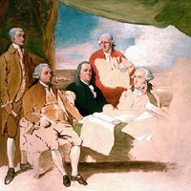
- In 1783, Britain recognized the independence of the thirteen American colonies
The Articles of Confederation:
- 1781 while the Revolutionary War was still being fought
- The confederation was a weak, loose association of independent states
- Each state sent one representative to the Confederation Congress, where it had one vote
- There was no national executive or court
- A weakness was that the Congress could not levy national taxes, regulate trade, or enforce its laws
- Each state government was more powerful than the new national government
The Northwest Ordinance:
- The Confederation Congress passed the Northwest Ordinance (1787)
- Provided a system for admitting new states into the union
Shays’ Rebellion:
- Western Massachusetts
- Convinced Americans that changes in the national government were necessary
- Farmers crushed by demands for payment of debts joined together, rebelled, attacked a federal arsenal but stopped by state troops
- Yet a reminder of the need for a stronger federal government
Constitutional Convention:
- Delegates from twelve states met in Philadelphia in 1787
- Decided to abandon the Articles of Confederation
- Agreed on the need for a stronger central government
The Great Compromise:
- Large and small states differed on the method for each state’s representation
- This Connecticut Compromise resolved the conflict
- Created a bicameral (two-house) Congress
* Number of representatives in House of Representatives based on state’s population
* But two senators for every state
Three-Fifths Compromise:
- Three-fifths of the slave population in a state would be counted for the purposes of representation and taxation
The Census:
- Taken every ten years to determine each state’s population for purposes of representation
Antifederalists:
- Feared a strong central government
- Objected to new constitution – claimed it created too powerful a government
- Lacked protections for individual rights (lacked a Bill of Rights)
- Preferred increasing the power of the states
Federalists:
- Favored the ratification (approval) of the Constitution
- Believed in a strong central government
- Alexander Hamilton, James Madison, John Jay, and George Washington
Federalist Papers:
- 85 published essays arguing for the need for a strong Constitution
- Alexander Hamilton argued in favor of Constitution in The Federalist Papers
- Authors claimed that a stronger government was needed to protect against rebellion or foreign attack and to regulate interstate trade
- Said citizens should not fear the new government, since its power was divided among three separate branches of government
Popular Sovereignty:
- Idea that government is created by the people and subject to the will of the people
- Most basic principle of Constitution is that the power of government is held by the people
- This is reflected in the first words of the Preamble: “We the people…”
Preamble U.S. Constitution:
“We the People of the United States, in Order to form a more perfect Union, establish Justice, insure domestic Tranquility, provide for the common defence, promote the general Welfare, and secure the Blessings of Liberty to ourselves and our Posterity, do ordain and establish this Constitution for the United States of America.”
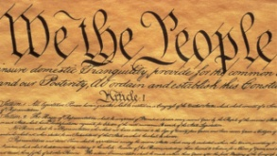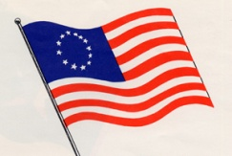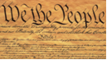
Federalism:
- A system of sharing power between the national and state governments
- Some powers are concurrent powers, such as the power to tax, are held by both the federal and state governments
- reserved powers are those held exclusively by state governments
Elastic Clause:
- In the Constitution
- Expands the powers of the federal government
- Gives Congress additional powers to do what is “necessary and proper” for carrying out its responsibilities
- Also called implied powers
The Bill of Rights:
- First ten amendments of the Constitution
- Include the right to freedom of speech, the right to bear arms, and the right to a trial by jury
“Checks and Balances”:
- To prevent the national government from having too much power
- Government is divided into three branches [executive, legislative, and judicial]
- Yet each branch of government can limit the power of the other branches
- To check is to limit
Strict Constructionist:
- Individuals who felt that the Constitution should be read literally
- Believed the elastic clause should be used only for expanding the powers of Congress in cases where the expansion is absolutely necessary
Loose Constructionist:
- Individuals who held the belief that the Constitution and specifically the elastic clause should be read broadly
- And that the framers intended the elastic clause to mean that Congress should have the “proper” powers resulting from its other powers
The Flexibility of the Constitution:
- The Constitution has the ability to adapt to changing situations
- The Constitution can be changed by amendment
- To prevent changes for unimportant reasons, the amending process was made much more difficult than the passage of an ordinary law
- After Congress votes for a Constitutional amendment, three-quarters or three-fourths of the states must ratify it
The Unwritten Constitution:
- The federal government relies on many practices that developed after the Constitution was put into effect
- These practices became customary
- Often based on examples or precedents established by George Washington
- Examples: the President’s cabinet, political parties, and judicial review
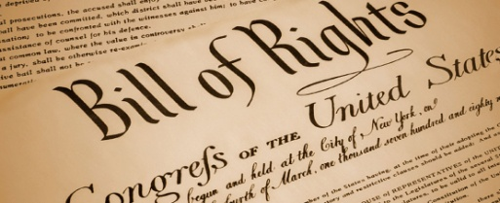
The Legislative Branch:
- A bicameral Congress with a House of Representatives and a Senate
- Two senators for every state; thus, 100 senators
- 435 representatives in House of Representatives based population of states (determined by census)
- Two-thirds of the Senate is needed to ratify treaties negotiated by the President and the Senate must also confirm all Presidential appointments
- Representatives in Congress or the legislative branch make laws
The Executive Branch:
- The Presidency is the Executive Branch of government
- The President must be a natural-born citizen who is at least 35 years old
- Traditionally, Presidents only served two terms of office, until Franklin D. Roosevelt was elected four times
- In 1951, the Twenty-second Amendment limited a President to two terms
- The President is Chief Executive, Chief of State, Commander-in-Chief, foreign policy chief, chief legislator, and chief of a political party
The Judicial Branch:
- Federal courts form the Judicial Branch of government
- The U.S. Supreme Court is our highest federal court
- Has nine members, each nominated by the President and confirmed by the Senate
- Can review lower-court decisions that come before it on appeal
Judicial Review:
- The power of the Supreme Court to determine the constitutionality of a law
- The Supreme Court has the power to determine that a law is unconstitutional
- Chief Justice John Marshall (1801 – 1835) introduced judicial review
- Helped establish the importance of the federal judiciary and the supremacy of the national government over the states
Marbury v. Madison:
- Supreme Court case (1803) with Chief Justice John Marshall
- Established the principle of judicial review
- Strengthening Supreme Court’s role as the final interpreter of the Constitution
McCulloch v. Maryland
- Supreme Court case (1819) with Chief Justice John Marshall
- Court ruled that a state could not tax an agency of the national government, such as a branch of the national bank
- The Court said that when a state law conflicts with a federal law, the federal law is supreme
Gibbons v. Ogden:
- Supreme court case (1824) with Chief Justice John Marshall
- The Court supported the Constitution’s statement that only Congress has the power to regulate interstate commerce
The Electoral College:
- The members of the Constitutional Convention did not trust the people to elect the President directly;
- They turned selection of the President to electors who form the Electoral College
- To become President, candidate needs to win majority of Electoral College votes
- The number of electors each state has is equal to the number of its Representatives in the House combined with the number of its Senators
- The candidate with the most votes in a state wins all of the electors of that state
- Sometimes the popular vote is less than the electoral vote but the President must win a majority of the electoral vote!
Alexander Hamilton:
- Federalist; supported a loose construction of the Constitution, a National Bank, tariffs, and a strong federal government
A List of Some of the 27 Amendments Commonly Asked on Examinations:
From Bill of Rights:
1st – Freedom of speech and press, religion, assembly, and right to petition the government
2nd – To bear arms (carry firearms/guns)
4th – Protections against unreasonable searches and seizures
5th – Right to Due Process (Fair treatment in court – to be charged with a crime, to have a trial, to have an impartial jury, etc.) and a Person cannot be charged twice for the same crime (freedom from double-jeopardy)
6th – Right to a fair trial and attorney
10th – Division of power between states and federal government (federalism)
Added after the Civil War:
13th – Abolished slavery
14th – Equal rights for citizens
15th – Universal Male Suffrage (all male citizens have right to vote)
Progressive Era Amendments:
16th – Graduated Income Tax (the more you make, the more you pay)
17th – Direct Election of Senators
18th – Prohibition (No alcohol)
19th – Women’s suffrage
Two More to Consider:
22nd – Two term limit for President
26th – Lowered the voting age to 18 (during Vietnam War – if you can serve in the military, you should vote!)
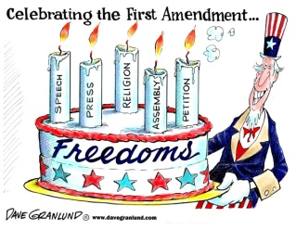
Thomas Jefferson:
- Favored a “strict construction” of the Constitution
- Opposed a national bank for nowhere in the Constitution was a bank mentioned
- Division over the National Bank led to the formation of the first political parties
- Purchased the Louisiana Territory (more on this topic later!)
Whiskey Rebellion:
- Secretary of the Treasury, Alexander Hamilton, proposed a tax on whiskey to raise money for the national debt
- Small farmers distilled whiskey and resisted the tax
- Attacked federal revenue officers who attempted to collect it
- President George Washington issued a congressionally authorized proclamation ordering the rebels to return home and calling for militia
- Washington ordered troops to stop rebellion, but opposition melted
- Demonstrated power of federal government to insure domestic tranquility
Farewell Address:
- Washington cautioned against entering into a permanent alliance with any European country; encouraged neutrality and isolationism
The Louisiana Purchase:
- 1803: France offered to sell Louisiana Territory to USA for $15 million
- Although Jefferson was not sure if the Constitution allowed the federal government to buy territory, he went ahead with the purchase
- Doubled the size of the United States
- Gained full control of the Mississippi River, the port of New Orleans (connecting the Mississippi River to the Gulf of Mexico), and the Great Plains
Lewis and Clark and Sacagawea:
- Explored the new Louisiana Territory and went as far as the Pacific Ocean
- Maps were produced of the new territory
- These maps encouraged westward expansion
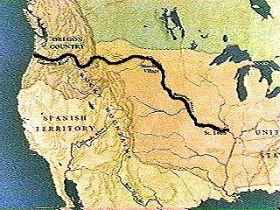
The War of 1812:
- Britain vs. USA
- Causes: to prevent the British seizure of American sailors (impressment), to stop British support of Native American Indian raids in the Northwest Territory, and to try to seize British Canada
- During the war, the English burned the capitol, Washington
- War is often called the “Second War for American Independence”
- The Treaty ended the war but no land changes occurred
- Americans gained a sense of pride and respect and nationalistic fervor
- Francis Scott Key wrote his poem, Defence of Fort M’Henry (McHenry) – it became the U.S. National Anthem
The Monroe Doctrine:
- After many nations in Latin America gained independence from Spain, President Monroe issued the Monroe Doctrine
- It stated that the Americas were closed to future colonization
- The Americas were off limits to would-be European conquerors
Andrew Jackson:
- Elected President in 1828
- First President not born to wealth and not from an Eastern state
- His main supporters were ordinary people
- Jackson’s two terms in office saw an expansion of democracy
- States eliminated property qualifications, allowing most adult males to vote
- Jackson developed the spoils system
- Supporters of his campaign and presidency were rewarded with government jobs
- Jackson also forced the National Bank to close
- Believed it gave an unfair advantage to Eastern bankers and investors
- Enacted the Indian Removal Act
Indian Removal Act:
- President Andrew Jackson moved all remaining Native American Indians to territories west of the Mississippi River
- Jackson refused to help the Cherokees of Georgia even though the Supreme Court declared that their forcible removal was unconstitutional
Worcester v. Georgia:
- Even though the Supreme Court ruled in favor of the Cherokee in Worcester v. Georgia, the Cherokee were forcibly removed from their lands
The Trail of Tears:
- In 1838 and 1839, as part of Andrew Jackson’s Indian removal policy, the Cherokee nation was forced to give up its lands east of the Mississippi River and to migrate to an area in present-day Oklahoma
- The Cherokee people called this journey the “Trail of Tears,” because of its devastating effects
- The migrants faced hunger, disease, and exhaustion on the forced march
- Over 4,000 out of 15,000 of the Cherokees died
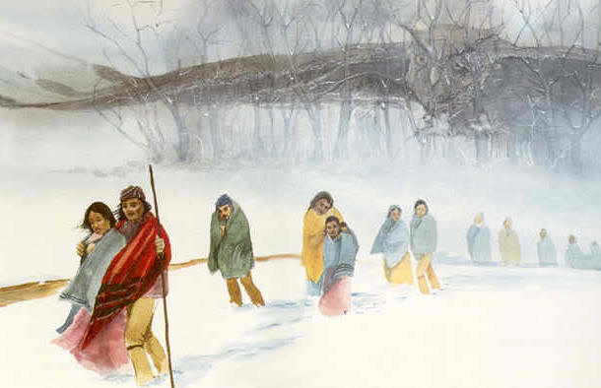
The Nullification Proclamation:
- Issued by President Andrew Jackson
- Stated that states are forbidden from nullifying federal laws
- To nullify a federal law means to invalidate it or to not accept it
- Jackson believed the federal government was supreme
- While Southern states did not like certain tariffs or taxes on imported goods, Jackson believed that states must obey federal laws
Manifest Destiny:
- American Belief in the 1840s
- The United States should extend its borders from the Atlantic to the Pacific
- Encouraged westward expansion
Texas:
- Americans had settled in Texas before 1836
- Mexico hoped American settlers would become Mexicans
- American settlers declared independence; in 1845, President John Tyler annexed Texas as a state (became a slave state)
The Mexican American War:
- In 1846, war broke out between the U.S. and Mexico over the border of Texas
- In the Mexican-American War (1846 – 1848), Mexico was quickly defeated
- Mexico was forced to give up California, Nevada, Utah, Arizona, and parts of Colorado and New Mexico
The Gadsden Purchase:
- In 1853, the Gadsden Purchase from Mexico completed U.S. expansion in southwest
- Mexico gave the United States southern Arizona and southern New Mexico in exchange for $10,000,000
54º40' or Fight:
- President James K. Polk wanted more land north of Oregon, believing that the border between the U.S. and Canada was at the 54º40' latitude line
- Britain insisted the border was further south at 42º
- The Americans threatened “54º40' or fight” but settled at 49º latitude line
- Another example of Manifest Destiny and westward expansion
The Oregon Territory:
- In an agreement with Great Britain in 1846, the line dividing Canada and the United States was extended westward to the Pacific, giving the U.S. part of the Oregon Territory
Alaska:
- In 1867, the United States purchased Alaska from Russia for $7.2 million
- Marked the end of Russian efforts to expand trade and settlements to the Pacific coast of North America
Hawaii:
- Formally annexed by the United States in 1898
- The event marked the end of a lengthy internal struggle between native Hawaiians and white American businessmen for control of Hawaii
- In 1893, the last monarch of Hawaii, Queen Lili’uokalani, was overthrown by a party of American businessmen
- Soon after, President Benjamin Harrison submitted a treaty to annex the islands
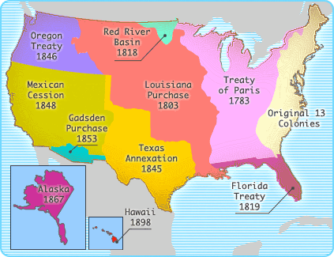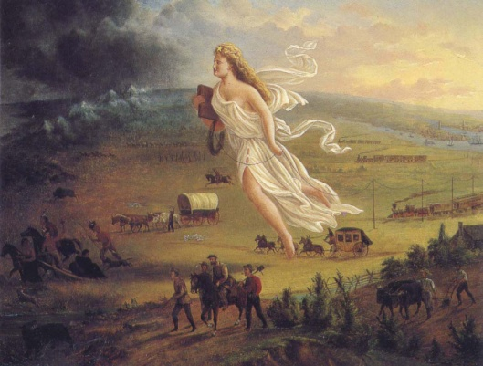
Sectionalism:
- By the early 19th century, each section of U.S. had developed its own characteristics
- These differences led to the rise of sectionalism or the greater loyalty many Americans felt towards their own particular section (North, South, or West) than the country as a whole
- Slavery and tariffs were viewed differently in different regions of the nation
Temperance:
- A movement in the mid-nineteenth century that looked to rid society of alcohol
- Viewed alcohol as a vice or immoral leading to crime and destruction of families
- Eventually led to ratification of the Eighteenth Amendment in 1919 which prohibited or banned alcohol
- But the Eighteenth Amendment was repealed or declared invalid by the Twenty-First Amendment
Seneca Falls Convention:
- An important meeting at Seneca Falls, New York in 1848
- Led by Elizabeth Cady Stanton and Lucretia Mott
- A movement for women’s rights
- In the years after the Convention, focused more on gaining the vote for women
- Susan B. Anthony became a leader women’s suffrage movement [suffrage means the right to vote]
Dorothea Dix:
- A social reformer; fought for the better treatment of mentally ill patients in asylums
Antebellum:
- Means existing before the war…In U.S refers to the period before the Civil War
Abolitionists:
- Wanted an end to slavery
Harriet Beecher Stowe:
- Abolitionist…Wrote Uncle Tom’s Cabin
- Helped spread moral outrage against slavery in the North
Frederick Douglass:
- Abolitionist and former slave (escaped to freedom)
- Lectured about the evils of slavery
- Autobiography titled Narrative of the Life of Frederick Douglass
- Published an abolitionist paper, The North Star
Harriet Tubman:
- Abolitionist and former slave (escaped to freedom)
- Conductor on the Underground Railroad, a network of escape routes and safe houses to help bring an escaped slave to freedom in the North
- After passage of the Fugitive Slave Act, escaped slaves were brought to Canada to ensure their freedom
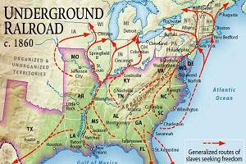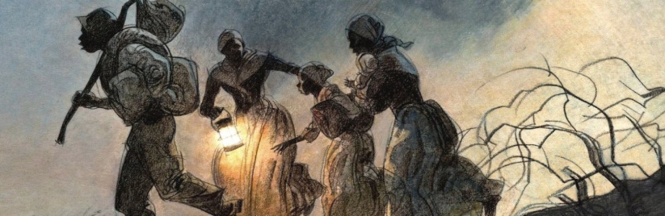
The Missouri Compromise:
- Between 1820 and 1850, national unity was preserved by admitting new states in a series of compromises that tried to maintain a balance between slave and free states
- The Missouri Compromise allowed Maine to enter the Union as a free state and Missouri to be admitted without restrictions on slavery
- The area north of Missouri Compromise line of 36°30′ was to be free of slavery
The Compromise of 1850:
- To keep a balance between slave and free states
- California was admitted to the Union as a free state after the Gold Rush of 1849
- The slave trade was abolished in the District of Columbia
- The territories of New Mexico and Utah were organized under popular sovereignty (the people of the state voted on whether to be free or slave states)
- The Fugitive Slave Act was passed
- Required that runaway slaves be returned to their masters
The Kansas-Nebraska Act:
- Abandoned the Missouri Compromise
- Established the idea of deciding whether a state should be a free state or a slave state through popular sovereignty (the people of the state would vote and decide whether the state would permit slavery or not permit slavery)
“Bleeding Kansas”:
- There was fighting in Kansas over the issue of slavery
- Both pro-slavery and anti-slavery groups were strong in Kansas
- Fighting resulted
The Republican Party:
- A new political party
- Main goal was to stop the spread of slavery in the west
William Lloyd Garrison:
- Abolitionist
- From 1831-1865, published The Liberator, an anti-slavery newspaper
- Founder of the American Anti-Slavery Society
- Also favored increasing rights for women
Dred Scott v. Sanford:
- Supreme Court case, 1857
- Dred Scott was a slave who had been taken by his owner to a free state
- Scott sued for freedom in court and appealed to the Supreme Court
- Claimed that because he lived on free soil, he was free
- Supreme Court held that Scott was not a citizen of the United States or and could not sue in federal courts
- Court went on to say that Dred Scott’s temporary residence in a free state did not make him free, and the Congress could not outlaw slavery since slavery was recognized in Constitution and private property was protected
- Made the Missouri Compromise unconstitutional
- After the Civil War, the 13th amendment to the Constitution abolished slavery
John Brown:
- Abolitionist who believed one should fight the evil of slavery
- Organized a raid on the federal arsenal at Harper’s Ferry, Virginia, in October 1859, hoping to seize weapons to arm slaves and start an uprising
- Was captured, tried, and executed
- Became a martyr in the North but frightened Southern plantation owners
The Election of President Abraham Lincoln:
- When the Republican Presidential candidate Abraham Lincoln was elected in 1860, most Southern states seceded (withdrew) from the United States
- The seceding states formed the Confederate States of America
- Lincoln refused to recognize the secession of the South
- Lincoln resolved to preserve the unity of the United States
The Causes of the Civil War:
- Slavery and sectionalism
- The creation of the Republican party
- Failure of slave compromises
- The election of Lincoln in 1860
- Secession began on December 20, 1860
The Civil War:
- Began on April 12, 1861 when the Confederate States of America attacked the federal fort, Fort Sumter, in the harbor of Charleston, South Carolina
- Eleven Southern states joined the Confederacy
- Alabama, Florida, Georgia, Louisiana, Mississippi, South Carolina as well as Texas, Arkansas, North Carolina, Tennessee and Virginia
- The Union
- Maine, New York, New Hampshire, Vermont, Massachusetts, Connecticut, Rhode Island, Pennsylvania, New Jersey, Ohio, Indiana, Illinois, Kansas, Michigan, Wisconsin, Minnesota, Iowa, California, Nevada, and Oregon
- And Kentucky, Maryland, Delaware and Missouri (the Border States) remained in the Union, and what is now West Virginia broke off from the state of Virginia during the war to form a new state to join the Union
- The Civil War was bloody
- 1861 – 1865
- The North had immense long-term advantages: a larger population, more money, more railroad lines, greater manufacturing facilities, and superior naval power
- Yet despite advantages, it took the North four years to defeat the South
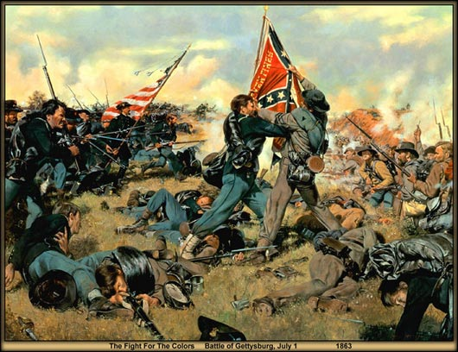
The bloodiest battles of the Civil War were:
· Gettysburg: 51,116 casualties
· Seven Days: 36,463 casualties
· Chickamauga: 34,624 casualties
· Chancellorsville: 29,609 casualties
· Antietam: 22,726 casualties

Note: Antietam had the greatest number of casualties of any single-day battle.
The Emancipation Proclamation (January 1, 1863):
- Lincoln announced that all slaves in states still in rebellion would be freed
- The Proclamation gave a moral purpose to the war
- However, it soon became unclear whether Lincoln had power to free the slaves
- Congress proposed the Thirteenth Amendment
- When it was ratified in 1865, it abolished slavery throughout the United States
The Gettysburg Address:
- A famous speech delivered by President Abraham Lincoln at the dedication (November 19, 1863) of the National Cemetery at Gettysburg, Pennsylvania, the site of one of the decisive battles of the American Civil War (July 1–3, 1863)
- “Four score and seven years ago our fathers brought forth on this continent a new nation, conceived in Liberty, and dedicated to the proposition that all men are created equal.”
Reconstruction:
- The name given to the process of reestablishing the Union to again include the seceded states, began during the war and lasted until 1877
- The South’s infrastructure had to be rebuilt
- African Americans needed to be given Constitutional rights
- To be readmitted to the Union, South had to agree to follow the Constitution
Lincoln’s Lenient Plan for Reconstruction:
- Lincoln believed secession was unconstitutional, and so legally, the Southern states were still in the Union
- He believed the executive branch, particularly the president, should establish the process of reconstruction and the terms should be generous
- “With malice toward none; with charity for all; with firmness in the right, as God gives us to see the right, let us strive on to finish the work we are in; to bind up the nation’s wounds; to care for him who shall have borne the battle, and for his widow, and his orphan—to do all which may achieve and cherish a just, and a lasting peace, among ourselves, and with all nations.” ~ Abraham Lincoln
Radical Republicans:
- Led by Senator Charles Sumner and Congressman Thaddeus Stevens
- Intolerant of slavery, abolitionist, and wanted the South to “pay” for the war
- Disagreed with Lincoln’s plan for Reconstruction
The Assassination of Abraham Lincoln and Conflict over Reconstruction:
- John Wilkes Booth assassinated Abraham Lincoln on April 14, 1865
- Andrew Johnson became President
- Both Lincoln and Johnson favored lenient Reconstruction
- The Radical Republicans disagreed and wanted harsh Reconstruction; they wanted to punish the South and give freed slaves constitutional rights
The Freedmen’s Bureau:
- Established in 1865
- Looked to adjust newly-freed African Americans to Southern society
- Aimed to help with housing, education, food, healthcare, and jobs
- President Johnson later vetoed a bill in 1866 that would have increased the Bureau’s power
Black Codes:
- Southern states passed Black Codes to preserve traditional Southern lifestyles despite the ban on slavery
- Black Codes made it illegal for freedmen to hold public office, travel freely or serve on juries
Military Reconstruction:
- Passed over President Andrew Johnson’s veto
- Divided the South into five districts occupied by Union troops
- Forced all former Confederate states to ratify the Fourteenth Amendment and create new state constitutions which would ensure voting rights of former slaves
- Southern states had to obey these acts to be readmitted to the Union
Three Important Amendments Due to the Civil War:
- Thirteenth Amendment – abolished slavery
- Fourteenth Amendment – citizenship to former slaves and equal protection for all citizens under the law
- Fifteenth Amendment – right to vote for all male citizens (including former male slaves who were now citizens)
Carpetbaggers:
- Northerners who went to the South during Reconstruction to profit from Reconstruction
Scalawags:
- Southern whites who collaborated with northern Republicans during Reconstruction
Ku Klux Klan:
- White terrorist group targeting black freedmen and their allies
The Impeachment of Andrew Johnson:
- The Radical Republicans dislike Johnson, the Democratic President
- When Johnson fired the Secretary of War, Edwin M. Stanton, he violated the Tenure of Office Act (the President was supposed to consult with Congress first)
- The House of Representatives impeached Johnson (brought him up on charges)
- However, the Senate found him not guilty by one vote
The End of Reconstruction (1877):
- Reconstruction officially ended when the last remaining Northern troops were withdrawn from the South
- Home rule was restored to Southern state governments
- Former Confederate leaders could now serve in office
- State legislatures quickly moved to bar African Americans from political process
The Solid South:
- For over a century after Reconstruction, every Southern State would vote Democratic in Presidential Elections
- Thus, the South during this period was called the Solid South
Share-cropping System:
- Plantation owners entered into share-cropping arrangements with former slaves
- A sharecropper was a tenant farmer who was provided with credit for seed, tools, etc. and received an agreed share of the value of the crop minus charges
- The charges were usually exceptionally high and thus, the sharecropper lived in a state of permanent debt and poverty
Literacy Tests:
- Were introduced as a requirement for voting in the South
- Most freedmen lacked a formal education and could not pass these tests
- Denied African Americans in the South the right to vote
Poll Taxes:
- A tax on voting to prevent African Americans from voting in the South
“Grandfather Clauses”:
- Stated that if ancestors had voted before the war, then the potential voter did not have to pass a literacy test or paying a tax to vote
- These clauses empowered poor whites but not poor African Americans
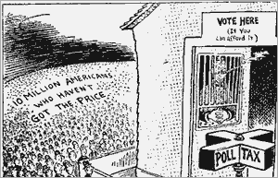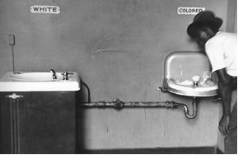
Jim Crow Laws:
- Segregation laws in the South
- African Americans were not permitted to ride in the same train cars, attend the same schools, or use any of the same public facilities as whites
Plessy v. Ferguson:
- Supreme Court upheld racial segregation (1896) in the South
- Court upheld a Louisiana law segregating railroad facilities
- Court held that if facilities were separate but equal, the African-American was not deprived of equal protection of the law under the Fourteenth Amendment
- Not reversed until Brown v. Board of Education in 1954
Booker T. Washington:
- Former slave – Autobiography titled “Up from Slavery”
- Believed African Americans should concentrate on first trying to achieve economic independence before seeking full social equality
- In 1881, founded Tuskegee Institute in Alabama for vocation (job) training
W.E.B. DuBois:
- Believed African Americans should work for full social equality immediately and not accept an inferior social and economic status
- In 1909, DuBois helped form the N.A.A.C.P. (the National Association for the Advancement of Colored People) and began editing its journal, The Crisis
The Industrial Revolution:
- Instead of producing goods by hand, people worked on machines in factories
- Cities grew as people moved into them (urbanization) in order find work
Commodore Matthew C. Perry:
- U.S. Admiral ended Japan’s policy of isolationism – opened Japan to trade (1850s)
- The Treaty of Kanagawa opened Japan to Western trade and influences
- Prior to Perry, the Tokugawa shoguns had isolated Japan
- U.S. wanted refueling stations in Japan en route to China
- Occurred during the Age of Imperialism – when a strong country dominates a weaker region
The Open Door Policy:
- While many Western European nations had gained spheres of influence in China, the United States wanted to make certain that Americans could trade with China
- The principle stated that all nations should have equal access to any of the ports open to trade in China
- The Open Door Policy was a American statement for the protection of equal privileges among countries trading with China
Causes of the Spanish-American War:
- An insurrection against Spain began in Cuba in the early 1890s
- Cubans wanted independence from Spain’s colonial control
- Treatment of Cuban rebels by Spanish seemed intolerable to Americans
- The U.S. battleship Maine sank in Havana harbor in February 1898
- Americans blamed Spain but recent research suggests the explosion may have been an accident, involving a spontaneous combustion fire on the ship
- President McKinley in April 1898 asked Congress for permission to use “forcible intervention” in Cuba
Effects of the Spanish-American War:
- The United States won the war due to naval superiority
- Americans occupied Wake Island and annexed Hawaii
- The Treaty that ended the war stated that Spain would free Cuba and cede (give up) Puerto Rico and Guam to the United States
- Spain also agreed to cede the Philippines to the United States
- Outcome of war led to U.S. imperialism (stronger nation dominates weaker one)
Yellow Journalism:
- The use of lurid (widely shocking) features and sensationalized news in newspaper publishing to attract readers and increase circulation
- Used in Spanish-American War
- Spanish-American War is often referred to as the first media war
- Led by newspaper owners William Randolph Hearst and Joseph Pulitzer, journalism of the 1890s used melodrama, romance, and hyperbole to sell millions of newspapers – a style that became known as yellow journalism
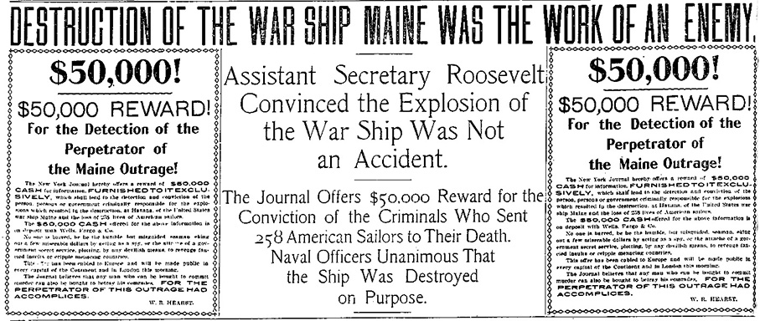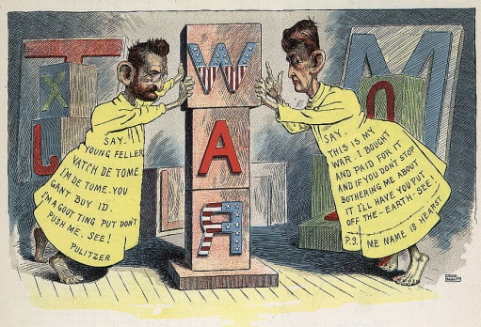
First Transcontinental Railroad:
- Linking east and west coasts – was completed in 1869
- Railroads connected raw materials to factories and factories to consumers
- Construction of the railroads stimulated the iron, steel, and coal industries
- Also played a key role in the settlement of the West
- Government gave free land grants to railroad companies to encourage construction
Corporation:
- New form of business – became popular after Civil War
- A corporation is a business organization composed of stockholders
- Each stockholder is a partial owner of the corporation, share in profits, and are limited in liability (responsibility)
Entrepreneur:
- An individual who brings together land, labor, and capital to create a new business
Gilded Age:
- Because of the lavish lifestyles of those who became rich from industry, the period from 1856 to 1900 became known as the Gilded Age
- Gilded means covered in gold but not fully golden!
Robber Barons:
- Entrepreneurs who used ruthless (cruel) tactics to destroy competition and to keep down worker’s wages
- Monopolists!
- Examples: Andrew Carnegie and John D. Rockefeller
Andrew Carnegie:
- A famous entrepreneur in Gilded Age
- 1835-1919; worked his way up from a penniless Scottish immigrant
- His steel mills ruthlessly undercut all competition; his workers put in 12-hour shifts at low wages - Carnegie hired thugs to crush any attempt to unionize
John D. Rockefeller:
- 1839-1937; formed the Standard Oil Company in 1870
- Rockefeller forced railroad companies to give him special, secret rates for shipping his oil, while they charged his competitors higher prices
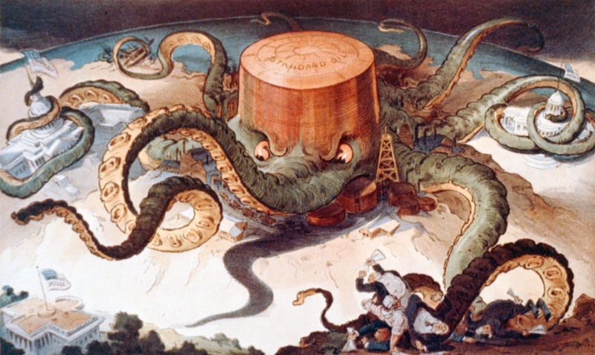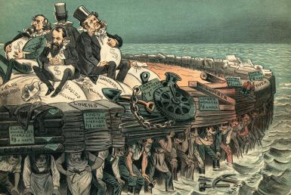
Trusts:
- Act like monopolies
- A monopoly occurs when a single seller dominates a market – no competition, higher prices
Social Darwinism:
- Loosely applied Charles Darwin’s Theory of Evolution to economics
- Taking Darwin’s suggestions of the survival of the fittest as the determinant in evolution, Social Darwinists believed that those on top in the business world were there because they were the fittest
- The rich had survived the battle of the marketplace because they were the best
- Believed that the strong must dominate weaker groups
- Encouraged laissez-faire or that the government not intervene in the market
Laissez-faire:
- “Let them do as they [business] as they please”
- The idea that government should not intervene in the market
- Businesses should not be regulated or controlled by government
“The Gospel of Wealth”:
- Andrew Carnegie’s belief that the rich should use their wealth to benefit society
- Encouraging charitable contributions and philanthropy (the desire to promote the welfare of others, expressed especially by the generous donation of money to good causes)
The Interstate Commerce Act:
- 1887
- This new federal law prohibited unfair practices by railroads, such as charging more money for shorter routes
Sherman Anti-Trust Act:
- 1890
- Was passed to check the spread of monopolies
- It outlawed unfair monopolistic practices that stifled competition
Treatment of Workers in Early Years of Industrial Revolution:
- Safeguards around machinery were inadequate
- Thousands of workers were injured or killed in accidents each year
- Workers faced a six-day work week of 10 to 14 hours per day
- Low wages
- Industrial workers could be fired for any reason
- There was no unemployment insurance, worker’s compensation, health insurance or old-age insurance
Unions:
- An organization of workers that promotes safer working conditions, higher wages, and fewer hours of work (“eight hours for work; eight hours for sleep; eight hours for what we will”)
The Knights of Labor:
- 1869
- One large national union
- Skilled and unskilled workers
- Under leadership of Terrence Powderly
- Called for eight-hour day and graduated income tax
- Collapsed after a general strike for an eight-hour day failed in Chicago and the Haymarket Massacre occurred
The Haymarket Affair:
- 1886
- Occurred when labor leaders were blamed when a bomb exploded at a demonstration of striking workers at Haymarket Square in Chicago
- Seven police were killed; eight anarchists were later arrested
- Four were found guilty and hung, yet no one was found guilty of throwing the bomb
- Frightened by the incident, the average American citizen saw a threat to traditional standards of society in the actions of unions
The American Federation of Labor (AFL):
- 1881
- Founded by Samuel Gompers
- Only skilled workers
- Consisted of associations of skilled workers joined together into a federation
- Cigar-makers association + Carpenters association + etc. = AFL
- Goals limited to higher wages, safer working conditions, 8-hour work day
- Bread and Butter unionism
Triangle Shirtwaist Factory Fire:
- 1911
- Occurred in New York City sweatshop or factory in which workers work long hours for low wages in unsafe working conditions
- 145 women died because the factory doors had been bolted shut from the outside
- Most of the workers were immigrants
- Soon after the fire, Congress passed legislation favorable to unions
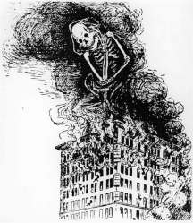
Urbanization:
- The movement of people from rural areas to cities
- An important result of industrialization
- Cities grew so quickly that municipal authorities could not deal with their problems
- Large families were crowded into tenements or single-room apartments without heat or lighting
Political Bosses like Boss Tweed:
- Cities were often run by corrupt “political machines”
- Political bosses provided jobs and services for immigrants and the poor in exchange for their votes
- William Marcy “Boss” Tweed was the leader of New York City’s corrupt Tammany Hall political organization during the 1860s and early 1870s
- Tweed became a powerful figure in Tammany Hall – New York City’s Democratic political machine
- He openly bought votes, encouraged judicial corruption, extracted millions from city contracts, and dominated New York City politics
“Old Immigrants”:
- Up until 1880, most immigrants to the USA had come from Northern Europe
- In general, these “Old Immigrants” were Protestant, except for Irish Catholics, and most spoke English
“New Immigrants”:
- Immigration patterns changed in the 1880s
- Railroads and steamships made the voyage to America more affordable
- Most “New Immigrants” came from Southern and Eastern Europe, especially Poland, Italy, Austria-Hungary, Greece, and Russia
- They were Catholics and Jewish, spoke no English, were poor, and dressed differently from Northern Europeans
- Asian immigrants also arrived
Ghettos:
- A ghetto is a quarter of a city in which members of a minority group live especially because of social, legal, or economic pressure
- However, this isolated minority groups from mainstream American life
Assimilation:
- To assimilate is to learn the ways of another culture
- The children of the “new immigrants” attended public schools and learned English and American culture
- They assimilated
Melting Pot Theory:
- A theory of immigration that states when different types of people live together, they gradually create one community
Cultural Pluralism:
- A different theory of immigration that states that different groups can live together in a society but still maintain different traditions and interests
Nativism:
- Anti-immigrant sentiment
- As the “New” immigration increased, nativist hostility mounted
- Nativists called for restricted immigration
- They argued that “New Immigrants” were inferior to “true” Americans – white, Anglo-Saxon and Protestant
Chinese Exclusion Act:
- 1882
- The first major law restricting immigration to the United States
- It was enacted in response to economic fears, especially on the West Coast, where native-born Americans attributed unemployment and declining wages to Chinese workers whom they also viewed as racially inferior
- Effectively halted Chinese immigration for ten years and prohibited Chinese from becoming US citizens
The Gentlemen’s Agreement:
- 1907
- Japanese government promised to limit future Japanese immigration
The Gold Rush:
- 1848
- In January, gold was discovered in California
- Thus began one of the largest human migrations in history as a half-million people descended upon California (the California Gold Rush) in search of wealth
The Homestead Act:
- In 1862, the Homestead Act was passed into law
- Any US citizen or intended US citizen could file an application with the government
- If accepted, the person would receive 160 acres of government land
- The homesteader had to live on the land for five years, build a home, and grow crops
- After five years, the homesteader could file for the deed to the land by submitting proof of living there and making improvements to the land
- Encouraged westward expansion
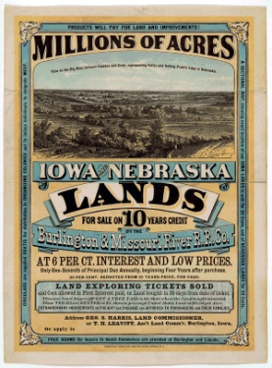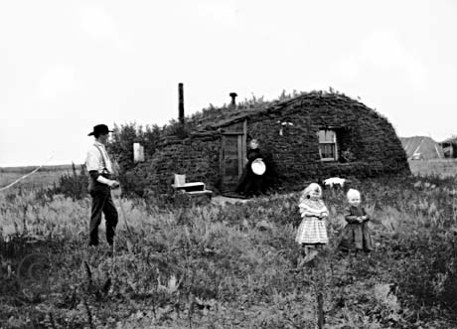
The “Indian Wars”:
- From 1830 to 1890, federal and state governments followed a policy of pushing Native American Indians from the traditional lands onto government reservations in the West
- The “Indian Wars” pitted settlers and federal troops against the tribes, lasted from 1860 to 1890
- Reservations were often smaller than the lands from which the tribe was removed, and frequently consisted of undesirable land
A Century of Dishonor:
- Helen Hunt Jackson wrote A Century of Dishonor (1881)
- In the book, Ms. Jackson harshly criticized the government for repeatedly breaking its promises to Native American Indians
The Dawes Act (1887):
- Many reformers urged that Native American Indians adopt American culture
- The Dawes Act split up reservations held communally by Native American tribes
- The head of each Native American family received 160 acres
- The government held such lands in trust for 25 years, until the recipients could prove themselves self-sufficient farmers
- If the family did not succeed at farming, the land reverted back to the federal government for sale, usually to white settlers
- Also created federally funded boarding schools designed to assimilate Native American children into white society
- Family and cultural ties were practically destroyed by boarding schools, in which children were punished for speaking their native language or performing native rituals
The Grange Movement (The Granger Movement):
- Organized by farmers in 1867
- Grangers blamed the railroads for their difficulties
- Farmers had to ship crops to markets and relied on railroads
- Since railroads lacked competition, railroad companies could charge higher rates for short distances
- In several Midwestern states, Grangers elected candidates to state legislatures who promised to regulate the railroads
- Farmers also faced low prices due to overproduction of crops as well as new machinery which greatly increased production but lowered prices
Munn v. Illinois (1877):
- Supreme Court supported state government attempts to regulate railroads
Wabash v. Illinois (1886):
- Supreme Court reversed itself in Wabash v. Illinois (1886) and ended state regulation of railroads
- Grangers now turned to Congress to regulate railroads
Interstate Commerce Act:
- 1887
- Prohibited railroads from charging different rates to customers shipping goods equal distances and other unfair practices
- The railroads became the first industry subject to Federal regulation
- The act also established a five-member enforcement board known as the Interstate Commerce Commission
- Railroad companies held a natural monopoly in areas that only they serviced
- Addressed the problem of railroad monopolies by setting guidelines for how the railroads could do business
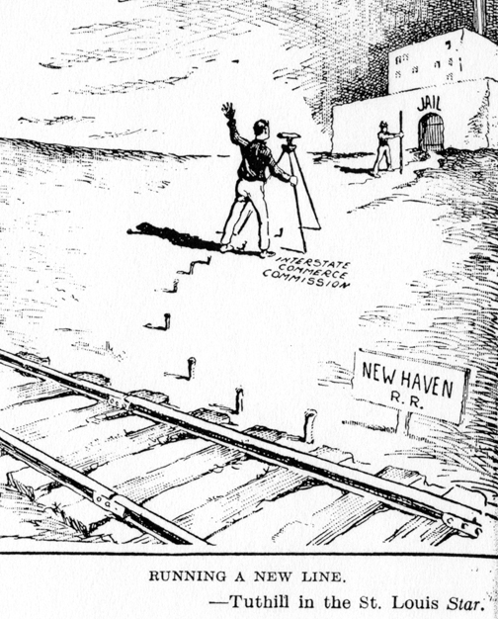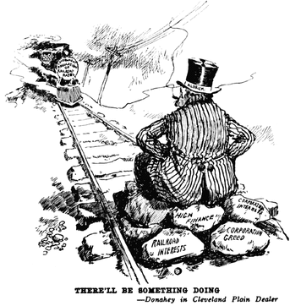
The Populist Party:
- 1892
- Farmers gave their support to the new Populist Party
- Represented interests of farmers and workers against banking and railroad interests
- Believed rich industrialists and bankers had too much influence on government
- Party platform included:
- Unlimited coinage of silver to raise farm prices and make loans easier to repay
- Direct election of Senators
- A graduated income tax (taxing wealthy individuals at a higher rate)
- Immigration quotas to restrict the influx of newcomers
- A shorter work day of eight hours
William Jennings Bryan and the “Cross of Gold” Speech:
- In 1896, the Democratic Party nominated William Jennings Bryan for President after he delivered a speech at the Democratic Convention
- His “Cross of Gold” speech denounced bankers for “crucifying mankind on a cross of gold”
- Although the Populists supported Bryan for President, he lost the election
The Influence of the Populist Party on American History:
- Many Populist reforms, such as the graduated income tax and the direct election of Senators, were later passed by other political parties
- Illustrates the role often played by third parties in American politics
- Third parties often generate new ideas
The Progressives:
- In the early decades of the 20th century, Progressives were reformers
- Wanted to reform government and use government to advance human welfare
- Opposed the abuse of power by political machines and monopolies
- Wanted to apply scientific management to solve urban problems
- Flourished between 1900 and the start of World War I
- Were mainly middle-class city dwellers
- Their activities reflected the rising influence of the middle class
- The goal was to correct the political and economic injustices that had resulted from America’s industrialization
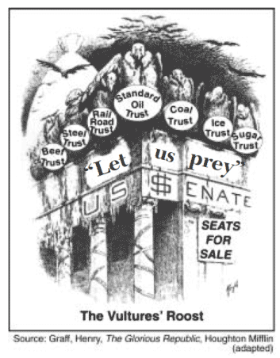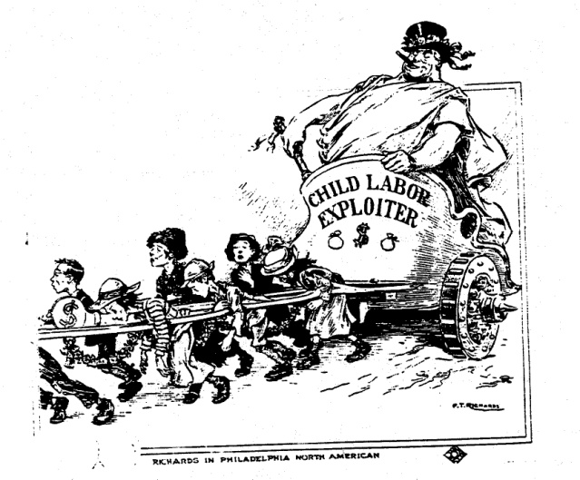
Muckrakers:
- Investigative reporters, writers, and social scientists that exposed government corruption and the abuses of industry
- Provided detailed, accurate journalistic accounts of the political and economic corruption and social hardships caused by the power of big business
- Important muckrakers were:
- Upton Sinclair: Wrote The Jungle (1906) and described the unsanitary practices of the meat-packing industry
- Ida Tarbell: Wrote The History of the Standard Oil Company (1902) and showed how John D. Rockefeller’s rise was based on ruthless practices
- Jacob Riis: Wrote How the Other Half Lives and photographed and described the appalling conditions of the urban poor
Jane Addams:
- Settlement houses were started in slum neighborhoods by Progressives like Jane Addams (Hull House) and Lillian Wald (Henry Street Settlement)
- These houses provided such services as child care, nursing the sick, and teaching English to immigrants
Progressive Politicians:
- Expanded services to deal with overcrowding, fire hazards, and the lack of public services
- In some cities, Progressives introduced new forms of city government to halt corruption
- Progressive governors, such as Robert LaFollete in Wisconsin and Theodore Roosevelt in New York, took steps to free their state governments from the corrupting influence of big business
Progressive Political Reforms:
- The secret ballot: voters were less subject to pressure and intimidation when they could cast their ballots without anyone knowing who they voted for
- Greater participation in government for voters
- Initiative: Enables citizens to draft laws to place on the ballot for a popular vote
- Referendum: Allows citizens to vote on laws passed or proposed by legislature
- Recall: Allows citizens to remove elected officials
- Direct party primaries
- Direct election of Senators
- Senators were elected directly by voters, instead of being chosen by state legislatures (the Seventeenth Amendment)
Theodore Roosevelt:
- U.S. President from 1901 – 1909
- Believed that the President should exercise vigorous leadership in the public interest
- Revived the use of the Sherman Anti-Trust Act to break-up Rockefeller’s Standard Oil Company
- But distinguished between “good trusts” from “bad trusts” rather than condemn all trusts
- Proposed new laws to protect consumer health, to regulate some industries, and to conserve the nation’s natural resources
- The Meat Inspection Act (1906) provided government inspection of meat
- The Pure Food and Drug Act (1906) regulated food preparation and sales of medicines
- Also drew national attention to the need to conserve forests and wildlife (Conservationist)
- Cited his fondness for a West African proverb, “Speak softly and carry a big stick; you will go far”
- The phrase was also used later by Roosevelt to explain his relations with domestic political leaders and his foreign policy especially in Latin America and the Caribbean
- Responsible for ordering the construction of the Panama Canal
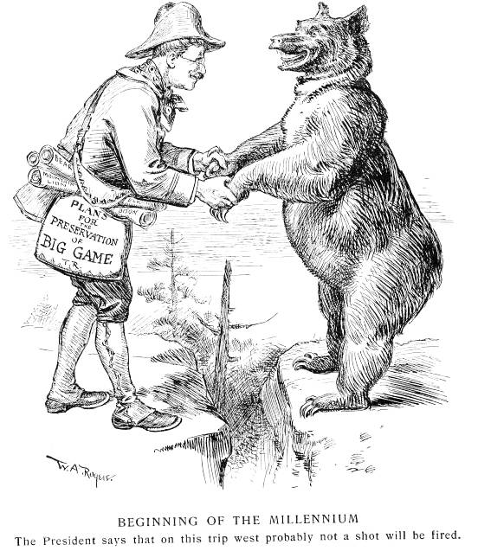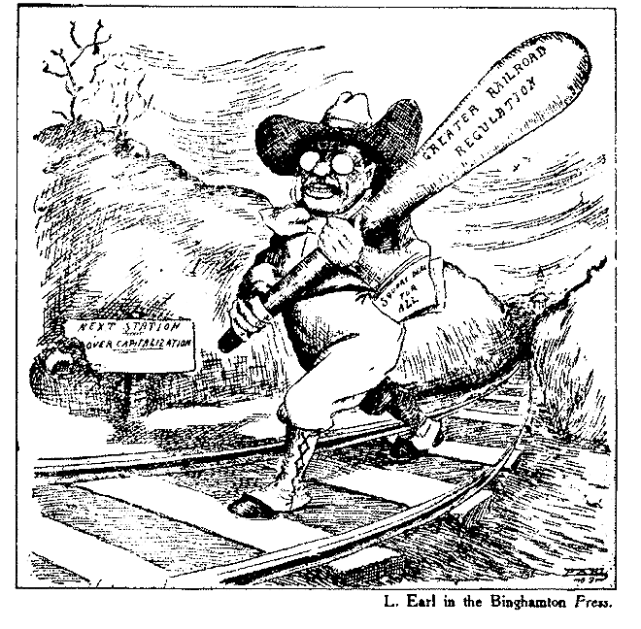
The Roosevelt Corollary to the Monroe Doctrine:
- President Theodore Roosevelt’s approach to Latin America
- Often known as the “Big Stick” Policy
- Stated that the USA would intervene as a last resort to ensure that nations in the Western Hemisphere fulfilled their obligations to international creditors thus preventing foreign nations from coming into the Americas
- Led to the United States increasingly using military force to restore internal stability to Latin American nations
Dollar Diplomacy:
- From 1909 to 1913, President William Howard Taft followed this foreign policy
- Believed that the goal of diplomacy was to create stability and order abroad that would best promote American commercial interests
- The goal of U.S. diplomacy was to improve financial opportunities but also to use private capital to further U.S. interests overseas
- As U.S. investments grew in Latin America, any threat to U.S. investments would bring in the U.S. Marines to protect American business interests
Temperance Movement:
- Anti-alcohol movement
Women’s Christian Temperance Union (W.C.T.U.):
- Founded in 1874
- Under the leadership of Frances Willard and Carrie Nation
- Carrie Nation gained fame for smashing bottles in bars with her hatchet
- However, in 1893, the Anti-Saloon League was formed and became a very successful lobbying group for prohibition (making alcohol illegal)
The Eighteenth Amendment:
- Prohibited the sale and consumption of alcohol
- However, the Amendment was repealed in 1933
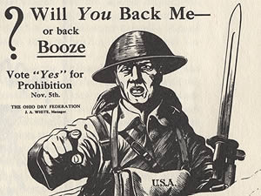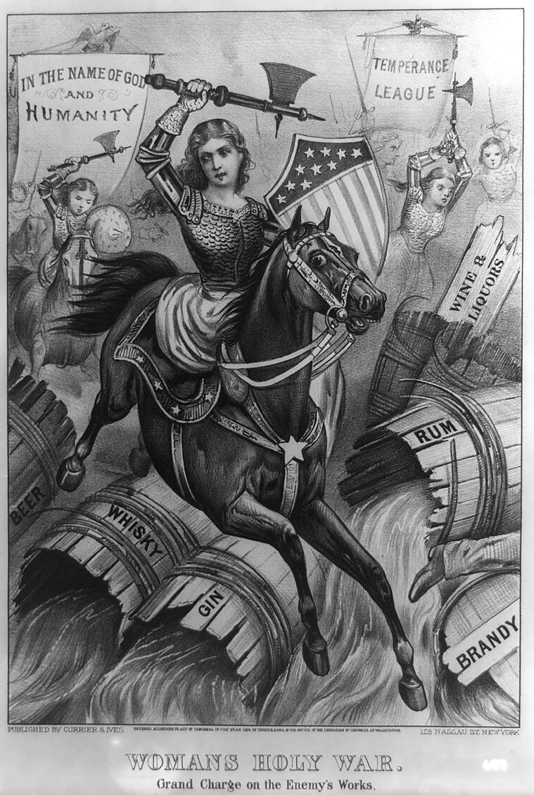
The Nineteenth Amendment:
- Suffrage for women or women finally can vote!
- Guaranteed women the right to vote in federal elections
- Ratified by states in 1920
- After almost a hundred years of agitation, women achieved equality at the ballot box (Thank you Elizabeth Cady Stanton, Susan B. Anthony, and the suffragists!)
- When American men went off to fight in World War I in 1917, millions of women took their places in factories and workshops
- Women’s contribution to the war was the final argument in favor of women’s suffrage
Imperialism:
- The domination of one country by another
- A militarily stronger nation conquers and colonizes a weaker region
- As an industrial power, the United States could gain inexpensive raw materials or natural resources from colonies
- However, opponents of U.S. imperialism felt it violated democratic principles
An American Empire:
- From the mid-1800s to the early 1900s, the U.S. acquired a colonial empire in the Pacific consisting of the Philippine Islands, Guam, Hawaii, Samoa, and Midway
- Filipino rebels fought against their American colonial rulers until they were finally defeated in 1902
- Philippine independence was later granted by the United States in 1946, after World War II
- American settlers built sugar and pineapple plantations on Hawaii
- In the 1890s, Queen Liliuokalani tried to take political power away from American landowners
- In response, American landowners overthrew her in 1893
- After the outbreak of the Spanish-American War, Congress voted for the annexation of Hawaii in 1898 and it later became the 50th state in 1959
The Open Door Policy:
- USA favored equal trading rights for all foreign nations in China
- As European nations gained spheres of influence in China, U.S. officials wanted to ensure that Americans could trade with China
The Boxer Rebellion:
- An anti-foreigner rebellion in China in 1900
- Rebels attacked foreigners and Chinese Christians
- An international army, with U.S. participation, crushed rebellion
Commodore Matthew C. Perry:
- In 1853, U.S. forced Tokugawa shoguns of Japan to end their policy of isolationism
- Commodore Perry forced Japan to open to Western trade
- After Perry, Japan industrialized during the Meiji Restoration (1868)
- By 1905, Japan surprised West by defeating Russia in Russo-Japanese War
- President Theodore Roosevelt negotiated the peace settlement in the Treaty of Portsmouth (1905) and was awarded the Nobel Peace Prize
Puerto Rico and Cuba:
- The Spanish-American War also gave the U.S. direct control of Puerto Rico and indirect control of Cuba, leading to increased American interest in the Caribbean
- Cubans were forced to agree to the Platt Amendment (1901), which gave the USA the right to intervene in Cuban affairs at any time
- The U.S. was also given the rights to a naval base in Cuba (Guantánamo Bay)
The Panama Canal:
- Connecting the Atlantic Ocean and the Pacific Ocean
- The land for the canal originally belonged to Columbia
- But when Panamanian rebels declared their independence from Colombia, President Theodore Roosevelt sent warships to protect them
- In return, the new government of Panama gave U.S. control of the land
- Important strategic artificial waterway in world (As is the Suez Canal)
The Causes of the First World War:
- Militarism, alliances, imperialism and nationalism (MAIN)
- Fighting in the First World War began in Europe in August 1914
- Crisis that precipitated (caused) WWI was assassination on June 28, 1914 of Archduke Francis Ferdinand, heir of the Austro-Hungarian Empire
- Assassination triggered the alliance system when Austria tried to avenge the assassination of Archduke Francis Ferdinand by attacking Serbia
Alliances of the First World War:
- Central Powers – Germany, Austria-Hungary, the Ottoman Empire, and Bulgaria
- Allied Powers – England, France, Russia, Japan, and Italy
- Woodrow Wilson attempted to follow the traditional American policy of neutrality but eventually U.S. became involved in conflict
Zimmerman Telegram:
- Secret message from a German official that promised to return territories to Mexico if Mexico helped Germany against the United States (should the USA enter WWI)
- Americans were outraged when the telegram was printed in the newspapers
Unrestricted Submarine Warfare:
- Main reason for American entry into World War I
- In 1915, a German submarine sank the British passenger ship Lusitania, killing over 1,000 passengers, including 128 Americans
- Germany pledged not to sink any ocean liners without prior warning; however, German submarines began to attack American merchant vessels again in 1917
- In response, Wilson asked Congress to declare war
- 1917 was the year the USA entered the war (with Allies) but also the year Russia dropped out of the war due to the Bolshevik (Communist) Revolution
Selective Service Act:
- After USA formally entered WWI, Congress passed the Selective Service Act (1917)
- Gave the president the power to draft soldiers (military conscription)
- Required all men between the ages of 21 and 30 to register for military service
Schenck v. U.S. (1919):
- Shortly after U.S. entry into World War I, Congress passed the Espionage Act
- Made it illegal during wartime to interfere with the recruiting of troops or the disclosure of information dealing with national defense
- Charles T. Schenck was general secretary of the U.S. Socialist Party, which opposed the implementation of a military draft in the country
- Socialists distributed leaflets that called for men to resist military service
- Schenck was arrested for having violated the Espionage Act
- The Supreme Court upheld the government’s restrictions on speech
- Writing for the court, Oliver Wendell Holmes, Jr., argued: “Words which, ordinarily and in many places, would be within the freedom of speech…may become subject to prohibition when…as to create a clear and present danger...”
- During the war, civil liberties can be curtailed (restricted)
Fourteen Points:
- President Woodrow Wilson’s war aims or goals for the First World War
- Called for freedom of the seas, reduced armaments, and end to secret diplomacy as well as self-determination (a country determines its own government)
- Also called for a League of Nations (an international peacekeeping organization)
- Fresh American troops had helped end stalemate of trench warfare in Europe and led to an armistice (an agreement to stop fighting) in 1918
The Treaty of Versailles:
- The final terms of the peace treaties did not conform to goals of the Fourteen Points
- Extremely harsh
- Germany was forced to pay reparations for the war, lost colonies, forced to demilitarize but League of Nations was established (although U.S. did not join)
- The Senate rejected the Treaty of Versailles; USA returned to isolationism
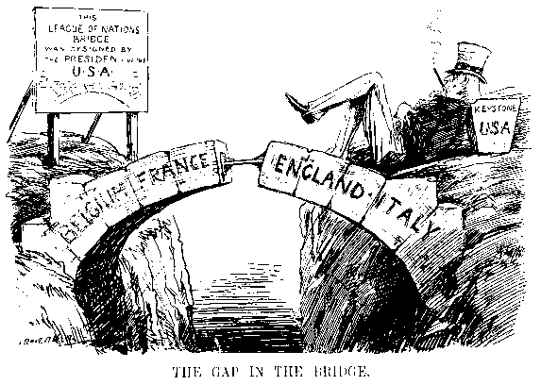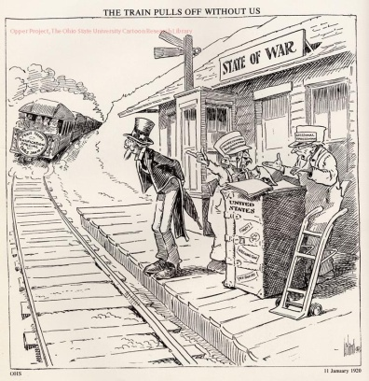
The “Roaring Twenties”:
- In 1920s, Republicans regained presidency and were pro-business
- Government policies, technology, and consumer society produced a booming economy
- America entered a period of isolationism and severely limited immigration
- The younger generation rebelled against traditional morals
- The two symbols of this new, looser social behavior were jazz and the “flapper”
- Flappers were young women who exhibited freedom from conventions
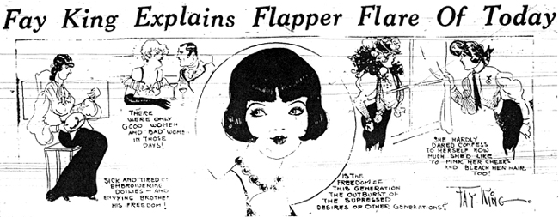
“The Red Scare”:
- The Bolshevik or Communist Revolution in 1917 had frightened Americans
- There was a fear that communism was spreading
- When a wave of strikes hit the nation in 1919, citizens feared they were seeing the beginning of a Communist revolution
- This “Red Scare” led Attorney General Palmer to arrest radicals accused of plotting to overthrow the government
- During the Red Scare, civil liberties were sometimes grossly violated and many innocent aliens were deported
Sacco and Vanzetti:
- Soon after the “Red Scare,” two Italian immigrants, Sacco and Vanzetti were convicted of murder to get funds for an anarchist revolution
- Although the evidence was insufficient, they were found guilty and executed
- Many people felt that the trial had been less than fair and that the defendants had been convicted for their radical, anarchist beliefs rather than for the crime for which they had been tried
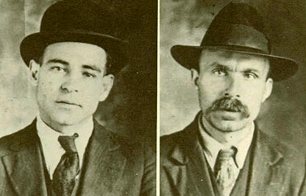
The Immigration Acts of 1921, 1924, and 1929:
- The “Red Scare” and the Sacco and Vanzetti trial greatly contributed to the rise of nativism – a dislike of foreigners
- The Immigration Acts of 1921, 1924, and 1929 restricted immigration from Southern and Eastern Europe (the “New Immigrants”) by establishing quotas for each nationality based on America’s existing ethnic composition
The Scopes Trial:
- Religious Fundamentalists in Tennessee brought to trial in 1925 John C. Scopes for breaking a Tennessee state law forbidding the teaching of evolution
- These Fundamentalists advocated traditional values and condemned Darwin and evolution as against the Bible’s story of creation in seven days
- The Scopes trial was nicknamed the Monkey Trial by the press because evolution suggested humans were descended from monkeys and not created by God
- William Jennings Bryan, Fundamentalist and three-time presidential candidate, testified as an expert on the Bible
- Scopes was found guilty, but the trial lawyers made Bryan appear ridiculous, and the Fundamentalist cause was temporarily set back
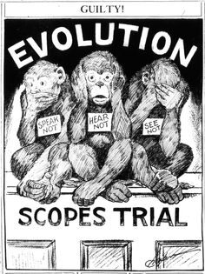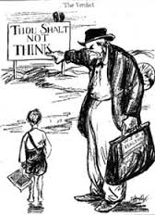
President Warren Harding:
- 1921 – 1923
- Republican
- Captured the national spirit by calling for a “return to normalcy”
- Supported laissez-faire economic policies
- However, the Teapot Dome Scandal revealed that a high-ranking administration official had been bribed to lease oil-rich government lands at Teapot Dome, Wyoming, to businessmen
President Calvin Coolidge:
- 1923 – 1929
- Republican
- Symbolized old-fashioned values like honesty and thrift
- Supported laissez-faire economic policies
- His motto embodied his philosophy: “The business of America is business”
President Herbert Hoover:
- 1929-1933
- Republican
- Supported laissez-faire economic polices
- Believed in “rugged individualism” or that an individual can succeed with minimal government help – the individual makes success happen
- He strongly felt that government interference in business could threaten the nation’s prosperity
- Believed that prosperity depended on freedom
- Feared that federal relief programs would undermine individual character by making recipients dependent on the government
Impact of Automobile:
- Cars gave people greater mobility
- Made the growth of the suburbs possible
- Automobile production required vast amounts of steel, glass, and rubber – stimulating those industries
Speculation Boom on the New York Stock Exchange:
- Millions of people invested in stocks in the hope of striking it rich
- During the years of business prosperity in the 1920s, the value of stock on the New York stock market climbed steadily
- Many people bought “on margin,” investing a small amount of cash and borrowing the rest to be paid back when the stock price went up
- For example, if a share of stock sold for $100, a buyer might put up $10 in cash and borrow $90
- But if stock price dropped, the investor lost the investment and the person from whom he borrowed lost
Eighteenth Amendment and Twenty-First Amendment:
- In 1919, the Eighteenth Amendment was ratified, banning the sale of alcohol
- Gradually Americans began to see this “experiment” as a failure, since many people refused to accept the ban on alcohol
- In addition, the great demand for illegal liquor stimulated the growth of organized crime in the 1920s
- Prohibition was repealed in 1933 by the Twenty-first Amendment.
- Americans learned from this experience that widely unpopular laws are sometimes unenforceable
The Lost Generation:
- A new group of writers, known as the Lost Generation, rejected the desire for material wealth
- Novelists such as Sinclair Lewis in Main Street and Babbitt, ridiculed the narrowness and hypocrisy of American life
- In The Great Gatsby, F. Scott Fitzgerald hinted that the search for purely material success often led to tragedy
The Jazz Age:
- The 1920s is often referred to as the Jazz Age, reflecting the greater importance of African-American music
- In 1925 the Jazz Age was in full swing
- It was the year Louis Armstrong and Duke Ellington made their first recording
- The Jazz Age glorified city life
The Great Migration:
- Many African American sharecroppers from the South -- were leaving their farms in record numbers to live and work in places like Chicago and New York City
- The relocation of more than 6 million African Americans from the rural South to the cities of the North, Midwest and West from 1916 to 1970
- Driven from their homes by unsatisfactory economic opportunities and harsh segregationist laws, many blacks headed north, where they took advantage of the need for industrial workers that first arose during the First World War
The Harlem Renaissance:
- Literary, artistic and intellectual movement that kindled a new black cultural identity
- An awakening of African-American culture that occurred in Harlem between the end of World War I and the middle of the 1930s
- African-American writers such as Langston Hughes and Countee Cullen expressed a new pride in their heritage while attacking racism
- During this period Harlem was a cultural center, drawing black writers, artists, musicians, photographers, poets, and scholars
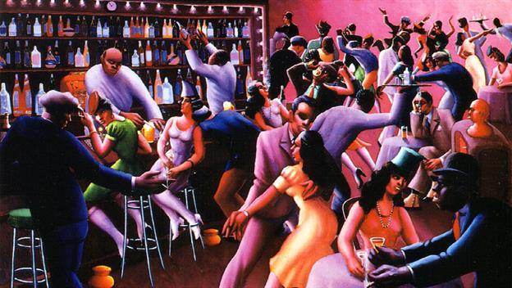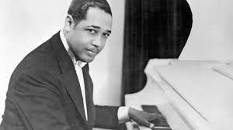
The Great Depression:
- A worldwide economic downturn that began in 1929 and lasted until about 1939
- It was the longest and most severe depression ever experienced by the industrialized Western world
- Although it originated in the United States, the Great Depression caused drastic declines in output, severe unemployment, and acute deflation in almost every country of the world
Causes of the Great Depression:
- Overproduction: the 1920s saw the rapid introduction of many new products like cars, radios and refrigerators
- Companies were soon producing more goods than people could afford to buy
- Uneven distribution of income: not all groups shared in the national prosperity
- Speculation: in the 1920s, stocks soared in value – many people bought stocks on margin but then were unable to repay the loans when stock prices fell
- Unsound banking practices: the government failed to regulate effectively the banking system or the stock market – bankers often invested their depositors’ money in unsound investments and many consumers were buying more than they could afford on credit
- The overextension of debt made the entire economy vulnerable
The Stock Market Crash:
- On October 29, 1929, prices on the New York Stock Exchange began to plunge and soon hit all-time lows (the Stock Market Crash)
- Corporations could no longer raise funds
- People were unable to repay their loans or rents thereby leading to bank failures
- Bank failures led thousands of people lost their life savings
- In this new economic climate, the demand for goods decreased sharply
- Factories closed and workers lost jobs
- Unemployment led to a further decrease in demand thereby leading to more factories closing
- Businesses closed, farmers lost their farms, banks failed, and millions of people were out of work
- Unlike today, there was no “safety net” – unemployment insurance and bank deposit insurance did not exist – millions depended on soup kitchens for food
The Dust Bowl:
- Occurred during the drought years of the 1930s
- A series of droughts in the early 1930s dried up crops and topsoil, turning the soil into dust
- Heavy winds destroyed harvests and carried soil away in huge clouds of dust that darkened their land
- Many farmers moved west to California
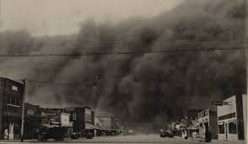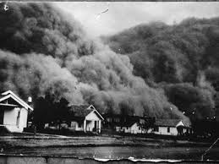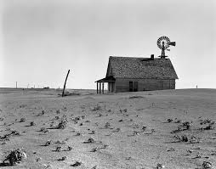
The Grapes of Wrath:
- John Steinbeck wrote The Grapes of Wrath, a novel about Dust Bowl farmers moving west to California, in 1939
- Revealed the difficulties and prejudices migrants faced
“Hoovervilles”:
- During the Great Depression, shanty towns of the homeless and unemployed sarcastically called “Hoovervilles,” sprang up on the outskirts of cities
- A shantytown is a section of a city or town characterized by crudely built houses
- As President Herbert Hoover opposed to direct relief (i.e. payments) to the unemployed due to his belief in “rugged individualism” and laissez-faire economics (government should not intervene in the market because the market would fix itself), many unemployed suffered homelessness and hunger
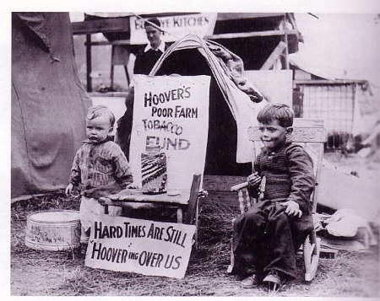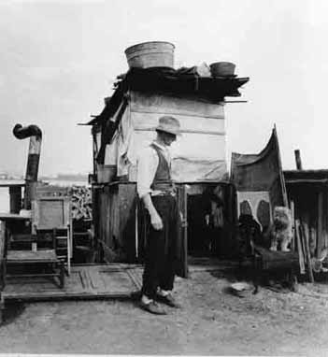
President Franklin Delano Roosevelt:
- 1933 – 1945
- Became president during the Great Depression, easily defeated Hoover
- Promised Americans a “New Deal,” to put them back to work
- The New Deal was a major turning point in American history
- It established the principle that the federal government bears the chief responsibility for ensuring the smooth running of the American economy
- Roosevelt believed the President’s task was to find a way for the economy to return to prosperity
- The New Deal marked an end to the long-held view that government and the economy should be separated
- The New Deal permanently increased the size and power of the federal government
The First One Hundred Days:
- President Franklin D. Roosevelt used his first three months in office to lay the foundations of the New Deal; his First 100 Days
- Roosevelt explained the New Deal measures in terms of three R’s – Relief, Recovery, and Reform
- Relief measures were short-term actions to tide people over until the economy recovered
- Recovery measures were designed to restore the economy by increasing incentives to produce and by rebuilding people’s purchasing power
- Reform measures were aimed at remedying defects in the structure of the nation’s economy, to ensure another depression would never strike again
The Civilian Conservation Corps (CCC):
- One of FDR’s New Deal programs
- 1933
- Gave jobs to young people, such as planting trees and cleaning up forests
- Members of the C.C.C. lived in camps and received free food
The Works Progress Administration (WPA):
- One of FDR’s New Deal programs
- 1935
- Created jobs by hiring artists, writers and musicians to paint murals, write plays and compose music
- Both the C.C.C. and W.P.A. put Americans back to work
The National Recovery Administration:
- One of FDR’s New Deal agencies
- 1933
- Asked businesses to voluntarily follow codes which set prices, production limits and a minimum wage
- However, in 1935, the Supreme Court found the N.R.A. unconstitutional
The Agricultural Adjustment Act:
- One of FDR’s New Deal plans
- The government paid farmers to plant less in hope of increasing crop prices
- In 1936, the Supreme Court declared the A.A.A. unconstitutional
- In 1938, the second A.A.A. succeeded in raising farm prices by having the government buy farm surpluses and sorting them until prices went up
Federal Deposit Insurance Corporation (FDIC):
- 1933
- The F.D.I.C. insured bank deposits so that people would not lose their savings in case of a bank failure
Securities and Exchange Commission:
- 1934
- Was created to oversee the operations of the stock market, prevent fraud, and guard against another stock market collapse
National Labor Relations Act:
- 1935
- Often called the Wagner Act
- Gave workers right to form unions; to bargain collectively with their employer
The Social Security Act:
- 1935
- It provided workers with unemployment insurance, old age pensions, and insurance if they died early
Schechter Poultry Corp. v. United States:
- Supreme Court case that invalidated as unconstitutional a provision of the National Industrial Recovery Act (NIRA) that authorized the President to approve “codes of fair competition” for the poultry industry
- These codes regulated schedules of minimum wages, prices, maximum work hours, collective bargaining, and other rules
- In reviewing the conviction of a poultry company for breaking the Live Poultry Code, the Court held that the code violated the Constitution’s separation of powers because it was written by agents of the president with no genuine congressional direction
- The Court also held that much of the code exceeded the powers of Congress because the activities it policed were beyond what Congress could constitutionally regulate
- By unanimous vote, the Supreme Court held that Congress had exceeded its authority by delegating too much legislative power to the president
FDR’s Court-Packing Scheme:
- On February 5, 1937, FDR announced a controversial plan to expand the Supreme Court to as many as 15 judges, allegedly to make it more efficient
- Critics immediately charged that Roosevelt was trying to “pack” the court and thus neutralize Supreme Court justices hostile to his New Deal
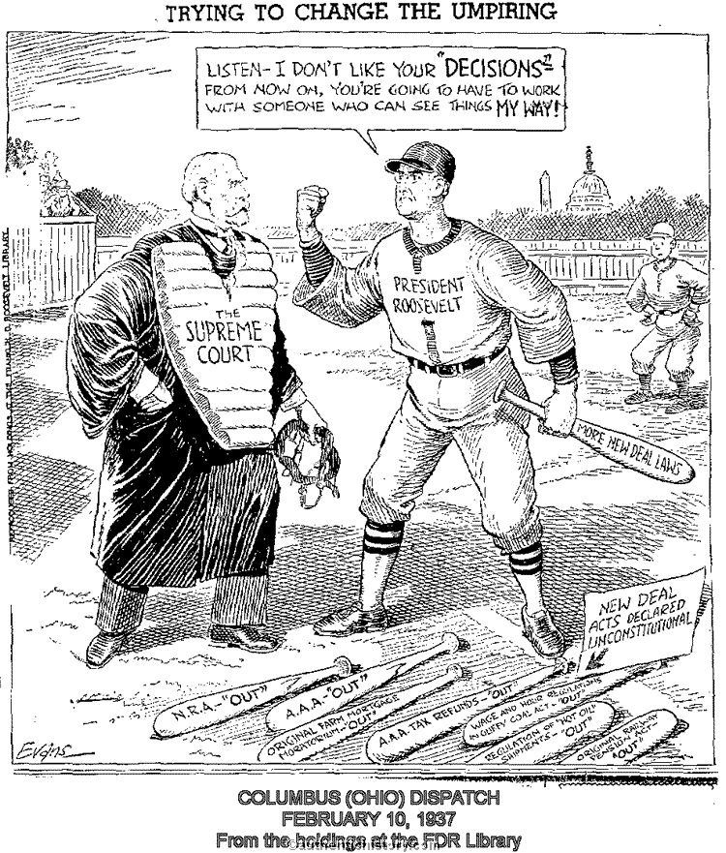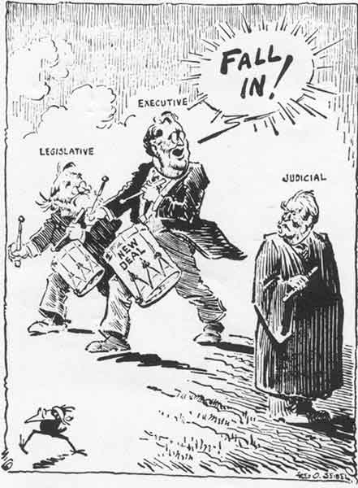
The Twenty-Second Amendment:
- Roosevelt broke with tradition and successfully ran for a third and even fourth term
- In 1951, the Twenty-second Amendment was ratified in 1951, limiting future Presidents to no more than two elected terms
The Congress of Industrial Organization (CIO):
- Labor provisions of the NRA encouraged growth in union membership
- There were disagreements within the American Federation of Labor (AFL) as to whether it should organize unskilled workers in major industries
- The AFL decided against it
- However, John L. Lewis of the Coal Miners Union and others organized the Committee for Industrial Organization (CIO) within the AFL to organize these unskilled industrial workers
- CIO’s goal was to organize unskilled workers on an industry-wide basis
- The United Automobile Workers Union of the CIO introduced a new technique, the sit-down strike
- In a sit-down strike workers remain in the plant at jobs but do not work
- By the end of the decade, the CIO, which had been expelled from the AFL in 1936, had won recognition from most major industries
- In 1955, the AFL and CIO merged to form the AFL-CIO
Kellogg-Briand Peace Pact:
- In 1928, the U.S. joined 61 nations in signing the Kellogg-Briand Peace Pact, renouncing the use of war as an instrument of national policy
The “Good Neighbor Policy”:
- Franklin D. Roosevelt rejected Theodore Roosevelt’s “Big Stick” policy and tried to improve relations with Latin America
- Under the “Good Neighbor Policy,” the U.S. agreed not to interfere in the internal affairs of Latin American nations
The Causes of the Second World War:
- The Great Depression led to the rise of fascist dictatorships in Nazi Germany and Fascist Italy
- Nazi aggression was the major cause of World War II
- In 1938, Hitler demanded the Sudetenland – a part of Czechoslovakia
- At the Munich Conference, British and French leaders gave in to Hitler’s demand in order to avoid war
- This policy of giving in to the demands of a potential enemy is known as appeasement
- Appeasement only encouraged Hitler to make further territorial demands
- When Germany invaded Poland in 1939, Britain and France felt they had no choice but to declare war
- The League of Nations, the international peace-keeping organization formed at the end of World War I, proved incapable of preventing another war
- The idea of collective security – that peaceful nations would band together to stop aggressors – failed because major powers like the United States and the Soviet Union had refused to join the League of Nations
The Neutrality Acts:
- As tensions rose in Europe in the 1930s, Congress passed a series of acts to keep the country out of war (isolationism)
- To avoid a repetition of America having been drawn into war when German submarines attacked American ships in WWI, the Neutrality Acts prohibited Americans from selling arms to warring nations or traveling on their ships
The Lend-Lease Act:
- While Americans hoped to avoid war, they nonetheless began making preparations in case they were dragged into the conflict
- When Nazi Germany defeated France in 1940, Americans proposed in late 1940 and passed in March 1941, the Lend-Lease Act
- It was the principal means for providing U.S. military aid to foreign nations during World War II
- The Lend-Lease Act allowed Americans to sell, lease, or lend war materials to “any country whose defense the President deems vital to the defense of the United States”
The “Four Freedoms”:
- In 1941, Roosevelt told Americans he hoped in the future to establish a world based on “Four Freedoms:” freedom of speech and expression, freedom of religion, freedom from want, and freedom from fear
The Bombing of Pearl Harbor:
- On December 7, 1941, Japanese airplanes attacked the U.S. Pacific fleet stationed in Pearl Harbor, Hawaii, destroying many ships and causing a large number of deaths
- The next day, President Roosevelt asked Congress to declare war on Japan
- Four days later, Germany and Italy, allies of Japan (the Axis Powers), declared war on the United States
- Americans were now engaged in war on two fronts – in Europe and the Pacific
- Japanese leaders had bombed Pearl Harbor because they realized that Japanese conquests of Southeast Asia might bring the United States into the war and thus decided to attack first
- Japanese leaders believed that Americans would quickly tire of the war and negotiate a compromise peace – leaving Japan in control of East Asia
World War II and the Draft:
- All men between 18 and 45 were eligible for military service
- For the first time, women could enlist
- One out of every ten Americans served in the war
- The draft and the expansion of production brought a final end to the Great Depression
- Women, African Americans, and other minorities filled the gap in available jobs, as other workers went to war
War Bonds:
- To pay for the cost of World War II, most of that money had to be borrowed
- To finance the war, the government issued bonds
- A bond is a way for an American citizen to invest money by lending it to the government and then to be repaid with interest after a given period of time
- The war cost Americans $350 billion – ten times the cost of World War I
- The United States changed from a creditor to a debtor nation
From WWI 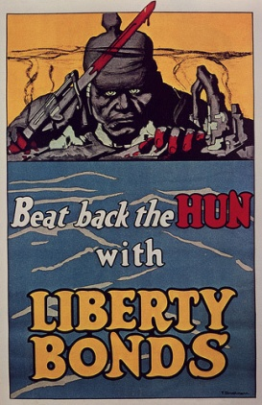 to WWII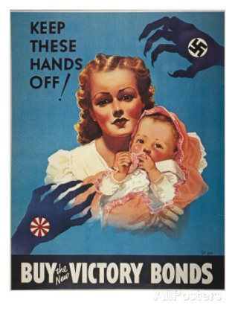 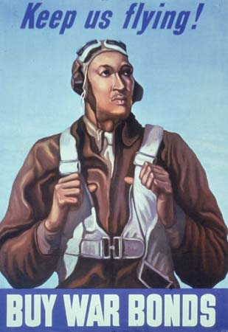
Executive Order 9066:
- Following the Japanese attack on Pearl Harbor on December 7, 1941, President Franklin D. Roosevelt issued Executive Order 9066
- The order set into motion the exclusion from certain areas and the evacuation and mass incarceration of 120,000 persons of Japanese ancestry living on the West Coast, most of who were U.S. citizens or legal permanent resident aliens
- These Japanese Americans, half of whom were children, were incarcerated for up to 4 years, without due process of law or any factual basis, in bleak, remote camps surrounded by barbed wire and armed guards
- Japanese Americans were forced to evacuate their homes and leave their jobs
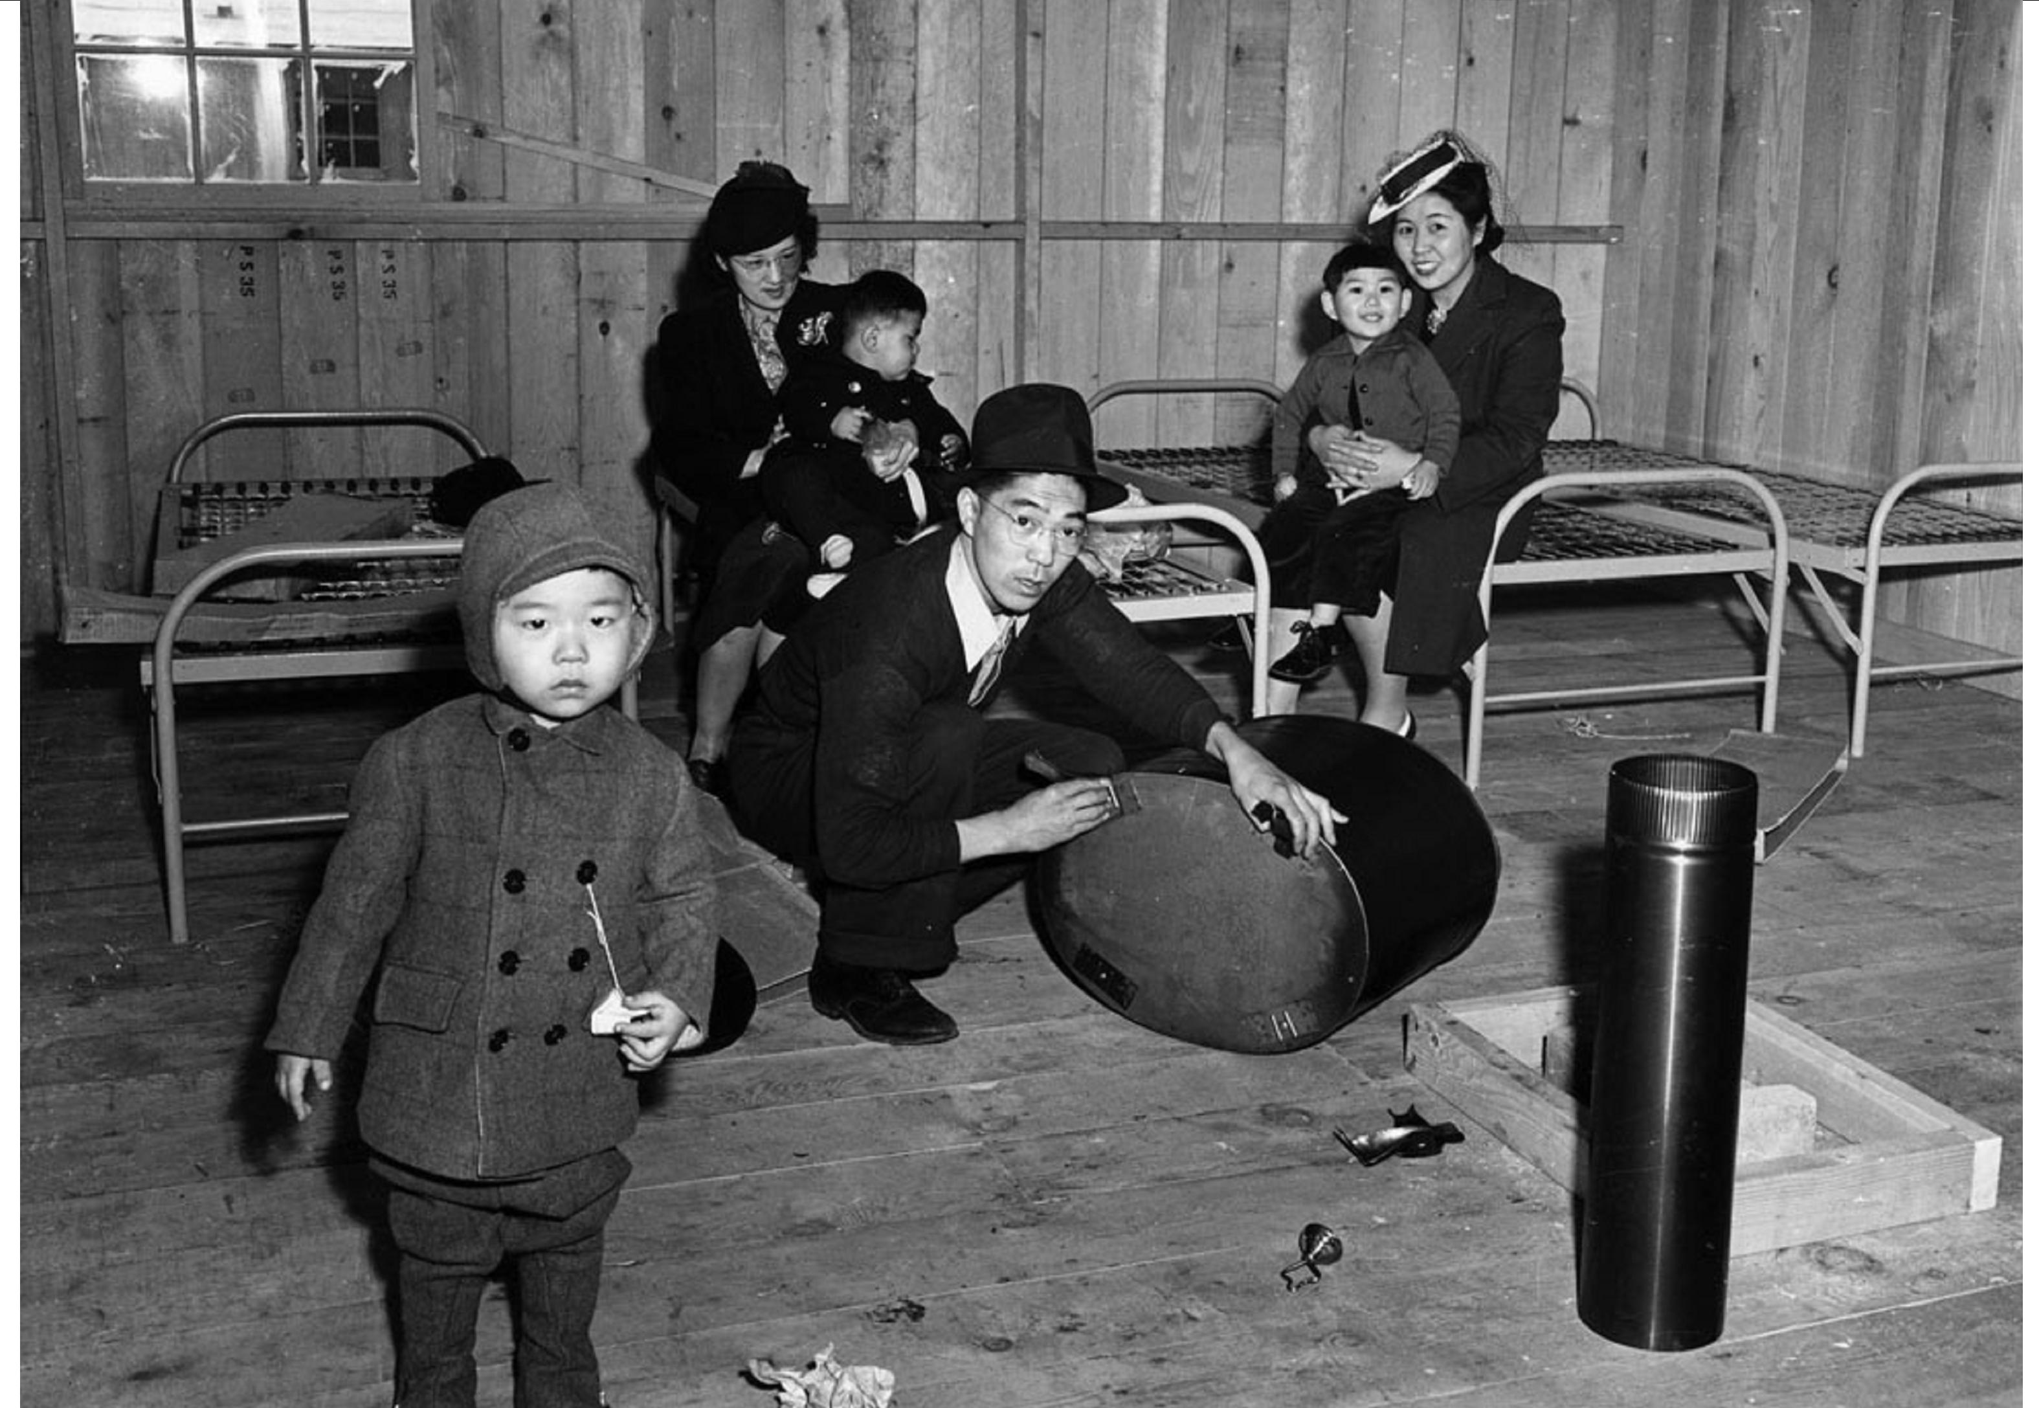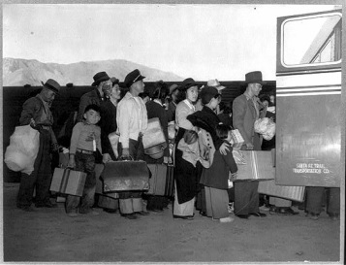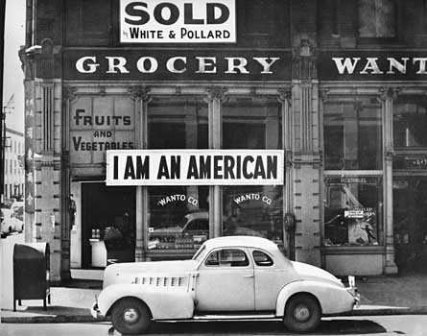
Korematsu v. United States:
- In Korematsu v. United States (December 18, 1944), the U.S. Supreme Court upheld the conviction of Fred Korematsu – a son of Japanese immigrants who was born in Oakland, California – for having violated an exclusion order requiring him to submit to forced relocation during World War II
- The Court upheld the relocations of Japanese Americans during the Second World War
- However, more recently, the U.S. Congress apologized for these forced relocations
World War II – Turning Point:
- By the time the U.S. entered the war, Hitler controlled most of Europe and North Africa
- Hitler made his greatest mistake when he invaded the Soviet Union
- Roosevelt and Churchill promised Stalin they would open a second front against Germany in the west
- Late in 1942, Allied troops landed in North Africa
- By 1943 – 1944, the Allies advanced to Sicily and Italy
- Meanwhile, Soviet forces defeated the German army at Stalingrad and advanced westward toward Germany
D-Day:
- On June 6, 1944, D-Day, United States, British and Canadian forces under the supreme command of General Dwight David Eisenhower invaded the Normandy peninsula of France
- The Battle of Normandy, which lasted from June 1944 to August 1944, resulted in the Allied liberation of Western Europe from Nazi Germany’s control
- Codenamed Operation Overlord, the battle began on June 6, 1944, also known as D-Day, when some 156,000 American, British and Canadian forces landed on five beaches along a 50-mile stretch of the heavily fortified coast of France’s Normandy region
- The invasion was one of the largest amphibious military assaults in history
- By late August 1944, all of northern France had been liberated, and by the following spring the Allies had defeated the Germans
- The Normandy landings have been called the beginning of the end of war in Europe
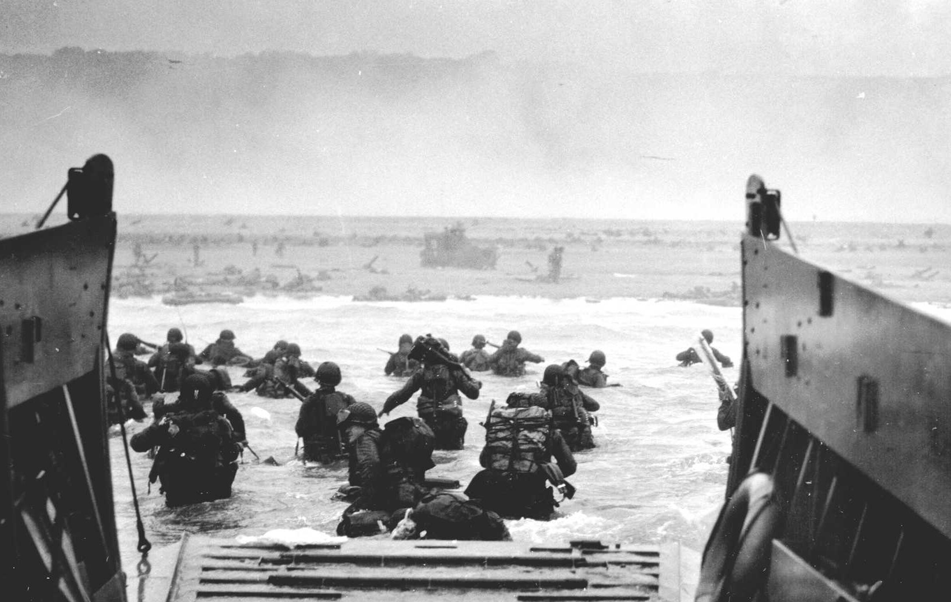
“Island-Hopping”:
- In these same years, the United States was also at war with Japan
- At first, the Japanese made significant gains in Asia and the Pacific
- In 1943, the tide began to turn
- The United States regained naval superiority in the Pacific and the American forces began “island-hopping” – liberating Pacific islands from Japanese control one at a time
Hiroshima and Nagasaki:
- Harry Truman, who had become President when Roosevelt died, feared an invasion of Japan might lead to a million American casualties
- Truman decided to use the atomic bomb rather than risk sustaining such losses
- On August 6, 1945, an atomic bomb exploded over Hiroshima
- Three days later, Nagasaki was bombed
- Japan surrendered after the second explosion, when U.S. leaders agreed to allow the Japanese emperor to remain on his throne
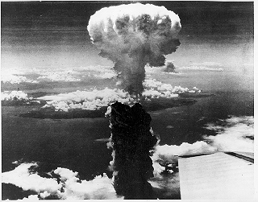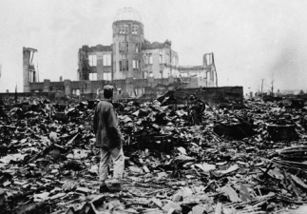
The Nuremberg Trials:
- A series of trials held in Nuremberg, Germany in 1945 – 1946, in which former Nazi leaders were indicted and tried as war criminals
- Hitler had murdered millions of European Jews and others in the Holocaust
- The liberation of concentration camps revealed the full extent of Nazi brutality
- The Allies put Nazi leaders on trial for “crimes against humanity”
- Those on trial claimed they were only following orders
- Many were found guilty and were hanged or imprisoned
- The Nuremberg Trials established that individuals are responsible if they commit atrocities, even during war
The Occupation of Japan:
- After the defeat of Japan in World War II, the United States led the Allies in the occupation and rehabilitation of the Japanese state
- Between 1945 and 1952, the U.S. occupying forces, led by General Douglas A. MacArthur, began the task of rebuilding and reforming post-war Japan
- Japan’s overseas empire was taken away, and military leaders were tried and punished
- Japan renounced nuclear weapons and waging war
- The country was forbidden from having a large army or navy
- A new constitution in 1947 made Japan a democracy
The “Cold War”:
- The end of World War II left the United States and Soviet Union as the only two superpowers
- The U.S. had tremendous economic power and control of the atomic bomb
- The Soviet Union had the world’s largest army, which occupied most of Eastern Europe.
- Although allies during the war, these two superpowers soon became rivals in the “Cold War”
- The war was “cold” only in the sense that, because of nuclear weapons, the two superpowers never engaged one another in open warfare
- The roots of the Cold War lay in competing ideological systems
- The United States wanted to spread its democratic capitalist system
- The Soviet Union wanted to spread its Communist system
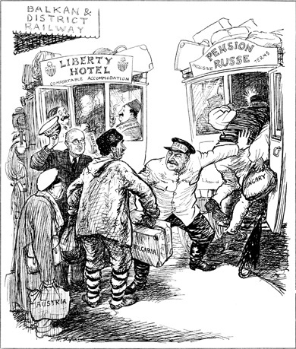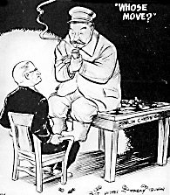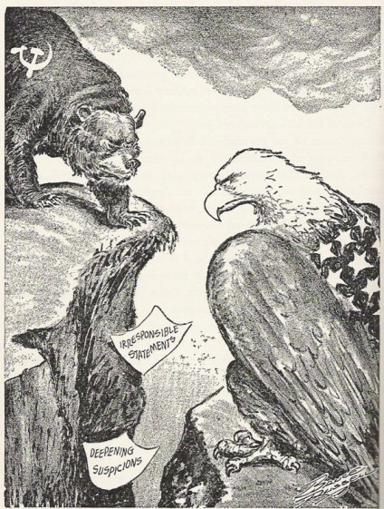
The United Nations (UN):
- When the Allies finally began to prepare for the end of World War Two, they rejected any idea of restoring the League of Nations (the peacekeeping organization established at the end of World War I that did not prevent World War II)
- Instead the Allies moved to establish a new organization, the United Nations
- And unlike the League of Nations, the United States joined the United Nations
- A peacekeeping organization dedicated to collective security (the cooperation of nations to work together to maintain peace and security)
The Division of Germany:
- After Germany’s defeat in WWII, the four main allies in Europe - USA, Britain, USSR, and France - took part in a joint occupation of the German state
- With the understanding that Germany would eventually be reunified, the Allied Powers agreed to share the responsibility of administering Germany and its capital, Berlin, and each took responsibility for a certain portion of the country
- However, the Allies could not agree and the division of Germany occurred
Soviet Satellites:
- When Stalin refused to allow free elections in Poland and Truman refused to share the secrets of the atomic bomb, the “Cold War” began in earnest
- Instead of withdrawing after WWII, the Soviet army continued to occupy Eastern Europe
- Stalin put Communist puppet governments in power in all of Eastern Europe, making these countries Soviet “satellites”
- As if an “Iron Curtain” had fallen between Eastern and Western Europe, contact between Eastern Europe and Western Europe was limited over the next forty years
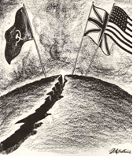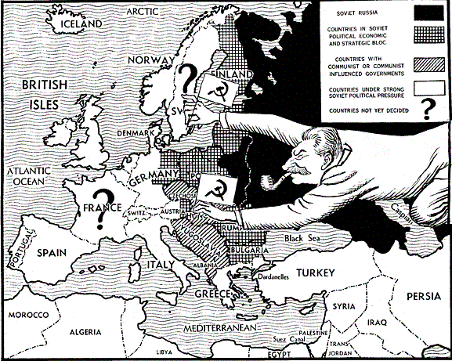 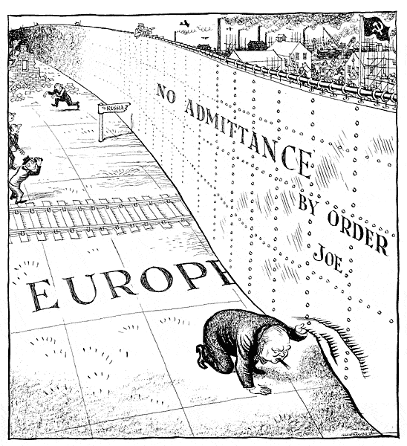
Truman Doctrine:
- A civil war was raging in Greece between the government and Communist forces
- In 1947, President Truman decided Greece and Turkey should be helped
- Announcing the Truman Doctrine, he asked Congress for funds to aid Greece and Turkey
- The Truman Doctrine declared the United States would aid any free peoples who resisted armed minorities attempting to overthrow an established government
- With this support from the United States, the Greek government defeated the Communist guerrillas
- The acceptance of the Truman Doctrine illustrates the fear of communism, an important factor in Cold War decisions
Containment Policy:
- American leaders responded to the Soviet domination of Eastern Europe by developing the policy of containment
- Under this policy, American leaders would not attempt to overturn Communism where it already existed, but resolved to prevent Communism from spreading to new areas
- USA policy to stop the spread of communism
- The Truman Doctrine was containment
The Marshall Plan:
- USA plan to aid the recovery of the economies of Western European nations still suffering from the effects of World War II
- The Marshall Plan, named for Secretary of State George C. Marshall, sought to revitalize the European economy
- It provided a “counter force” to the Soviets since capitalist prosperity in Western Europe reduced the attractiveness of communism
- Eastern European nations could have joined the Marshall Plan but none did so at the insistence of the Soviet Union
The Berlin Airlift:
- In 1948, the French, British and Americans decided to merge their occupation zones into a single West German state
- The Soviets reacted to this by announcing a blockade of West Berlin, closing all highway and railroad links to West Berlin
- It is important to note that Berlin, the capital, had been divided when Germany was divided
- West or Democratic Berlin was in the Soviet-controlled East Germany
- Therefore, when the Soviets blockaded the roads leading to West Berlin, West Berlin was cut off from the democratic West
- But Western Allies refused to abandon Berlin, and began a massive airlift to feed and supply the city
- Within a year, Stalin lifted the Soviet blockade
- The Berlin Airlift of 1948 was a success for the Western Allies
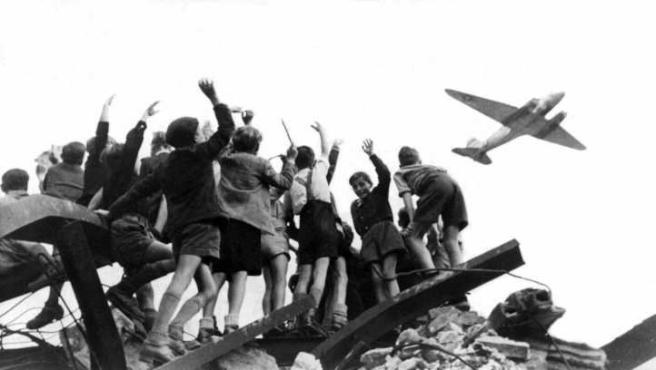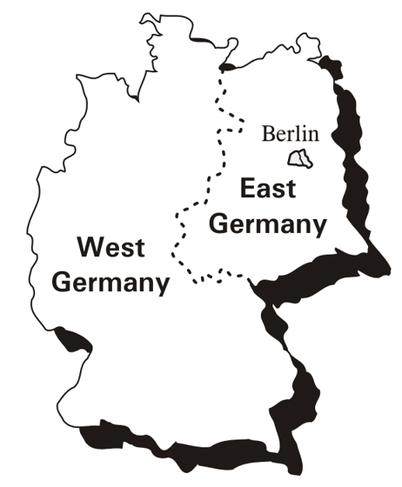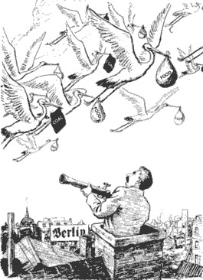
NATO:
- Another response following the policy of containment was the establishment of NATO – the North Atlantic Treaty Organization – in 1949 after the ending of the Berlin Blockade
- An alliance of the United States and its Democratic partners to stop the spread of communism
- Breaking with the precedent set by George Washington of not signing peacetime alliances, the United States joined NATO
The Warsaw Pact:
- The Soviet Union (USSR) organized her allies into a military alliance, the Warsaw Pact, to counter the strength of NATO
USA Refusal to Recognize Communist China in 1949:
- In 1949, the Communists, led by Mao Zedong, defeated the Nationalist government in China
- Mao Zedong then proceeded to create the world’s largest Communist state
- President Truman refused to recognize the Communist government in China
- Using its veto power in the United Nations, the United State prevented admission of Mao’s China to the U.N.
- The United States recognized the Nationalist government of Taiwan as China (the Nationalists had been defeated by the Communists during the Chinese civil war and fled to the island nation of Taiwan)
The Korean War:
- After World War II, Korea had been divided into two zones: in North Korea, the Soviets established a Communist government, while South Korea elected a non-Communist government
- In 1950, North Korea invaded South Korea in an attempt to unify the country under Communist rule
- President Truman saw this as similar to earlier Nazi aggression and ordered U.S. forces to South Korea to resist the invasion
- When the Soviet Union boycotted the United Nations, the United States was able to pass a resolution authorizing the operation of U.N. troops in South Korea
- Truman sent General Douglas MacArthur to Korea to command U.N. forces.
- MacArthur landed his forces at Inchon and then attacked North Korea, bringing the Chinese army into the war
- MacArthur wanted to recapture China from the Communists, by using atomic weapons if needed
- When Truman refused, MacArthur publicly criticized the President
- Truman fired MacArthur, successfully asserting civilian control over the military
- In 1952, Dwight Eisenhower was elected President after pledging that he would end the war in Korea
- An armistice was signed that left Korea, with minor border adjustments, divided as it had been before the war
1949 and an Atomic Bomb in the USSR:
- Soviet espionage agents gained access to American secrets
- In 1949 the Soviet Union detonated an atomic bomb
- Thus, an arms race had begun
- A competition between nations for developing superior weapons
- In 1952, the United States developed the hydrogen bomb, vastly more powerful than the atomic bomb
- The Soviet Union exploded its first hydrogen bomb a year later, showing that the technology gap between the two superpowers was narrowing
Deterrence:
- When only the United States possessed a nuclear bomb, it used the threat of using it as a means to deter (discourage) Soviet aggression
- By the late 1950s, the Soviet Union had built up a convincing nuclear arsenal
- By the mid-1960s, unilateral deterrence gave way to “mutual deterrence,” a situation of strategic stalemate
- The superpowers would refrain from attacking each other because of the certainty of mutual assured destruction, better known as MAD
Sputnik:
- In 1956, the Soviet Union launched the first satellite, Sputnik, into space
- It was clear that the Soviets were developing the ability to launch nuclear missiles that could strike the United States
- This prompted the United States to send its own satellite into space in 1958, and the “Space Race” began
- The “Space Race” was competition between nations regarding achievements in the field of space exploration
Loyalty Checks and the House Un-American Activities Committee (HUAC):
- As the Cold War grew more intense, Americans became very concerned with internal security (the fear that American Communists were plotting revolution)
- President Truman ordered the establishment of Loyalty Review Boards to investigate individual “un-American” acts, such as participation in organizations like the American Communist Party
- Congress conducted its own loyalty checks through the House Un-American Activities Committee
Julius and Ethel Rosenberg:
- In 1950, Julius and Ethel Rosenberg were indicted for selling secret information about the atomic bomb to the Soviet Union
- The Rosenbergs were executed for treason, even though many Americans had doubts about their guilt
- The Rosenbergs were the first American civilians to be executed for espionage (spying) and the first to suffer that penalty during peacetime
Senator Joseph McCarthy and the “Red Scare”:
- In 1950 Republican Senator Joseph McCarthy from Wisconsin claimed he had the names of 205 Communists in the State Department
- He never produced the names and kept changing the numbers, but he captured national attention
- McCarthy then expanded his accusations to include scholars and the United States Army
- His accusations against the Army led to a Senate hearing
- It was televised nationally – the first Senate hearing to get such publicity
- McCarthy’s tactics at the hearing disgusted many viewers
- The hearings backfired
- No clear proof of misdeeds by the army was produced
- In 1954, the Senate censored McCarthy for discrediting the Senate
- McCarthyism has come to mean making wild accusations without proof
- McCarthyism showed the extent of anxiety caused by the Cold War
Jackie Robinson and the Beginning of Desegregation:
- In 1947, Jackie Robinson became the first African-American baseball player to cross the “color line” and join the major leagues
- The next year, President Truman signed an executive order to desegregate the armed forces and end racial discrimination in the hiring practices of the federal government
Brown v. Board of Education of Topeka:
- In Brown v. Board of Education of Topeka (May 17, 1954), the U.S. Supreme Court ruled unanimously (9–0) that racial segregation in public schools violated the Fourteenth Amendment to the Constitution, which prohibits states from denying equal protection of the laws to any person within their jurisdictions
- The decision declared that separate educational facilities for white and African American students were inherently unequal
- It thus rejected the “separate but equal” doctrine advanced by the Supreme Court in Plessy v. Ferguson (1896)
- It rejected racial segregation
- Although the 1954 decision strictly applied only to public schools, it implied that segregation was not permissible in other public facilities
- Considered one of the most important rulings in the court’s history, Brown v. Board of Education of Topeka helped to inspire the American civil rights movement of the late 1950s and 1960s
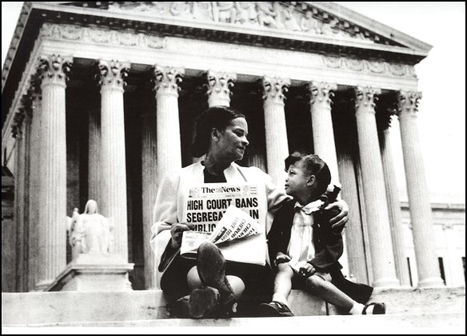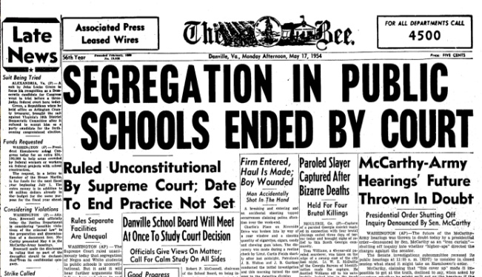
Rosa Parks:
- In Montgomery, Alabama, in December 1955, Rosa Parks, a tired seamstress who had worked for the N.A.A.C.P., refused to give up her seat to a white man on the city’s segregated private bus line
- Local African-American leaders had been waiting for an opportunity to make a case against segregated buses
- When Rosa Parks was arrested, they began court proceedings, and at the same time a bus boycott was organized by African-Americans in Montgomery
- African-Americans stayed off the buses for almost a year
- Dr. Martin Luther King. Jr. emerged as the spokesperson for the boycott and went on to become a leader and hero of the Civil Rights Movement until his assassination in 1968
The Little Rock Nine:
- In a key event of the American Civil Rights Movement, nine black students enrolled at formerly all-white Central High School in Little Rock, Arkansas, in September 1957, testing a landmark 1954 U.S. Supreme Court ruling that declared segregation in public schools unconstitutional
- On September 4, 1957, the first day of classes at Central High, Governor Orval Faubus of Arkansas called in the state National Guard to bar the black students’ entry into the school
- Later in the month, President Dwight D. Eisenhower sent in federal troops to escort the “Little Rock Nine” into the school, and they started their first full day of classes on September 25
- The Little Rock Nine completed the year with the troops protecting them
- The public schools, however, were closed for the next two years rather than continue with integration
“Sit-ins”:
- On February 1, 1960, four African-American students of North Carolina Agricultural and Technical State University sat at a “whites only” lunch counter inside a Greensboro, North Carolina Woolworth’s store to protest segregation in public facilities
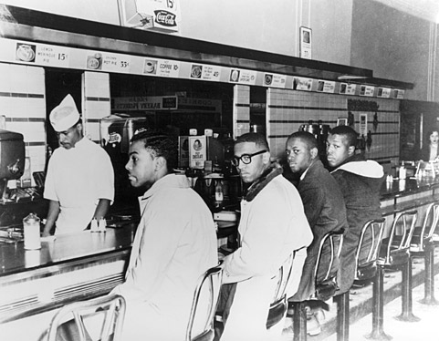
The Freedom Riders:
- In 1961, the Congress of Racial Equality undertook a new tactic aimed at desegregating public transportation throughout the south
- These tactics soon became known as the “Freedom Rides”
- Freedom Riders intended to test the Supreme Court’s ruling in Boynton v. Virginia (1960) which declared segregation in interstate bus and rail stations unconstitutional
- On May 4, 1961, a group of 13 African-American and white civil rights activists launched the Freedom Rides, a series of bus trips through the American South to protest segregation in interstate bus terminals
March on Washington:
- In 1963, Dr. King and other Civil Rights leaders called for a March on Washington in support of a new civil Rights bill pending in Congress
- A quarter of a million people attended the march
- King gave his famous “I Have A Dream” speech, in which he looked forward to the day when Americans of all colors would live together peacefully
- “Free at last, Free at last, Thank God almighty we are free at last.” ~ MLK
The Civil Rights Act of 1964:
- In 1964, President Johnson was able to push a bill through Congress
- The bill prohibited discrimination based on race, religion, or ethnic origin in hotels and in places of employment doing business with the federal government
- The act cut off federal money to districts with segregated schools
- In addition, the federal government was given power to register voters and to establish a commission to enforce the act
- The Civil Rights Act of 1964 was a turning point in the Civil Rights Movement
The Twenty-fourth Amendment (1964):
- Eliminated poll taxes in federal elections
The Voting Rights Act (1965):
- Ended poll taxes and suspended literacy tests where they were being used to prevent African Americans from voting
Affirmative Action:
- Increased minority representation in colleges and the profession
Malcolm X:
- A leader of the Black Muslims
- Malcolm X and other Black Muslim leaders called on African-Americans to be sober and thrifty and to seize freedom
- They inspired and encouraged self-awareness and a sense of self-respect and power for people in the ghettos
Black Panthers:
- Organized in 1966 to patrol the streets in the ghettos
- Quickly became urban revolutionaries and called attention to conditions in the ghetto
- In 1968, Stokely Carmichael joined the Black Panthers organization as the Prime Minister
- Stokely Carmichael spoke of the need to achieve Black Power
- The need for African-Americans to gain political and economic power
President Dwight D. Eisenhower:
- President from 1953 to 1961
- Eisenhower’s years in office were marked by several important developments:
- a housing boom –a time of high birth rates, known as the “baby boom”
- G.I. Bill helped veterans get mortgages
- This led developers to build cheaper, mass-produced housing as home ownership increased by 50%; prosperity
- Gross domestic product doubled from 1945 to 1960 and America dominated world trade
- Conformity – in the late 1950s, there was a greater emphasis on conformity as fear of Communism strengthened the dislike of non-conformist attitudes
- Civil Rights Movement
President John F. Kennedy:
- President from 1961 to 1963
- As part of his New Frontier, JFK proposed a tax cut to stimulate the economy, creation of Medicare, civil rights legislation, and increased aid to education
- One of his greatest challenges was the establishment of a Communist government by Fidel Castro in Cuba, only 90 miles from the coast of Florida
- Brought to the White House an aura of youthful idealism
- Kennedy’s idealism and goals for America are illustrated in his inaugural address and in his establishment of the Peace Corps, in which young Americans worked as volunteers on projects in undeveloped countries to aid the people, not the government, of those countries
- Kennedy provided a national purpose when, responding to the Soviet challenge in space, he called on the nation to place a man on the moon by the end of the decade
- Tragically, on a political campaign trip to Dallas, Texas, Kennedy was assassinated on November 22, 1963
- Lee Harvey Oswald was arrested as the suspect but was shot and killed by Jack Ruby while being transferred from jail.
The Bay of Pigs:
- In 1961, Cuban exiles, trained in the United States, invaded Cuba at the Bay of Pigs
- Kennedy, fearing Soviet involvement, refused to give them air support and they were defeated by Castro’s army
- This was a major foreign policy failure for the Kennedy Administration
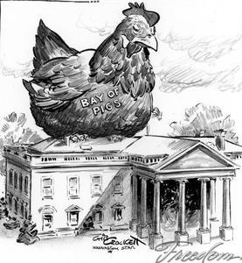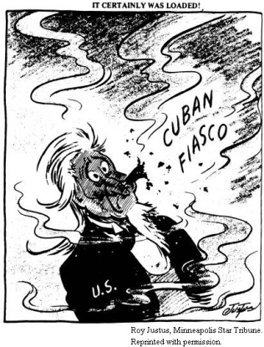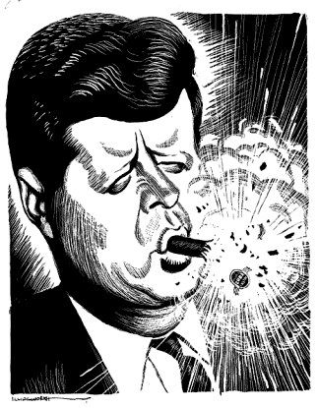
The Cuban Missile Crisis:
- In 1962, the United States discovered that Cuba was secretly trying to build bases for Soviet nuclear missiles
- Kennedy imposed a naval blockade on Cuba and threatened to invade if the missiles were not withdrawn
- For several days the world stood on the brink of nuclear war
- Soviet leader Khrushchev agreed to withdraw the missiles for a pledge that the United States would not invade Cuba
- The Cuban Missile Crisis was a major foreign policy success for the Kennedy
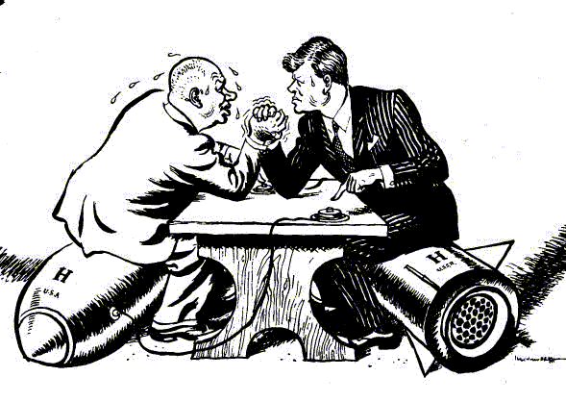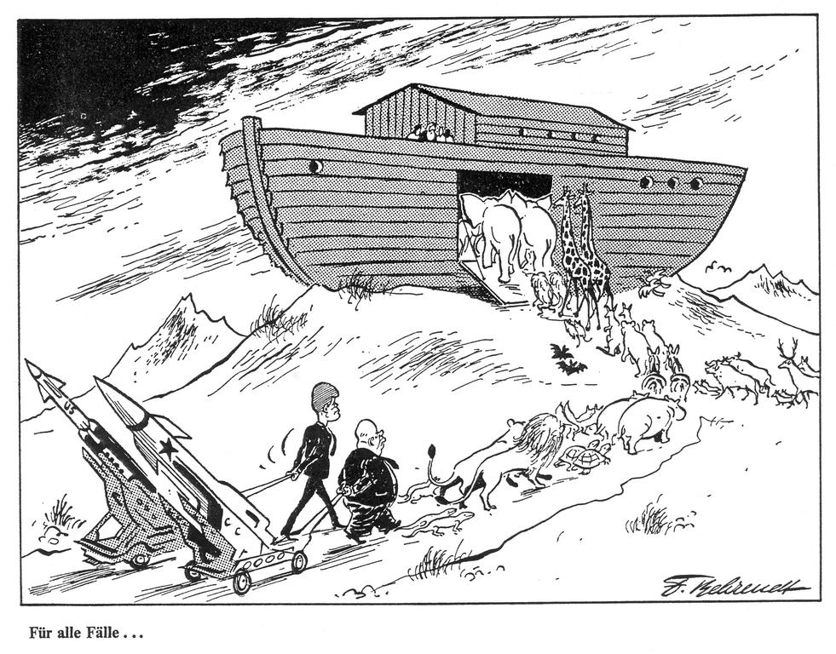
President Lyndon Baines Johnson:
- President from 1963 to 1969
- Vice President Lyndon Johnson was immediately sworn in as President upon the assassination of President John F. Kennedy
- Johnson proposed to Congress the most far-ranging legislation since the New Deal
- Johnson’s aim was to turn the United States into a “Great Society” by opening up opportunities for all citizens and improving the quality of American life
- Johnson passed a broad program of civil rights legislation including the Civil Rights Act of 1964 and the Voting Rights Act of 1965
- Social Security was expanded to provide medical care, hospital insurance, and post-hospital nursing for people over age 65 with the Medicare Act of 1965
- Johnson called for a “war on poverty”
- He created new programs to help the poor, such as the Job Corps to train underprivileged youths, and a domestic “Peace Corps” to help in depressed areas
- Money was also provided for urban planning, slum clearance, rental assistance to the poor, and the reconstruction of buildings.
- Despite these Great Society programs, many Americans remained in poverty
- The high cost of spending caused by U.S. involvement in the Vietnam War eventually forced Johnson to withdraw much of the funding for his new domestic programs
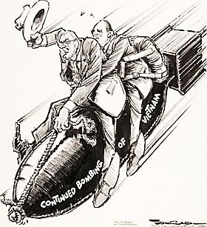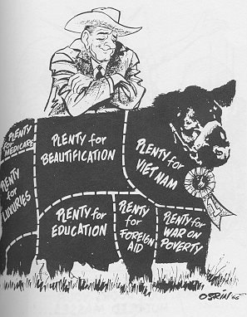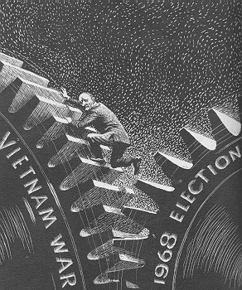
The “Youth Culture”:
- In the 1960s and 1970s, many young people adopted a spirit of rebelliousness
- They challenged the materialism of those in charge of American society
- They were shocked at the Establishment’s indifference to poverty and other problems
- The new “youth culture” experimented openly with drugs and sex
- They adopted new fashions to set them apart from traditional styles
- In the late 1960s, many youths focused on American involvement in Vietnam
- By 1968, millions of young people were actively protesting the war
- Protests continued until the United States withdrew from the war in 1973
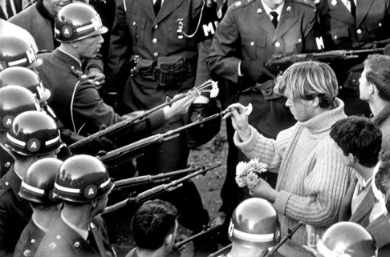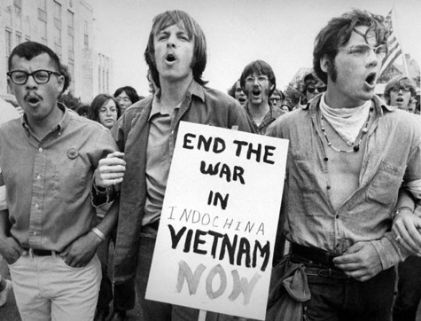
Women’s Liberation Movement:
- The Women’s Liberation or Feminist Movement of the 1960s also transformed American society
- Unlike the earlier Suffrage Movement, which focused on securing the vote, the Women’s Liberation Movement of the 1960s was directed at achieving economic and social equality
- Many women were dissatisfied with their roles as housewives and sought to express themselves in careers and work
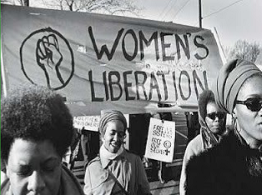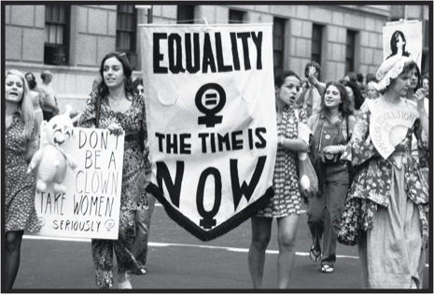
Betty Friedan:
- Wrote The Feminine Mystique
- A work of nonfiction that revealed the frustrations many women felt at being restricted to homemaking and motherhood
Roe v. Wade:
- In the Supreme Court case of Roe v. Wade (1973), the U.S. Supreme Court ruled unconstitutional a state law that banned abortions except to save the life of the mother
- In a 7 – 2 vote the Supreme Court held that a set of Texas statutes criminalizing abortion in most instances violated a woman’s constitutional right of privacy
- While abortion became one of the most divisive issues in American history, the Court ruled that women’s constitutional right to privacy guaranteed the right to an abortion in early pregnancy
- “Pro-choice” groups advocate a woman’s right to privacy and a woman’s right to abortion
- “Pro-life” groups believe that human life begins at conception and oppose the Roe v. Wade ruling
The Kerner Commission:
- Appointed by President Lyndon Johnson, a commission chaired by Governor Otto Kerner of Illinois explored the reasons behind the Detroit riots of 1967
- Violent confrontation occurred between residents of a predominantly African American neighborhood and a mostly white police department
- The commission presented its report in February 1968
- “Our nation is moving toward two societies, one black, one white – separate and unequal,” the report said. “What white Americans have never fully understood –but what the Negro can never forget – is that...white institutions created [the ghetto], white institutions maintain it, and white society condones it.”
The American Indian Movement:
- Under the slogan “Red Power,” Native American Indians formed the American Indian Movement (A.I.M.)
- Their leaders sought respect for the Indian heritage
- They introduced the term “Native American” and protested racial biases and stereotypes against their ethnic group
- To bring attention to their cause, they temporarily occupied government property like Alcatraz Island in California
The Warren Court:
- Under Chief Justice Earl Warren, the Supreme Court became an instrument of social change – protecting individual rights, minority groups and those accused of crimes
- Mapp v. Ohio (1961)
- The Supreme Court ruled that evidence obtained by the police through an illegal search could not be used in court
- Baker v. Carr (1962)
- The Court ruled that legislative districts must be reapportioned on the basis of “one man, one vote” since rural areas tended to be over-represented and cities under-represented due to shifting population patterns with the passing of time (i.e. more people migrated to cities)
- Gideon v. Wainwright (1963)
- The Court ruled that states must provide a free lawyer to any criminal defendant facing imprisonment who could not afford one
- Miranda v. Arizona (1966)
- A man confessed to a rape without being informed that he could have a lawyer present
- The Court overturned his conviction, ruling that the police must inform suspects of their “Miranda” rights: to remain silent, to have a lawyer present during questioning, and that what they say can be used against them
The Vietnam War:
- Vietnam was once a French colony in Indochina
- In 1954, the Vietnamese defeated the French
- At the Geneva Conference that followed, Vietnam was divided into two
- The country was to be reunited after elections were held in 1956
- South Vietnamese leaders later refused to hold the elections, however, since they feared elections in the North would not be free
- South Vietnamese Communists (Vietcong), with North Vietnamese support, began a guerrilla war against the government of South Vietnam
- Kennedy, responding to requests from the South Vietnamese government for help and sent aid and military advisers to train the South Vietnamese army to fight the Vietcong
- U.S. leaders believed in the domino theory: they thought if South Vietnam fell to Communism, other Southeast Asian countries might also fall
- In 1964, President Johnson announced that the North Vietnamese had attacked U.S. ships in the Gulf of Tonkin
- Congress gave the President power to stop this aggression
- Johnson used the Gulf of Tonkin Resolution to escalate the war, ordering massive bombing raids of North Vietnam
- He also sent more combat troops to South Vietnam
- Despite the large American force, the Vietcong launched the Tet Offensive in South Vietnam in 1968, seizing many cities
- This convinced Americans that victory was far off
- The war grew increasingly unpopular and opponents held demonstrations
“Vietnamization”:
- During Nixon’s term the war dragged on for five more years
- Under his “Vietnamization” policy, the South Vietnamese army gradually took over the brunt of fighting, allowing U.S. forces to gradually withdraw
- In 1973, Nixon’s negotiators in Paris worked out a cease-fire agreement with the North Vietnamese
- After the U.S. withdrew, fighting continued
- South Vietnam fell to Communist forces in 1975 and Vietnam was reunited under Communist rule
War Powers Act (1973):
- After the war, Congress passed the War Powers Act (1973) which limited the President’s power to involve the nation in armed conflict without a formal declaration of war by Congress
- The act required the President to inform Congress within 48 hours of sending troops to fight overseas
- If within 60 days Congress did not approve the use of these forces, the President must withdraw the troops
Nixon and the New Federalism:
- Nixon was President from 1969 to 1974
- Nixon believed that federal social programs were often inefficient, and that most social problems were best dealt with at the local level
- Under his policy of New Federalism, Nixon reversed the trend of increasing federal control by turning over some federal tax revenues to state governments
- The early 1970s saw rising inflation
- Nixon cut spending on social programs and imposed wage and price controls
- These attempts to control inflation proved unsuccessful
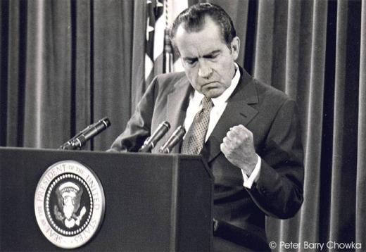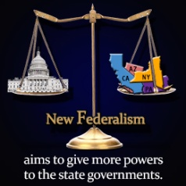
Nixon and Communist China:
- President Nixon believed the President’s major role was to direct the country’s foreign policy
- Ever since the Communist Revolution in China in 1949, U.S. leaders had refused to establish diplomatic relations with the Chinese
- Instead, they treated the Nationalist Chinese government on Taiwan as the official government of China
- Nixon finally visited mainland China and restored diplomatic relations with the Chinese
Détente:
- Nixon also introduced Détente – a relaxing of tensions – with the Soviet Union
- In 1972, Nixon visited Moscow and signed the SALT I Accord, which limited the development of certain types of missile systems
The Watergate Scandal:
- In 1972, a group of former CIA agents, working for Nixon’s re-election, were caught breaking into Democratic Party headquarters at the Watergate complex in Washington, D.C.
- Nixon tried to cover up an investigation of the break-in on the grounds of national security
- In Senate hearings, it was revealed that Nixon secretly recorded all his White House conversations
- When the Senate Committee asked to hear the tapes, Nixon refused, claiming executive privilege
- The Supreme Court ruled that Nixon must turn over the tapes, reaffirming the principle that no one is above the law
- The tapes revealed that Nixon had lied when he said he was not involved in the cover-up
- Fearing impeachment, Nixon became the first President ever to resign.
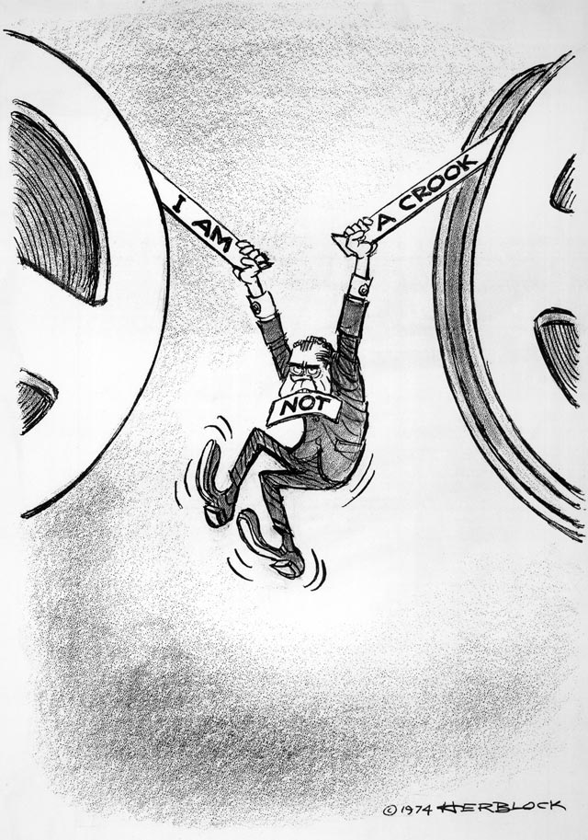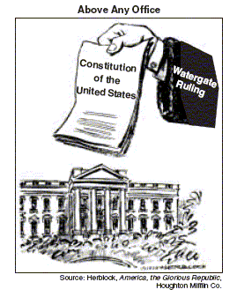
The Twenty-Fifth Amendment:
- Under the Twenty-fifth Amendment, Nixon appointed Congressman Gerald Ford to replace Agnew as Vice-President
- The Twenty-fifth amendment (1967) to the Constitution set forth succession rules relating to vacancies and disabilities of the office of the president and of the vice president
- It was proposed by the U.S. Congress on July 6, 1965, and it was ratified on February 10, 1967.
- In 1973 Spiro Agnew resigned as Vice President when it was discovered he had taken bribes while serving as Governor of Maryland
- Under the Twenty-fifth Amendment, Nixon appointed Congressman Gerald Ford to replace Agnew as Vice-President
Presidency of Gerald Ford:
- When Nixon resigned, Gerald Ford became president, the first not elected by the Electoral College
- One of Ford’s first acts was to pardon Nixon for any crimes he had committed. This caused severe public criticism
- As President, Ford’s main worries were over the economy
- The nation suffered from stagflation – high unemployment because of a stagnant economy, and high inflation
- Ford continued Nixon’s policy of détente with the Soviet Union
- In 1975, the U.S., USSR and other nations signed the Helsinki Accords, recognizing post-World War II borders and pledging to respect human rights
- During the Ford Presidency, the OPEC oil embargo pushed inflation from 3 percent in 1972 to 11 percent in 1974
- Increased foreign competition, particularly from Japan in autos and electronics, hurt the economy
- Many new jobs were added, but they were in service industries – restaurants and selling – rather than in heavy manufacturing
President Jimmy Carter:
- Democrat Jimmy Carter was elected President as an “outsider” who promised to clean up Washington
- Carter was President of the United States from 1977 to 1981
- Like Ford, Carter’s chief problems were economic
- The U.S. was heavily dependent on imported oil
- As oil prices skyrocketed, inflation went over 10%, interest rates rose to 20%, and unemployment grew
- High oil prices and shortages continued throughout the Carter years
- President Carter made human rights a high priority
- Carter also signed a treaty returning the Panama Canal to Panama in 1999 (the Panama Canal Treaty)
- In 1977, Carter invited Egypt’s President Anwar Sadat and Israel’s Prime Minister Menachem Begin to Camp David, where an agreement was reached
- Israel returned the Sinai Peninsula to Egypt in exchange for a peace treaty and the establishment of normal relations
- In 1978, widespread demonstrations broke out against the Shah in Iran
- The Shah was a brutal dictator supported by the United States
- When the Shah fled the country, religious leaders hostile to Western influences seized control
- They resented America for helping the Shah and backing Israel
- In retaliation, Iranian students seized the staff of the U.S. embassy in Iran, holding them hostage for 444 days
- Negotiations finally led to their release, but only on the day Ronald Reagan became President
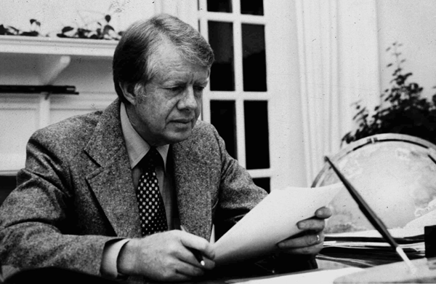
President Ronald Reagan:
- Carter was defeated by Ronald Reagan in the Presidential election of 1980
- Reagan believed strongly that individuals and businesses were better able to solve economic problems than the government was
- Reagan supported the policy of New Federalism first begun under President Nixon
- Reagan tried to solve stagflation with supply-side economics
- He believed a large supply of goods would decrease prices and stop inflation
- Under “Reaganomics,” he cut taxes on businesses and the wealthy
- He felt these groups would invest their tax savings to raise productivity and increase employment, resulting in benefits that would “trickle down” to other groups
- Reagan also eliminated many regulations on industry
- Reagan set out to rebuild American confidence in the aftermath of Vietnam and Watergate
- He believed that the United States should continue to act as the world’s defender of freedom and democracy
- In 1983, Reagan sent U.S. Marines to the island of Grenada to defeat Communists who had taken control
- In 1986, President Reagan announced the Reagan Doctrine – the U.S. would no longer just contain Communism, but would roll it back by aiding anti-Communist “freedom fighters”
- Under this policy, the Reagan Administration secretly sold arms to Iran
- Profits from the sale were used to support the “Contra” rebels fighting the Communist government of Nicaragua, even though Congress had passed a law forbidding aid to the Contras
- An investigation cleared the President but led to several Reagan officials being sent to prison
- The Iran-Contra Affair was a political scandal in which the National Security Council (NSC) became involved in secret weapons transactions and other activities that either were prohibited by the U.S. Congress or violated the stated public policy of the government
- The last years of Reagan’s Presidency saw the beginning of an end to the Cold War
- The economic failures of Communism forced Soviet leaders to introduce new reforms
- Soviet leader Mikhail Gorbachev agreed to withdraw troops from Afghanistan and to allow a peaceful transition to democracy in Eastern Europe
- Reagan and Gorbachev held a series of summit conferences, and signed an agreement to dismantle thousands of nuclear missiles
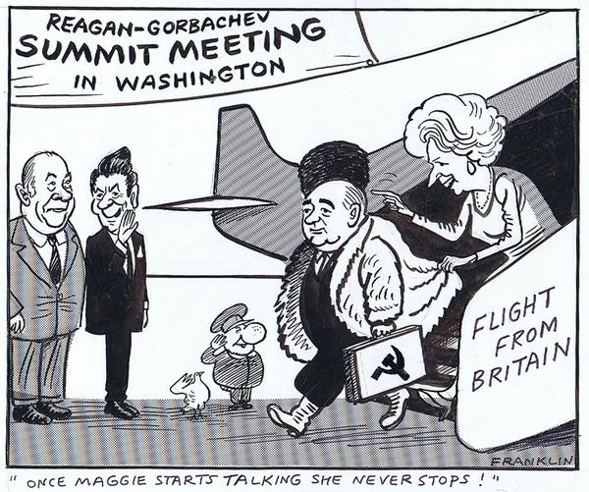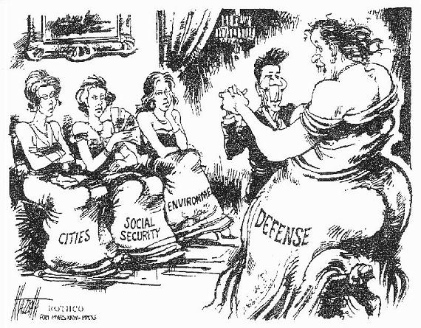
President George H.W. Bush:
- Reagan’s Vice President, George H.W. Bush, campaigned in the 1988 election on a promise to continue Reagan’s policies, but with an emphasis on improving education, fighting drug use, and greater compassion for the poor and the disadvantaged
- In 1990, Bush signed the Americans with Disabilities Act prohibiting discrimination against people with disabilities in the areas of employment and public accommodations
- In 1989, Bush sent U.S. forces to Panama against the drug-dealing dictator Manuel Noriega
- Noriega was taken to the United States and convicted on drug charges
- However, the most important event of the Bush Presidency was the end of the Cold War
- From 1989 to 1991, Eastern Europe moved from Communism to democracy, the Berlin Wall was torn down, and East and West Germany were reunited
- Gorbachev’s reforms set in motion a series of events that, by 1991, led to the collapse of the Soviet Union and its replacement by the Commonwealth of Independent States
The Gulf War:
- The Gulf War (1990 – 1991) was Bush’s greatest single foreign policy success
- In 1990, Iraqi dictator Saddam Hussein invaded Kuwait, seizing its vast oil wealth and extending Iraq’s borders
- Hussein refused demands by the United Nations to withdraw
- In response, U.N. forces under U.S. leadership attacked Iraq
- The invasion quickly succeeded
- In February 1991, all Iraqi troops were driven out of Kuwait, and Hussein agreed to pay Kuwait for damages
- The crisis was significant as the first major challenge to world order since the end of the Cold War
- American influence was greatly enhanced by U.S. success in the Gulf War
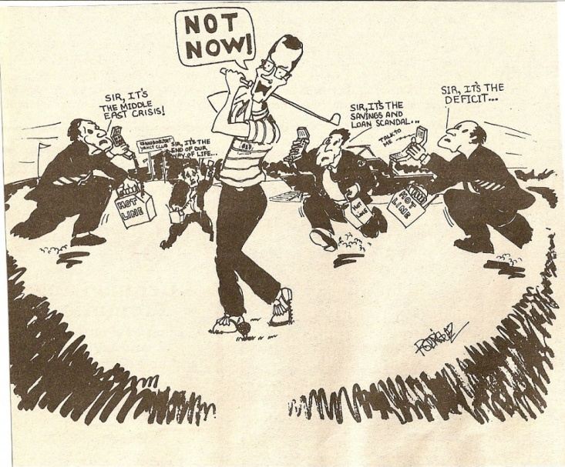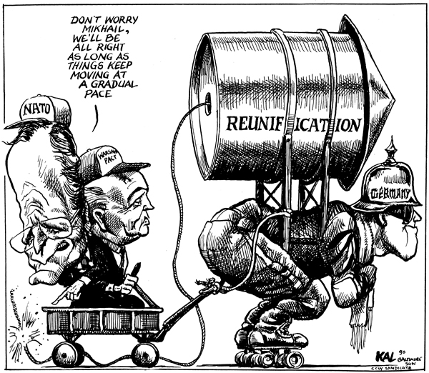
President Bill Clinton:
- Partly due to the recession, Bush lost the election of 1992 to Bill Clinton
- Clinton promised health care reform, but could not get a plan through Congress
- However, his economic policies and advances in computer technology were successful in restoring the economy
- By the end of his Presidency (1993 – 2001), the economy was enjoying its best period in history and the government had a series of budget surpluses
- The scandal that drew the most attention during the Clinton Presidency began when Paula Jones, an Arkansas State employee accused Clinton of sexual misconduct in 1991 and sued him while he was president
- The Supreme Court rejected Clinton’s plea to postpone the case until the end of his term and required that he give testimony
- In the course of the investigation information emerged concerning a possible sexual affair between Monica Lewinsky, a former White House intern, and the president
- After finding Clinton had lied about the relationship under oath, the prosecutor recommended impeachment
- The House voted along party lines to impeach the President, but the Senate vote fell short of the two-thirds required to convict him
- When Serb nationalists persecuted Muslims in Kosovo, Clinton spearheaded the use of NATO forces to bomb Serbia, and ended the bloodshed
- Clinton was a tireless negotiator in the peace talks between Israel and the Palestinians
- He tried using economic threats against China to force them to improve their human rights, but he abandoned this approach when it met with little success
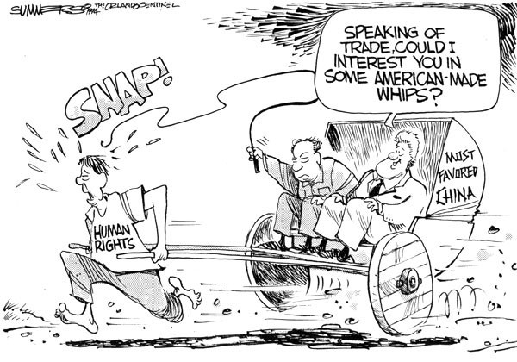
North Atlantic Free Trade Agreement (NAFTA):
- Clinton pushed the North American Free Trade Agreement (NAFTA) through Congress
- First proposed during the Bush Administration, it created a trade association between the U.S., Canada, and Mexico
- NAFTA is a free trade association and has eliminated most tariffs and other trade barriers on products and services passing between the United States, Canada, and Mexico
The 2000 Presidential Election:
- Proved the closest in U.S. history
- On election night it was clear that Al Gore had carried the Northeast (except New Hampshire) and Pacific Coast and scattered states in the Midwest.
- He was ahead in the popular and electoral votes, but three states were too close to call – Oregon, New Mexico, and Florida
- George W. Bush had won the entire South and many states in the Mountain West and the large states of Missouri, Ohio, and Indiana
- Finally, the election depended on who carried Florida and its 25 electoral votes
- On November 8, Bush led in Florida by 1,784 votes
- However, a recount of machine-cast votes cut the lead to 327
- There appeared to be some irregularities in ballot design and punching of ballots
- The two candidates then resorted to lawsuits to seek recounts or to block them as seemed best for their side
- The Florida Supreme Court became involved
- Finally, the U.S. Supreme Court took the case on December 12 voted 5 – 4 in Bush v. Gore to end the Florida recount
- In effect, this gave Florida’s electoral votes to Bush, for a total of 271 to Gore’s 266
- Thus, Bush was elected president although Gore had won the popular vote
President George W. Bush:
- As President, George W. Bush pushed through tax cuts to stimulate the economy
- He also introduced the No Child Left Behind Act, requiring states to test students in both English and mathematics
- However, the most dramatic event of Bush’s presidency occurred on September 11, 2001 when terrorists from the radical Islamic al-Qaeda network hijacked U.S. airliners and crashed them into the Pentagon and the World Trade Center
- About three thousand people were killed
- Bush immediately declared a “War on Terrorism”
- Federal agents replaced private security agents at U.S. airports and the Office of Homeland Security was created
- When the Taliban government of Afghanistan refused to hand over al-Qaeda’s leader, Osama bin Laden, the U.S. invaded Afghanistan
- Bush and other world leaders also insisted that Saddam Hussein of Iraq prove he had no biological, chemical, or nuclear weapons of mass destruction (WMD)
- Iraq repeatedly denied it had any such weapons
- In March 2003, President Bush issued an ultimatum, giving Hussein 48 hours to resign and leave Iraq
- When Hussein refused, the U.S., Great Britain, and their allies attacked
- U.S. forces entered Baghdad and Hussein’s regime collapsed
- Hussein was captured in December 2003, brought to trial, and executed
- Despite these successes, Iraq’s occupation proved difficult
- Meanwhile, religious and ethnic rivalries continue to divide Iraq
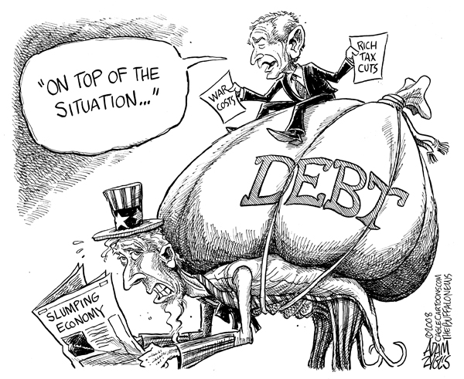
President Barack Obama:
- The inauguration of Barack Obama as the 44th president of the United States was of great significance in American history – President Obama was the first African-American president in the nation’s history
- President Obama has had to address economic and domestic concerns
- He has also reformed health care
- On March 23, 2010, President Obama signed the Affordable Care Act
- The law put in place comprehensive health insurance reforms
- In 2009, President Obama was awarded the Nobel Peace Prize “for his extraordinary efforts to strengthen international diplomacy and cooperation between peoples”
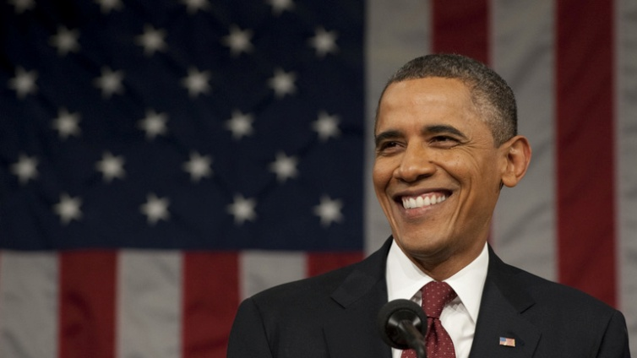
Environmental Issues:
- The United States, like all nations, has faced environmental problems
- Global warming – some pollutants in the atmosphere prevent heat from escaping into space and this greenhouse effect may permanently raise temperatures enough to cause farmland to become desert, or polar ices to melt, raising ocean levels
- Acid rain – when coal and oil are burned, they emit pollutants into the atmosphere and many pollutants released by industry and automobile exhaust turn into acids, which get washed out of the air when it rains only to return to the ground in a highly toxic form killing fish and destroying forests
- Thinning of the ozone layer – the ozone layer absorbs dangerous ultraviolent radiation from the sun, which would otherwise cause skin cancer and other diseases and the ozone layer had been rapidly eroded by widespread fluorocarbon use
- Water pollution – as cities become more crowded their ability to handle increased sewage and water is strained thus leading to the dumping of raw sewage into nearby lakes and rivers, contaminating drinking water
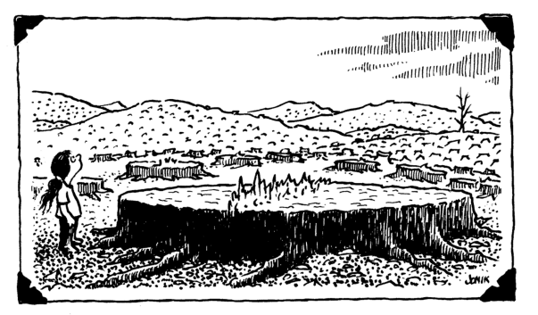
Rachel Carson:
- Americans became more aware of environmental problems when Rachel Carson wrote Silent Spring in 1962
- Ms. Carson’s book called attention to the use of pesticides in agriculture and the damage they had done
- Her book was a stimulus to the growth of environmental awareness
The Aging Baby Boom Generation:
- Medical advances have increased the number of people who live into their 70s and 80s
- As the “baby boomers” (those born between 1945 and 1965) begin to retire, there is concern that the Social Security system will not have enough money to fund their retirements
Post-Industrial Society:
- The United States began as an agricultural nation and then evolved to an industrial power
- In the last fifty years, however, the nation has been shifting from an industrial economy to a “post-industrial” or service economy
- Americans are now more likely to work as salespeople, computer programmers, bank tellers or teachers than as factory workers
- Much of the increased productivity of the economy in the 1990s was due to computers
- The Internet, a worldwide linking of computers, makes it easier to communicate and find information
Television:
- The most significant developments in American culture in the immediate postwar years resulted from the growth of the television industry
- Television provided shared experiences but can also reinforce conformity
The Environmental Movement:
- The Environmental Movement in the United States has had a long history
- It began as a conservation movement at the start of the 20th century and was led by people like John Muir who founded the Sierra Club as an environmental group in 1897 and President Theodore Roosevelt who established the first national parks
- Over the years it has included diverse groups who have focused on issues from saving the rain forests to the clean-up of toxic waste dumps
- After WWII, the focus was on restoring and maintaining a clean environment
- Groups as diverse as the World Wildlife Fund and Greenpeace were formed to call attention to various aspects of environmental concerns
- Rachel Carson in Silent Spring (1962) called attention to the use of pesticides in agriculture and the damage they had done
- It was a stimulus to the growth of environmental awareness
- In 1970 the first Earth Day was organized to draw attention to the environment
