Name _________________________________________ Date ____________
Geometry – Pd __ Constructions

Constructions Day 3

Recall: An ______________________ is a line segment with one endpoint on any vertex of a triangle that extends to the opposite side of the triangle and bisects the angle. Since there are three vertices in every triangle, there are ___________ angle bisectors of a triangle. The point of concurrency of the angle bisectors of a triangle is known as the ______________ of a triangle. To construct the incenter of a given triangle construct the angle bisector on ________
_______________________ vertices. The incenter will always be located ______________ a given triangle. The point of concurrency (the incenter) is the center of the circle that is inscribed within a given triangle.
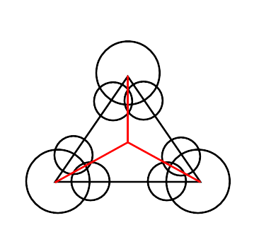
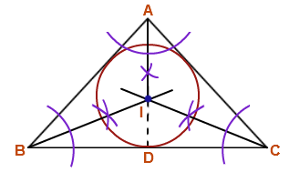
The Incenter Regents Common Core

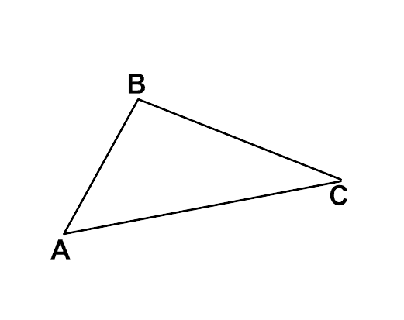
1) Using a compass and a straightedge, construct the incenter of $∆ABC$.

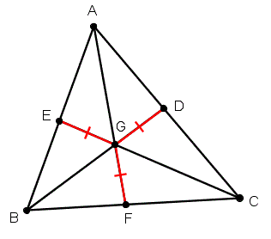
The Incenter:
- The incenter is formed by connecting the three angle bisectors
- The three angle bisectors of a triangle are concurrent at a point
equidistant from the sides of a triangle.

Directions: Using the above information, complete the following questions. Don’t forget justifications.
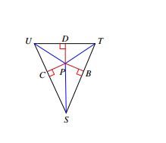
1) The incenter of $∆TUS$ is located at point P. If CP = 4x + 9 and PB = 6x – 11, find the value of x and
the length of CP and PD. Justify all calculations.

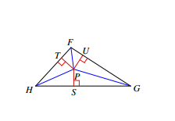
2) Point P is the incenter of $∆FGH$. If m<TFP = 3x + 15, and m<UFP = 5x – 13, find the value of x.
Justify all calculations.

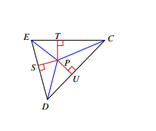
3) The incenter of $∆CDE$ is point P. If m<SDP = 7x + 5 and m<UDP = 9x – 5, find the value of x
and m<SDP. Justify all calculations.

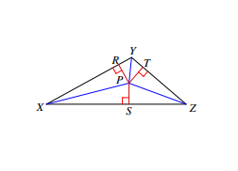
4) P is the incenter of $∆XYZ$. If m<SZP = 7x + 7, and m<SZT = 16x + 4, find the value of x and m<SZT.
Justify all calculations.

Name _________________________________________ Date ____________
Geometry – Pd __ Constructions

Constructions Day 3 HW
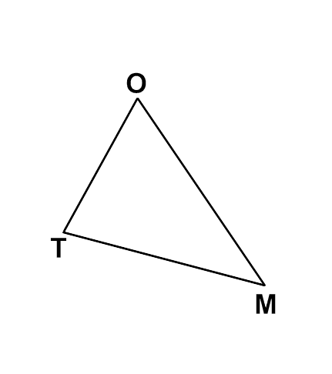
1) Construct the incenter of $∆TOM$. 2) Construct an equilateral triangle to DE.

_____ 3) P is the incenter of $∆XYZ$. If m<RYP = 2x + 20, and m<TYP = x + 40,
what is the m<RYT?
(1) 20 (2) 40
(3) 60 (4) 120

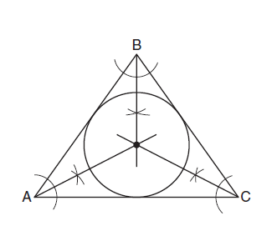
_____ 4) Which geometric principle is used in the construction shown below?
(1) The intersection of the angle bisectors of a triangle is the
center of the inscribed circle.
(2) The intersection of the angle bisectors of a triangle is the
center of the circumscribed circle.
(3) The intersection of the perpendicular bisectors of the sides
of a triangle is the center of the inscribed circle.
(4) The intersection of the perpendicular bisectors of the sides
of a triangle is the center of the circumscribed circle.

_____ 5) The incenter of $∆ABC$ is located at point G. If EG = 3x + 14 and
DG = 5x – 8, what is the length of GF?
(1) 5 (2) 11
(3) 22 (4) 47

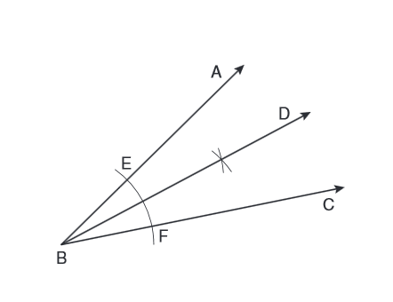
_____ 6) A straight edge and compass were used to create the following construction.
Which statement is false?
(1) $m<ABD=m<DBC$
(2) $\frac{1}{2}\left(m<ABC\right)=m<ABD$
(3) $2\left(m<DBC\right)=m<ABC$
(4) $2\left(m<ABC\right)=m<CBD$

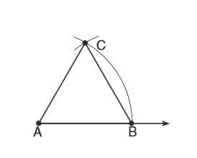
_____ 7) The diagram shows the construction of an equilateral triangle.
Which statement justifies this construction?
(1) $<A + <B + <C=180$
(2) $<A= <B= <C$
(3) $AB=BC=AC$
(4) $AB+BC>AC$

Review Section!!

_____ 8) What is the slope of a line perpendicular to the line whose equation is $3x-7y+14=0?$
(1) $\frac{3}{7}$ (2) $-\frac{7}{3}$
(3) 3 (4) $-\frac{1}{3}$

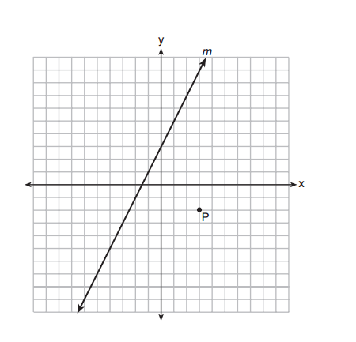
_____ 9) Line m and point P are shown in the graph. Which equation represents
the line passing through P and parallel to line m?
(1) $y-3=2\left(x+2\right)$
(2) $y+2=2\left(x-3\right)$
(3) $y-3= -\frac{1}{2}\left(x+2\right)$
(4) $y+2= -\frac{1}{2}\left(x-3\right)$

_____ 10) In $∆ABC$, m<A = 3x + 1, m<B = 4x – 17, and m<C = 5x – 20. Which type of triangle is $∆ABC?$
(1) right (2) scalene
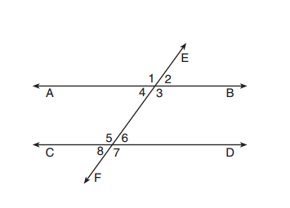
(3) isosceles (4) equilateral

_____ 11) Transversal EF intersects AB and CD as shown. Which statement
could always be used to prove AB // CD?
(1) $<2≅<4$ (2) $<3$and $<6$ are supplementary
(3) $<7≅<8$ (4) $<1$and $<5$ are supplementary

Constructions Day 3 HW

1) 2)

3) (4) 4) (1) 5) (4) 6) (4) 7) (3)
8) (2) 9) (2) 10) (3) 11) (2)

8) What is the slope of a line perpendicular to the line whose equation is $3x-7y+14=0?$

9) Line m and point P are shown in the graph. Which equation represents
the line passing through P and parallel to line m?

10) In $∆ABC$, m<A = 3x + 1, m<B = 4x – 17, and m<C = 5x – 20. Which type of triangle is $∆ABC?$

11) Transversal EF intersects AB and CD as shown. Which statement
could always be used to prove AB // CD?
(1) $<2≅<4$ (2) $<3$and $<6$ are supplementary
(3) $<7≅<8$ (4) $<1$and $<5$ are supplementary

