CAUSES OF THE AMERICAN REVOLUTION DOCUMENT PACKET

Directions - Answer the following questions on looseleaf based on what you read and the information provided by the documents.

Document 1

STAMP ACT, 1765
“No Taxation without Representation”
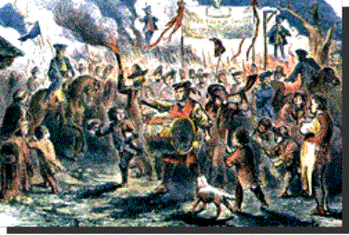  Protest against the Stamp Act  The sign in the background reads:  "The Folly of England and the Ruin of America" | 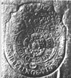  five shillings  A tax stamp placed on certain items showed that colonists had paid taxes on them.
Historical Background:
In 1765, upon George Grenville’s recommendation, the British Parliament enacted the Stamp Act as a means of raising colonial tax revenues to help pay the cost of the French and Indian War in North America. It was the first direct tax imposed by Britain on its American colonies. This law placed a tax on newspapers, almanacs, pamphlets, playing cards and legal documents.
The Colonists reacted immediately, asserting that the Stamp Act was an attempt to raise money in the colonies without the approval of colonial legislatures. Patrick Henry in the Virginia House of Burgesses stated, “No taxation without representation”. This became the slogan of the day. Patriotic societies, known as the Sons of Liberty”, were formed to organize resistance to the tax. Resistance to the act was demonstrated through debates in the colonial legislatures, written documents (including legislative resolves, prints, and songs), and mob/crowd actions such as tarring and feathering tax collectors. Merchants pledged to halt the import of British goods, and the people vowed to stop buying English products until the tax was repealed.
- What are the people protesting?
- Who do the dolls hanging from the trees represent?
- How did the colonists protest the tax?
4. What does the sign "The Folly of England and the Ruin of America" mean?
5. What is meant by “NO taxation without representation”?

Document 2

BOSTON MASSACRE, 1770
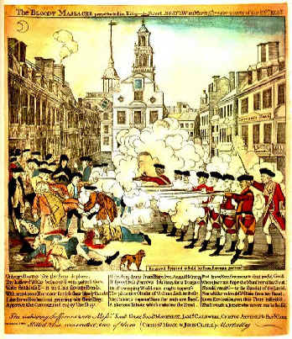 | Paul Revere’s print of "The Bloody Massacre perpetrated in King Street" in Boston, March 5, 1770. Three weeks after the occurrence, Revere was advertising his prints for sale in Boston's newspapers. Revere's historic engraving is long on political propaganda and short on accuracy. Patriotic propaganda like this called the incident a massacre to stir up feelings against the British government.
Historical Background:
The people of Boston threatened and harmed British customs officials trying to collect taxes. So, the British quartered troops in Boston to protect their officials (Quartering Act). In Boston, as elsewhere, there was bitter feeling between the colonists and the redcoats, the British troops. On one occasion, a riotous crowd of Bostonians shouted insults and threw snowballs at a detachment of soldiers. The redcoats fired into the mob, killing five townspeople and wounding six others. The angry citizens, led by Samuel Adams, demanded the removal of the British troops. To prevent an uprising, the governor withdrew the soldiers from the city. News of the massacre spread throughout the colonies and aroused hatred everywhere.
- What does "propaganda" mean?
- How did Paul Revere stir up anti-British sentiment among his fellow colonists?
- Why isn’t this a true depiction of what happened?
- Why did Revere misrepresent what happened?
- Why is this considered a milestone in America's road to independence?

Document 2
BOSTON TEA PARTY, 1773
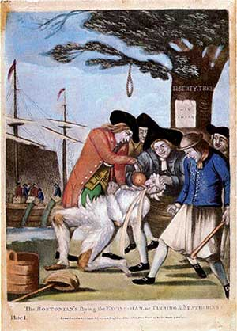 | Detail of The Bostonians Paying the Excise (tax) Man (1774), a color engraving by an unknown artist; John Carter Brown Library at Brown University, Providence, RI. The sign on the Liberty Tree is upside down and reads "Stamp Act". The pot has the word "TEA" printed on it.
Historical Background:
The British East India Company was in financial distress, partly as a result of the colonial boycott of English tea. To save the company from ruin, Parliament passed the Tea Act, which allowed the company to ship tea to America without paying the existing heavy duty in England. This allowed the company to sell the tea more cheaply than the colonial importers of English tea as well as the smugglers of foreign tea. This would ruin many American tea merchants.
In many American ports, the colonist boycotted the tea. It was either sent back to England, or locked up in warehouses and left to rot. In Boston, with the encouragement of The Sons of Liberty, the citizens refused to permit the unloading of three tea ships. During the night of December 16, 1773, the Boston Tea Party took place. Bostonians disguised as Indians boarded the ships and dumped 342 chests (worth $75,000) into the harbor.

- What does “boycott” mean?
- What event is taking place on the ships in the background? 13.
- Why are they doing this?
- Who is being tarred and feathered?
- What are they pouring into his mouth?
- Who are the people committing the act?
- What does “Liberty Tree” mean?
- Who do they want liberty from?
- Why is the "Stamp Act" turned upside down on the tree?

This journal entry was written by a participant in the Boston Tea Party.

It was now evening, and I immediately dressed myself in the costume of an Indian, equipped with a small hatchet…with which, and a club, after having painted my face and hands with coal dust in the shop of a blacksmith, I repaired [went] to Griffin’s Wharf, where the ships lay that contained the tea…I fell in with many who were dressed, equipped and painted as I was, and who fell in with me and marched in order to the place of our destination… We then were ordered by our commander to open the hatches and take out all the chests of tea and throw them overboard, and we immediately proceeded to execute [follow] his orders, first cutting and splitting the chests with our tomahawks, so as to thoroughly expose them to the effects of the water.

-George Hewes, a participant in the
Boston Tea Party

- What did the commander order the men to do?
- Were the men successful in destroying the tea?

Document 3

DATE | ACT | DESCRIPTION | COLONISTS’  RESPONSE
1764 | Sugar Act | Increased tax on imported goods from countries other than Great Britain | Protests – claimed it was taxation without representation
1764 | Currency Act | Prevented the colonies from printing their own money | Protests
1765 | Quartering Act | Required colonists to open their homes and provide supplies for British soldiers | Formed organized protests –  Created the Sons of Liberty
1767 | Townshend Act | Tax on glass, lead, paint, paper, and tea | Tried to discourage the buying of British products
1773 | Tea Act | Reduced tax on tea to encourage the colonists to buy British tea | Felt this was an unfair tax and it led to the Boston Tea Party
1774 | Intolerable Act | Closed Boston Harbor to all ships- supplies could not be loaded or unloaded | Formed 1st Continental Congress to discuss how to deal with Britain’s laws in the colonies

- Name and describe two of the acts that Great Britain forced on the colonists and their response to it.

Document 4

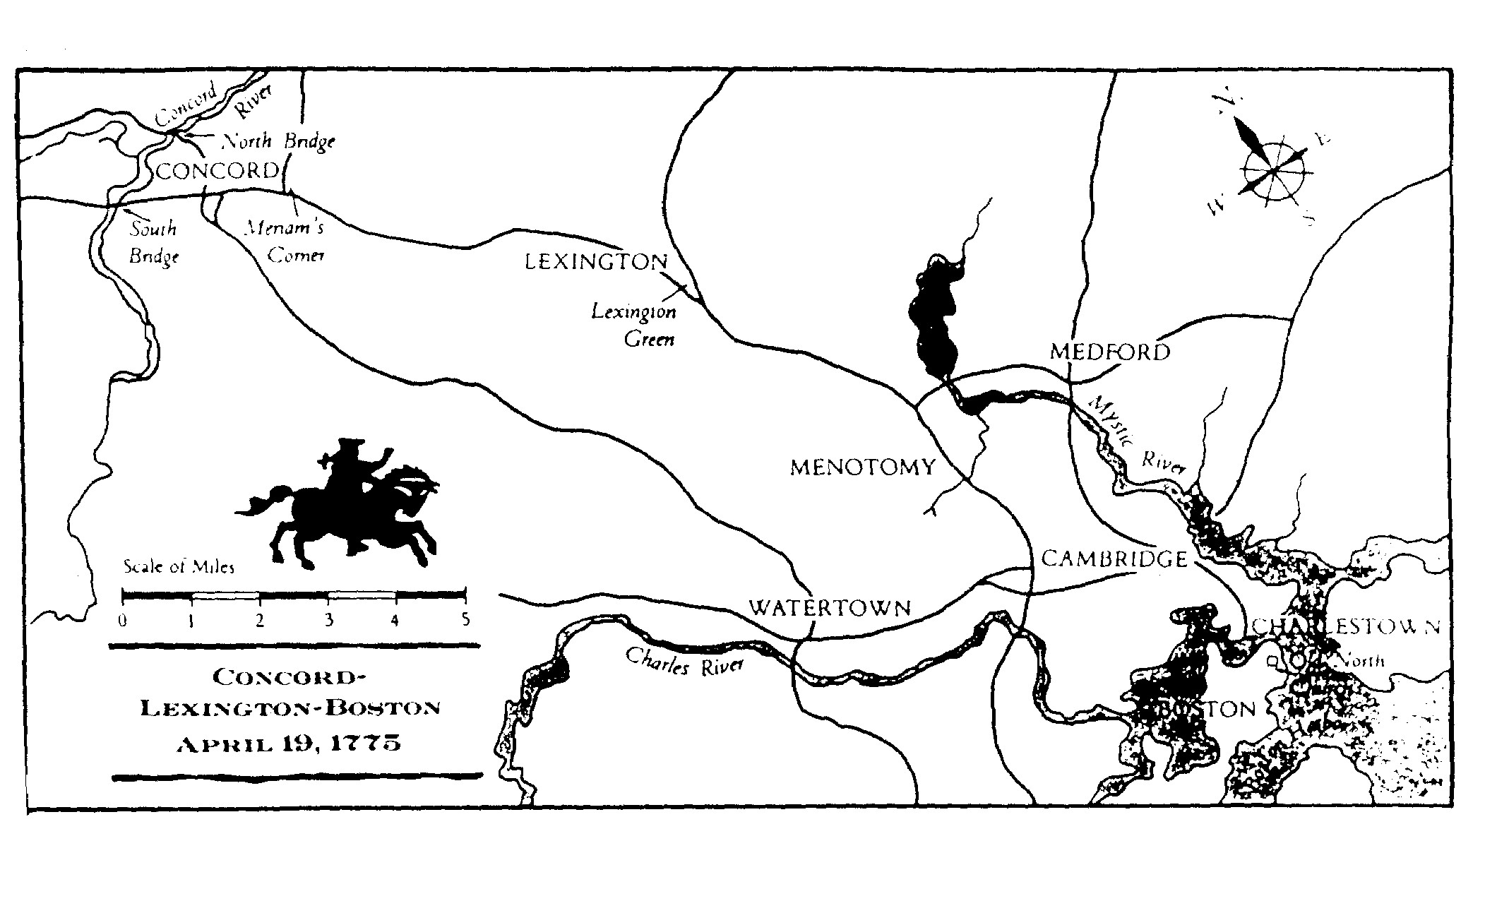
The British were to march to Lexington to arrest Patriot leaders John Hancock and Samuel Adams who were staying there. Then they were to go on to Concord to seize [take by force] the Americans’ weapons. Paul Revere and William Dawes, two of the best express riders, had to get a warning through the circle of British roadblocks around Boston. Due to their quick actions, the colonists were waiting for the British to arrive in Lexington and Concord. This showed the British that the colonists were willing to stand up for their rights.
Bliven, Bruce, The American Revolution, Random House, NY, 1958.
Johnson, Neil, The Battle of Lexington and Concord, Four Winds Press, NY, 1992.

- Why was it important for Revere and Dawes to warn the colonists?
- Were Revere and Dawes successful in warning the colonists?
- What proof in the document supports your answer?

THE SHOT HEARD ROUND THE WORLD  APRIL 19,1775 | 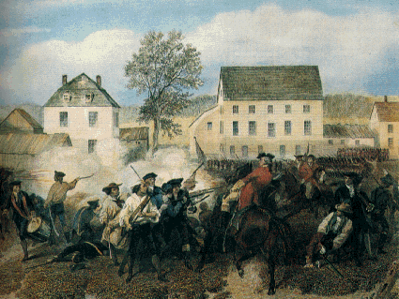  Battle of Lexington
Historical Background:
Anticipating war, the citizens of Massachusetts began to organize themselves into an army, or militia. They called themselves the Minutemen, since they stood ready for action at a minute’s notice. General Gage, the British military governor of Massachusetts, sent troops to capture the rebel ringleaders, John Hancock and Samuel Adams, who were rumored to be in Lexington, and seize the stores of ammunition and weapons hidden in Concord.
The colonials, however, learned of Gage’s plans. Two Patriots, Paul Revere and William Dawes, rode through the night and warned the countryside of the oncoming British. ( Paul Revere’s Ride by Henry Wadsworth Longfellow ) When the British troops arrived at Lexington, the local Minutemen met them. In an exchange of shots, 18 colonials were killed or wounded. The British proceed to Concord, and another skirmish took place. As the English marched back to their base in Boston, the aroused colonials, hiding behind houses, trees, and stone walls, poured a steady fire into the redcoats. Almost 4,000 Americans participated in the action of the day. The British suffered 273 casualties, the colonials 93.
In March 1775, just before the outbreak of hostilities in Massachusetts, Patrick Henry delivered a speech urging that Virginia prepare for war with England. He closed with,
“Is life so dear, or peace so sweet, as to be purchased at the price of chains and slavery? Forbid it, Almighty God! I know not what course others may take; but as for me, give me liberty, or give me death!"
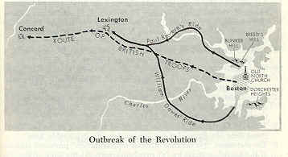  Outbreak of the Revolution | 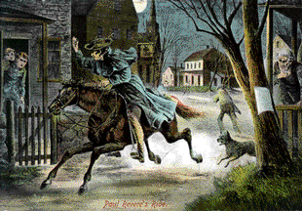  Paul Revere's Ride, 1775

26. Who were the Minutemen and how did they get that name?

27. Where were the first shots fired that began the American Revolution?
28. Why did the British send troops to Lexington and Concord, Massachusetts?
29. Why did the British lose so many more men than the Americans?
30. What did Patrick Henry mean when he said, "give me liberty, or give me death!" ?

