History of Music, Mr. Robert L. Johnston

The 16th Century (Day 3)

Aim:

Who was Claudio Monteverdi, and what contributions did he make to the development of Western Music?

Instructional Objectives:

At the conclusion of this unit, students will:

- Have met Claudio Monteverdi, and become more familiar with the Venetian School.
- Have had a basic introduction to opera.
- Have heard a strong representation of Monteverdi’s music.

Motivation:

Play Claudio Monteverdi’s Introductio: Domine ad adiuvandum me festina Deus in adiutorium” from the Vespreo della Beata Vergine, 1610 (2:06)

Development/Procedures:

- Biographical
  - Was born in Cremona in 1567
  - Started publishing music at age 16
  - Married in 1599, but his wife died in 1607
  - Served at the Court of the Duke of Mantua until 1610
  - In 1610, he became maestro di cappella at St. Mark’s in Venice
    - Remained in that position until his death
    - Was so highly regarded, that his salary rose from 300 ducats to 500 in his first three years
  - Ordained a priest in 1633
  - Looked like…

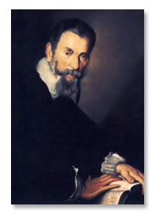
http://www.naxos.com/composerinfo/bio24641.htm


http://www.naxos.com/composerinfo/bio24641.htm

- Musical output
  - Wrote ten books of madrigals
    - The Harvard Brief Dictionary of Music defines the madrigal as, “based on love lyrics having no set form and is composed in four or, more often, five voices in an imitative style. The immediate ancestor of the 16th century madrigal is the frotolla.”
    - Wikipedia cites that it bloomed in the second half of the 16th century
    - The first book of madrigals was published in Venice in 1533
    - Often used madigalisms, or word painting
      - The music would purposely imitate the text
  - Wrote in other forms as well
    - Choral compositions
    - Operas
    - Cantatas
    - Ballets
    - Most of these are lost
  - Composed in the “second practice,” or “seconda practica”
    - The first practice was stricter for sacred works
    - The second practice was more expressive
  - Play the five vv madrigal, Cruda Amarilli (2:58)
  - The hallmark of Monteverdi’s legacy though is opera
    - Many musicologists consider Monteverdi’s L’Orfeo (1607), as the first legitimate opera
      - Based on the Greek myth of Orpheus
      - Text by Alessandro Striggio
      - Published in Venice in 1609
        - Frontispiece of L'Orfeo, 1609 Venice edition

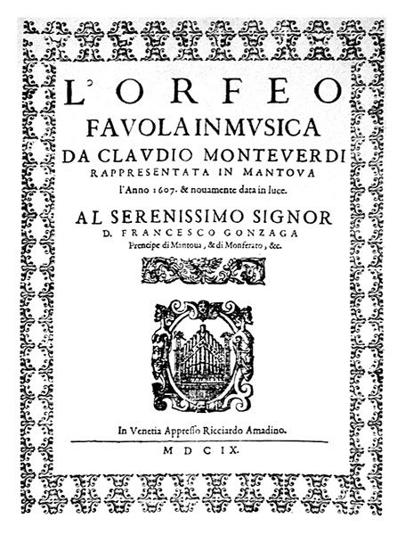
http://en.wikipedia.org/wiki/Image:Frontispiece_of_L%27Orfeo.jpg

      - Monteverdi listed specific instruments in the score, much like we have seen the Gabrielis start to do
        - 2 harpsichords
        - 2 large bass viols
        - 10 arm viols
        - 1 double harp
        - 2 French violins
        - 2 chitarones
        - 2 wooden-piped organs
        - 3 viole da gamba
        - 4 trombones
        - 1 regal (organ stop)
        - 2 cornetts
        - 1 small recorder
        - 1 clarino trumpet with 3 muted trumpets
      - This is considered pre-Baroque in style
      - Was premiered in a room in the ducal palace
      - Play excerpts from The Norton Anthology
        - Prologue and Act II excerpts (13:41)

Materials of Instruction:

Smart Board

Various Recordings

Summary:

Assignment:

Read the Monteverdi chapter in Bach, Beethoven and the Boys.

Bibliography:

Vespreo della Beata Vergine, 1610, Concentus musicus Wien, Nicholas Harnoncourt, Teldec, (p) & (c) 1987

http://www.naxos.com/composerinfo/bio24641.htm

http://www.newadvent.org/cathen/10538a.htm

http://en.wikipedia.org/wiki/Claudio_Monteverdi

http://en.wikipedia.org/wiki/Madrigal_%28music%29

http://concise.britannica.com/ebc/article-9372530/Claudio-Monteverdi

http://en.wikipedia.org/wiki/L'Orfeo

Norton Anthology Of Western Music, Vol. 1 (Disc 4), (c) W.W. Norton & Co., Inc. (p) 1988 Sony Special Music Products

Norton Anthology Of Western Music, Vol. 1 (Disc 5), (c) W.W. Norton & Co., Inc. (p) 1988 Sony Special Music Products

Suggested Reference:

History of Music, Hugh H. Miller, Barnes & Noble Books, New York. 1972

Vidal in Venice, Gore Vidal, Summit Books, New York. 1987

Robert L. Johnston

