Name: ____________________________________ Block: ______ Date: ________________

Virtual Scientific Method Lab: What Makes a Cricket Chirp?
Question: Some say that if you listen to the sound of a cricket chirping, you can determine the temperature. Is this true or is it just an urban legend? Do any other factors affect how fast a cricket will chirp, such as humidity, wind, atmospheric pressure, or nearby crickets?
Procedure: You will use a virtual lab to test a cricket subject.
Log on to:
http://www.gc.maricopa.edu/biology/glacier/scientific_method/index.swf

Materials:
Virtual Lab Handout
Computer with Internet Access
Procedure:
- Do the tutorial on scientific method first if you want to review the steps.
- Follow the instructions for investigating the role of environmental variables on cricket chirps. For your investigation, choose values that are high and low to get a wide range of data.
- Enter your results in the data charts provided. You need to record on your paper as you go because this website does not work well if you use the back button!
- Graph your results by hand using the blank graphs you insert below each data table.
- Discuss the results of your experiment including whether or not your data supported your hypothesis, any sources of error, and suggestions for improvements to the experimental design.
***Directions for how to use the website are on the last page of this packet.***

Write a hypothesis for your experiment (which factor increases cricket chirping) in the “If…then” format.

____________________________________________________________________________

Identify the independent variables in your different experiments: _________________________

____________________________________________________________________________

Identify the dependent variable in all of your experiments: ______________________________
Since you are not necessary a cricket expert, you will have to do some exploration by running different tests on different factors that could affect cricket chirping. Record your data in the tables on the following page.

Why is it important to test only one variable at a time? _________________________________

____________________________________________________________________________

____________________________________________________________________________

Data Tables:

Effect of Wind Speed on Cricket Chirp Rate
Wind Speed  (m/sec) | Chirp Rate (chirps/min)
Effect of Nearby Crickets on Cricket Chirp Rate
Wind Speed  (m/sec) | Chirp Rate (chirps/min)

Effect of Temperature on Cricket Chirp Rate
Temperature  (celcius) | Chirp Rate (chirps/min)
Effect of Atmospheric on Cricket Chirp Rate
Pressure (mm Hg) | Chirp Rate (chirps/min)

Effect of Humidity on Cricket Chirp Rate
Humidity  (%) | Chirp Rate (chirps/min)

Graph the results of your experiments on the following page. Make sure each graph has a title, labeled axes, and correct units.

Discussion:
Discuss the results of your experiment including 1) whether or not your data supported your hypothesis, 2) any sources of error, and 3) suggestions for improvements to the experimental design.

____________________________________________________________________________

____________________________________________________________________________

____________________________________________________________________________

____________________________________________________________________________

____________________________________________________________________________

____________________________________________________________________________

____________________________________________________________________________

____________________________________________________________________________

____________________________________________________________________________

____________________________________________________________________________

____________________________________________________________________________

____________________________________________________________________________

____________________________________________________________________________

____________________________________________________________________________

____________________________________________________________________________

____________________________________________________________________________

____________________________________________________________________________

____________________________________________________________________________

____________________________________________________________________________

____________________________________________________________________________

____________________________________________________________________________

____________________________________________________________________________

____________________________________________________________________________

____________________________________________________________________________How to Use the Scientific Method OnLine Lab

This is a two part website: the first part is a tutorial on the scientific method. The second part is a simulation of an experiment on crickets. You will actually get to design your experiment and collect data. You will want to have a pencil and paper ready to record data and where you can write down your results. You will get an opportunity to test several different variables and determine if they affect how fast or slow a cricket chirps.
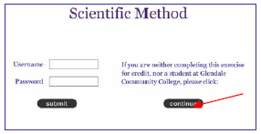
You will see the screen to the right when you log on. You DO NOT need to log in with a user name or password, just click on the continue button to get to the next page.

The next page has a place where you can input your name.
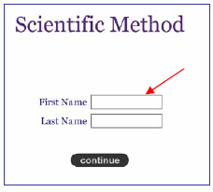
Do so, click continue, and then you will get the actual start page, where you can follow the instructions for the tutorial and for the cricket experiment.

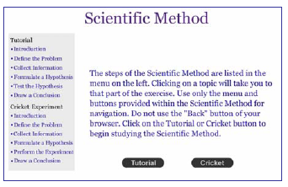
Do the tutorial first (if you think you might need to) and then the Cricket Experiment.

