Girls Conditioning
Name:___________________

Class:______________

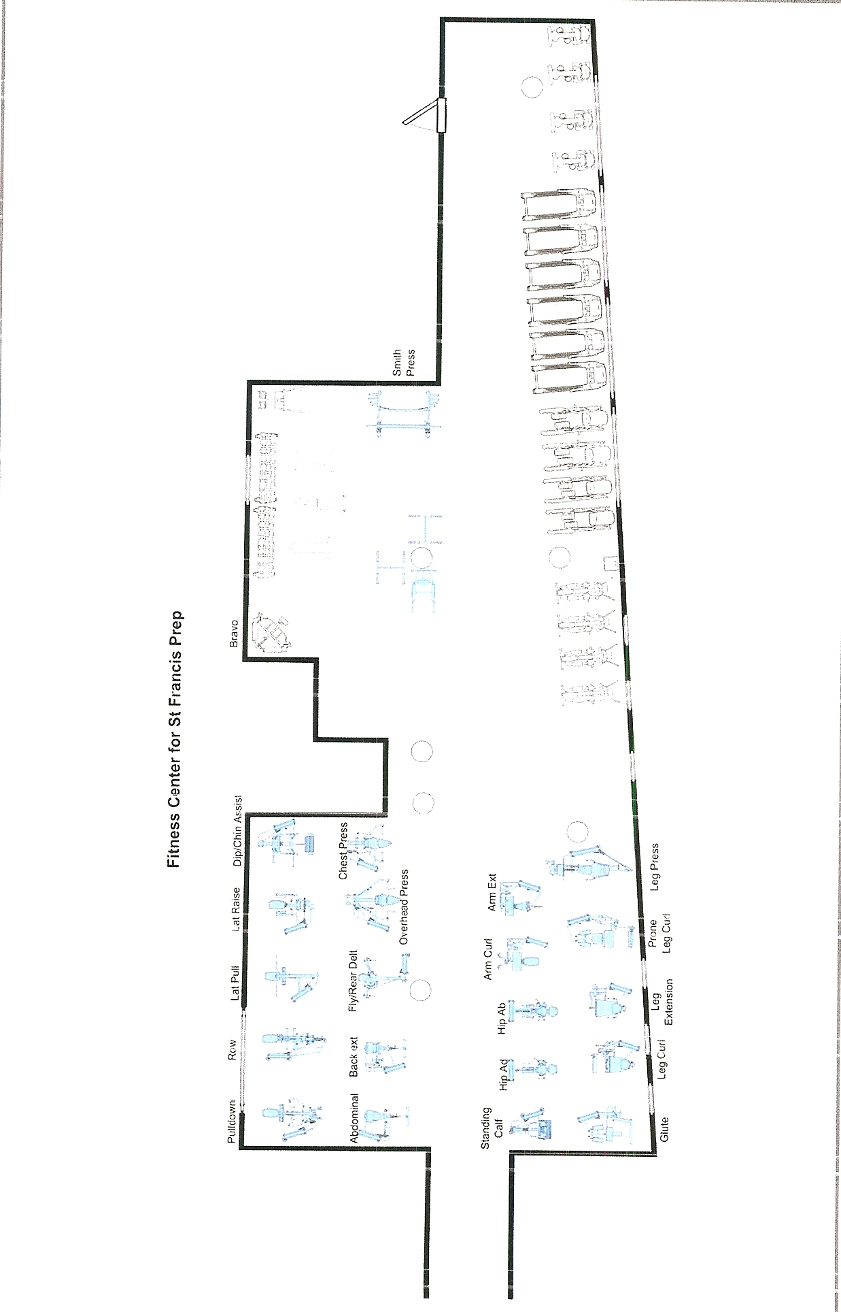

Cardio Equipment

- Upright Bike - Heart
- Treadmill - Heart
- Total Body Arc Trainer/Lower Body Arc Trainer - Heart
- Elliptical Trainer - Heart

Cybex Strength Equipment

- Abdominal – Rectus Abdominus
- Arm Curl – Biceps Brachii
- Arm Extension – Triceps
- Back Extension – Erector Spines, Deep Spinae Extensors
- Chest Press - Pectoralis Major, Anterior Deltoid, Triceps
- Dip/Chin Assist – Pectoralis, Anterior Deltoid, Triceps/Latissimus Dorsi, Teres Major, Biceps, Lower Trapezius, Rhomboid
- Glute – Gluteus Maximus, Hamstrings, Quadriceps
- Hip Abduction – Gluteus Medius, Gluteus Maximus, Piriformis, Tensor Fasciae Latae
- Hip Adduction – Adductor Magnus, Adductor Longus, Adductor Brevis, Pentineus
- Lat Pulldown - Latissimus Dorsi, Teres Major, Biceps, Lower Trapezius, Rhomboid
- Lateral Raise - Deltoids
- Leg Extension - Quadriceps
- Leg Press – Quadriceps, Gluteus Maximus, Hamstrings
- Overhead (Shoulder) Press – Anterior Deltoid, Middle Deltoid, Triceps
- Pec Fly/Rear Delt – Pectoralis Major, Anterior Deltoid, Biceps/Posterior Deltoid, Rhomboid, Triceps, Lower Trapezius
- Prone Leg Curl - Hamstrings
- Pulldown – Latissimus Dorsi, Teres Major, Biceps, Lower Trapezius, Rhomboid
- Row - Latissimus Dorsi, Teres Major, Biceps, Middle Trapezius, Rhomboid
- Seated Leg Curl - Hamstrings
- Standing Calf – Gastrocnemius, Soleus

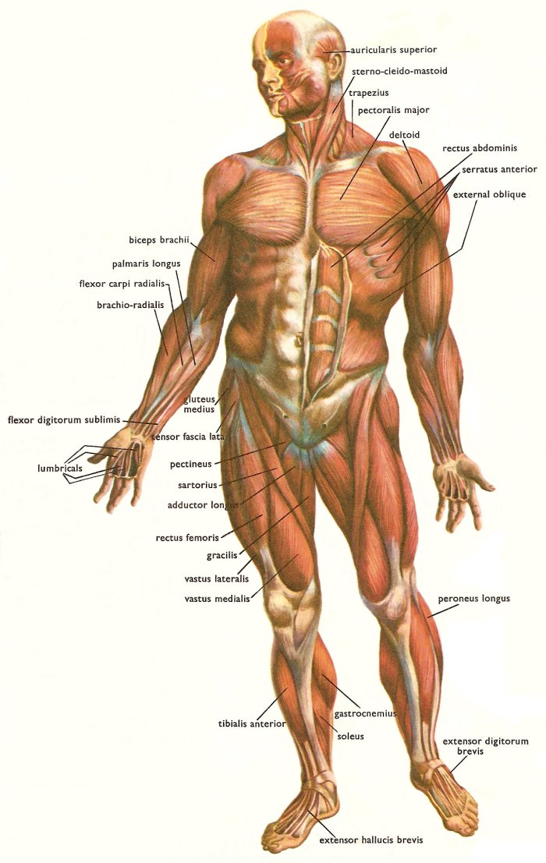
Front
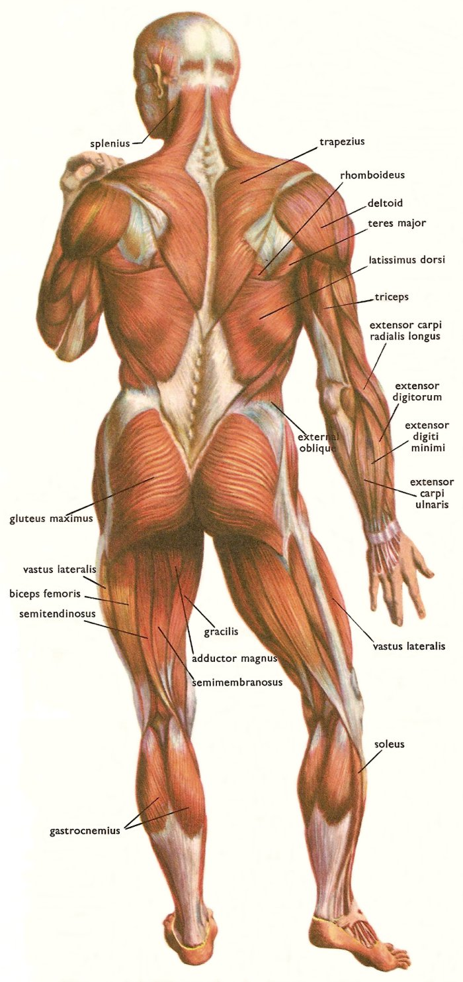
Back

- Weight Training/Strength Training:
  - The use of dumbbells, barbells, machines, and other equipment for the purpose of improving fitness, appearance, and/or sports performance
  - Strength is the ability to exert maximum force in a single effort
  - Muscular endurance is the ability of the muscle to contract for an extended period of time without undue fatigue
- Benefits – Improved:
  - Health
  - Self-image
  - Performance
  - Appearance
- Things that will impact your results
  - Training habits
  - Level of strength when you begin
  - Intensity of your training program (loads, reps, sets, rest)
  - Length of program (weeks, months, years)
  - Genetic potential
  - Gender
    - Men are typically stronger, quality of the muscle isn’t different but the quantity is the reason
    - Average male has 40%/female 23%
- Types of Muscle:
  - Smooth Muscle Tissue – muscle tissue found in the walls of many visceral organs, characterized as nonstriated, involuntary muscle
  - Cardiac Muscle - is a type of involuntary striated muscle found in the walls and histologic foundation of the heart, specifically the myocardium.
  - Skeletal Muscle - is a form of striated muscle tissue, it is voluntarily controlled. Skeletal muscle is made up of individual components known as muscle fibers. The muscle fibers are long, cylindrical, multinucleated cells composed of myofibrils.
- Muscle action:
  - Isometric Muscle Action – tension develops but no observable shortening or lengthening of the muscle occurs
  - Concentric Muscle Action – Tension develops and muscle shortens
  - Eccentric Muscle Action – Tension is present and muscle lengthens
- How and what muscles get involved depends on:
  - Exercise that is selected
  - Techniques used during exercise
  - Width of grip
  - Stance
  - Angle and path that an implement is pushed or pulled
- When to expect strength change:
  - About the 3rd or 4th week
- Overtraining
  - Is a condition in which there is a plateau or drop in performance
  - This occurs when the body doesn’t have adequate time to recuperate from training before the next workout
    - Overtraining Warning Signs:
  - Extreme muscular soreness and stiffness the day after training sessions
  - A gradual increase in muscular soreness from one session to the next
  - An inability to complete a training session, based upon your present physical condition, that is reasonable
  - A decrease in appetite

Full Body Workout

3 Days a Week |  | Every Other Day
- Sunday -  - Monday - REST  - Tuesday -  - Wednesday REST  - Thursday  - Friday - REST  - Saturday – REST  = Workout |  | - Sunday -  - Monday - REST  - Tuesday -  - Wednesday - REST  - Thursday -  - Friday - REST  - Saturday - REST  REST = DAY OFF
Split & Workout Examples
Legs, Torso, Arms | Legs, Pull, Push | Alternating Push / Pull | Alternating Upper / Lower
- Back, Chest, Arms,Legs  - Back  - Deltoid (Middle)  - Chest  - Deltoid (Anterior)  - Biceps  - Triceps  - Quadriceps  - Hamstrings  - Calves  - Abdominal  - Chest, Back, Arms, Legs  - Chest  - Deltoid (Anterior or Middle)  - Back  - Deltoid (Middle)  - Triceps  - Biceps  - Quadriceps  - Hamstrings  - Calves  - Abdominal | - Legs, Push, Pull  - Quadriceps  - Hamstrings  - Calves  - Chest  - Deltoid (Anterior)  - Triceps  - Back  - Deltoid (Middle)  - Biceps  - Abdominal  - Push, Pull, Legs  - Chest  - Deltoid (Front)  - Triceps  - Back  - Deltoid (Side)  - Biceps  - Quadriceps  - Hamstrings  - Calves  - Abdominal | - Thighs, Chest, Back, Shoulders, Arms  - Quadriceps  - Hamstrings  - Chest  - Back  - Deltoid (Anterior)  - Biceps  - Triceps  - Abdominal  - Calves  - Back, Chest, Shoulders, Legs, Arms  - Back  - Chest  - Deltoid (Middle)  - Quadriceps  - Hamstrings  - Calves  - Biceps  - Triceps  - Abdominal | - Back, Quads, Chest, Hams  - Back  - Quadriceps  - Chest  - Hamstrings  - Deltoid (Front)  - Calves  - Biceps  - Abdominal  - Triceps  - Chest, Hams, Back, Quads  - Chest  - Hamstrings  - Back  - Quadriceps  - Deltoid (Side)  - Calves  - Biceps  - Abdominal  - Triceps

Increase Power (Strength)  3 Sets = 6-8 Reps  Rest = 1–2 minutes in between Sets | Toning  3 Sets = 10 – 15 Reps  Rest = 30sec.-1min. in between Sets

FULL BODY WORKOUT
Start with Large Muscles and work toward smaller muscles.
Alternate Push/Pull and Upper/Lower Body
*New Exercises
Warm-up = Cardio 5 minutes
EXERCISE | SETS | REPS | WEIGHT | MUSCLES
CYBEX Chest Press
*Lunges
CYBEX Pulldown
CYBEX Prone Leg Curl
*Seated Dumbbell Shoulder Press
CYBEX Standing Calf
*Standing Dumbbell Curl
CYBEX Glute
*Kickbacks
CYBEX Hip Adduction
CYBEX Back Extension
CYBEX Hip Abduction
CYBEX Abdominal

Two Day Split Workouts

Four Days a Week | Every Other Day |  |  | 3 days a week
- Sunday - A  - Monday - B  - Tuesday - REST  - Wednesday -A  - Thursday - B  - Friday – REST  - Saturday - REST  = Workout | - Sunday - A  - Monday - REST  - Tuesday - B  - Wednesday - REST  - Thursday - A  - Friday – REST  - Saturday - B  *Next workout would start on Monday, follow every other day schedule. Workout schedule may not always start on Sunday. |  |  | - Sunday - REST  - Monday - A  - Tuesday - REST  - Wednesday - B  - Thursday - REST  - Friday – A  - Saturday - REST  REST = DAY OFF
Split & Workout Examples
Push / Pull |  | Upper / Lower | Torso / Legs & Arms
Workout A: Push  - Quadriceps  - Chest  - Quadriceps  - Chest (Upper)  - Hip Adductors  - Deltoid (Anterior)  - Calves  - Triceps  Workout B: Pull  - Back (Latissimus Dorsi)  - Hamstrings  - Back (Rhomboids)  - Hip Abductors  - Deltoid (Posterior)  - Biceps  - Hip Adductors  - Trapezius (Upper)  - Abdominal  - Obliques |  | Workout A: Upper Body  - Chest (General)  - Back (Teres)  - Chest (Upper)  - Back(Latissimus Dorsi)  - Deltoid (Anterior)  - Deltoid (Middle)  - Triceps  - Biceps  - Trapezius (Upper)  Workout B: Lower Body  - Quadriceps  - Hamstrings  - Quadriceps  - Hamstrings  - Calves  - Hip Abductors  - Hip Adductors  - Hip Flexors  - Abdominal  - Obliques | Workout A: Torso  - Chest (General)  - Back(Latissimus Dorsi  - Chest (Upper)  - Back (Teres)  - Deltoid (Anterior)  - Deltoid (Middle)  - Deltoid (Posterior)  - Trapezius (Upper)  Workout B: Legs & Arms  - Quadriceps  - Hamstrings  - Quadriceps  - Calves  - Triceps  - Hip Flexors  - Biceps  - Abdominal  - Obliques

Increase Power (Strength)  3 Sets = 6-8 Reps  Rest = 1–2 minutes in between Sets | Toning  3 Sets = 10 – 15 Reps  Rest = 30sec.-1min. in between Sets

TWO DAY SPLIT WORKOUT – PUSH/PULL
Warm-up = Cardio 5 minutes
PUSH/ PULL SPLIT - WORKOUT A – PUSH *new exercises
EXERCISE | SETS | REPS | WEIGHT | MUSCLES
CYBEX Leg Press
*Dumbbell Chest Press
CYBEX Leg Extension
*Incline Chest Press
CYBEX Hip Adduction
CYBEX Overhead Press
CYBEX Standing Calf
CYBEX Arm Extension
PUSH/PULL SPLIT - WORKOUT B – PULL*new exercises
EXERCISE | SETS | REPS | WEIGHT | MUSCLES
CYBEX Lat Pulldown
CYBEX Prone Leg Curl
*One Arm Row
CYBEX Hip Abduction
*One Arm Reverse Fly (Cable)
*Seated Dumbbell Bicep Curl
CYBEX Hip Adduction
*Barbell Shrug
Crunches
*Cable Side Bends

Three Day Split Workouts

Three Days On, One Day Off |  | Five Days A Week |  | Six Days A Week
- Sunday - A  - Monday - B  - Tuesday - C  - Wednesday - REST  - Thursday - A  - Friday – B  - Saturday - C  *Next workout would start on Monday, follow 3 on 1off schedule. Workout schedule may not always start on Sunday. |  | - Sunday - REST  - Monday - A  - Tuesday - B  - Wednesday-C  - Thursday - A  - Friday - B  - Saturday – REST  *Use with split methods that contain PUSH/PULL only |  | - Sunday - A  - Monday - B  - Tuesday - C  - Wednesday-A  - Thursday - B  - Friday - C  - Saturday – REST  *Use with split methods that contain PUSH/PULL only  * Not recommended year round
Split & Workout Examples Workout Examples
Pull / Push / Legs | Pull / Push / Thighs |  | Chest & Back / Legs / Shoulders & Arms
Workout A: Pull  - Back (Latissimus Dorsi)  - Deltoid (Middle)  - Back (General)  - Trapezius (Upper)  - Deltoid (Posterior)  - Biceps  - Wrist Flexors  - Wrist Extensors  Workout B: Push  - Chest (General)  - Chest (Upper)  - Chest (General)  - Deltoid (Front)  - Triceps  - Triceps  Workout C: Legs  - Quadriceps  - Quadriceps  - Hamstrings  - Hamstrings  - Hip Adductors  - Hip Abductors  - Calves  - Hip Flexors  - Calves  - Abdominal  - Obliques | Workout A: Pull  - Back (Latissimus Dorsi)  - Deltoid (Middle)  - Back (General)  - Trapezius (Upper)  - Deltoid (Posterior)  - Biceps  - Wrist Flexors  - Wrist Extensors  Workout B: Push  - Chest (General)  - Calves (General)  - Chest (Upper)  - Calves (Soleus)  - Chest (General)  - Deltoid (Front)  - Triceps  - Triceps  Workout C: Thighs  - Quadriceps  - Hamstrings  - Quadriceps  - Hamstrings  - Quadriceps  - Hip Adductors  - Hip Abductors  - Hip Flexors  - Abdominal  - Obliques |  | Workout A: Chest & Back  - Chest (General)  - Back (Latissimus Dorsi)  - Chest (Upper)  - Back (General)  - Chest (General)  - Back (General or Lats)  - Trapezius (Upper)  Workout B: Legs  - Quadriceps  - Hamstrings  - Quadriceps  - Hamstrings  - Hip Adductors  - Hip Abductors  - Calves (General)  - Hip Flexors  - Calves (Soleus)  - Abdominal  - Obliques  Workout C: Shoulders & Arms  - Deltoid (Anterior)  - Deltoid (Middle)  - Deltoid (Posterior)  - Triceps  - Biceps  - Triceps  - Wrist Flexors  - Wrist Extensors

Increase Power (Strength)  3 Sets = 6-8 Reps  Rest = 1–2 minutes in between Sets | Toning  3 Sets = 10 – 15 Reps  Rest = 30sec.-1min. in between Sets

THREE DAY SPLIT WORKOUT – PUSH/PULL
Warm-up = Cardio 5 minutes
PULL/PUSH/LEGS SPLIT - WORKOUT A – PULL *new exercises
EXERCISE | SETS | REPS | WEIGHT | MUSCLES
*Bent Over Row
*Lateral Raise
CYBEX Pulldown
*Dumbbell Shrugs
CYBEX Rear Delt
*Cable Arm Curl
*Barbell Wrist Curls
*Reverse Barbell Wrist Curls
PULL/PUSH/LEGS SPLIT - WORKOUT B – PUSH *new exercises
EXERCISE | SETS | REPS | WEIGHT | MUSCLES
CYBEX Chest Press
*Standing Incline Cable Chest Press
*Dumbbell Flies
CYBEX Overhead Press
Kickbacks
CYBEX Arm Extension
PULL/PUSH/LEGS SPLIT - WORKOUT C – LEGS *new exercises
CYBEX Leg Extension
Lunges
CYBEX Seated Leg Press
CYBEX Hip Adduction
CYBEX Hip Abduction
CYBEX Standing Calf
Crunches
*45 Degree Side Bends

Four Day Split Workouts

Four Days On, One Day Off | Six Days A Week
- Sunday - A  - Monday - B  - Tuesday - C  - Wednesday-D  - Thursday - REST  - Friday - A  - Saturday – B  *Sunday would start with Workout C and follow four day split schedule.  = Workout | - Sunday - A  - Monday - B  - Tuesday - C  - Wednesday-D  - Thursday - A  - Friday - B  - Saturday – REST  *Sunday would start with Workout C and follow four day split schedule.  REST = Day Off
Split & Workout Examples
Back & Biceps / Chest & Triceps / Thighs / Shoulders, Calves & Abs | Torso Pull / Torso Push / Leg & Arm Pull / Leg & Arm Push
Workout A: Back & Biceps  - Back (Lats)  - Back (General)  - Back (General or Lats)  - Biceps  - Wrist Flexors  Workout B: Chest & Triceps  - Chest (General)  - Chest (Upper)  - Chest (General)  - Chest (General or Upper)  - Triceps  - Triceps  - Wrist Extensors  Workout C: Thighs  - Quadriceps  - Hamstrings  - Quadriceps  - Hamstrings  - Quadriceps  - Hamstrings  - Hip Adductors & Abductors  Workout D: Shoulders, Calves & Abs  - Deltoid (Anterior)  - Calves (General)  - Deltoid (Middle)  - Calves (General)  - Deltoid (Anterior or Middle) & Posterior  - Calves  - Trapezius (Upper)  - Abdominal  - Obliques | Workout A: Torso Pull  - Back (Lats)  - Deltoid (Middle)  - Back (General)  - Deltoid (Middle)  - Trapezius (Upper)  - Back (General or Lats)  - Deltoid (Posterior)  Workout B: Torso Push  - Chest (General)  - Chest (Upper)  - Chest (General)  - Chest (General or Upper)  - Deltoid (Anterior)  - Deltoid (Anterior)  Workout C: Leg & Arm Pull  - Hamstrings  - Biceps  - Hamstrings  - Hip Abductors & Flexors  - Biceps  - Abdominal & Obliques  - Wrist Flexors & Extensors  Workout D: Leg & Arm Push  - Quadriceps  - Triceps  - Quadriceps  - Triceps  - Quadriceps  - Calves (General)  - Hip Adductors  - Calves (General)  - Calves (Soleus)  - Tibialis Anterior

Increase Power (Strength)  3 Sets = 6-8 Reps  Rest = 1–2 minutes in between Sets | Toning  3 Sets = 10 – 15 Reps  Rest = 30sec.-1min. in between Sets

FOUR DAY SPLIT WORKOUT
Warm-up = Cardio 5 minutes
BACK & BICEPS / CHEST & TRICEPS / THIGHS / SHOULDERS, CALVES & ABS SPLIT – Workout A
EXERCISE | SETS | REPS | WEIGHT | MUSCLES
Cybex Pulldown
Cybex Row
*One Arm Cable Row
*Standing Barbell Curl
CYBEX Arm Curl
Dumbbell Wrist Curls
BACK & BICEPS / CHEST & TRICEPS / THIGHS / SHOULDERS, CALVES & ABS SPLIT – Workout B
Bench Press (Smith)
Incline Dumbbell Press
CYBEX Flies
CYBEX Assisted Dips
Kickbacks
CYBEX Arm Extension
Reverse Barbell Wrist Curls
BACK & BICEPS / CHEST & TRICEPS / THIGHS / SHOULDERS, CALVES & ABS SPLIT – Workout C
CYBEX Leg Extension
CYBEX Prone Leg Curl
Lunges
CYBEX Seated Leg Curl
*Dumbbell Squat
CYBEX Hip Abduction
CYBEX Hip Adduction
BACK & BICEPS / CHEST & TRICEPS / THIGHS / SHOULDERS, CALVES & ABS SPLIT – Workout D
*Front Raises
CYBEX Standing Calf
Lateral Raise
*Seated Calf Raises
CYBEX Rear Delt
Dumbbell Calf Raises
Dumbbell Shrugs
CYBEX Abdominal
*Dumbbell Side Bends

Student Workout
Workout Goal =
Split Method Used= Workout A, B, C, D =
Warm-up = Cardio 5 minutes
EXERCISE | SETS | REPS | WEIGHT | MUSCLES
Student Workout
Workout Goal =
Split Method Used= Workout A, B, C, D =
Warm-up = Cardio 5 minutes
EXERCISE | SETS | REPS | WEIGHT | MUSCLES

Student Workout
Workout Goal =
Split Method Used= Workout A, B, C, D =
Warm-up = Cardio 5 minutes
EXERCISE | SETS | REPS | WEIGHT | MUSCLES

Student Workout
Workout Goal =
Split Method Used= Workout A, B, C, D =
Warm-up = Cardio 5 minutes
EXERCISE | SETS | REPS | WEIGHT | MUSCLES

