History of Music, Mr. Robert L. Johnston

Johannes Brahms (1833-1897) (Day 1)

Aim:

Who was Brahms?

Instructional Objectives:

At the conclusion of this unit, students will:

- Have met Brahms, and discovered that he is the last great composer of the German traditionalists.
- Have heard a strong representation of his music, ranging from orchestral, to vocal to chamber music.

Motivation:

“I have played over the music of that scoundrel Brahms. What a giftless bastard!”

- Pyotr Ilyich Tchaikovsky, 1886

“Brahms is just like Tennyson, an extraordinary musician, with the brains of a third rate village policeman.”

- George Bernard Shaw, 1893

“Those who enjoy their own emotionally bad health and who habitually fill their own minds with the rank poisons of suspicion, jealousy and hatred, as a rule take umbrage at those who refuse to do likewise, and they find a perverted relief in trying to denigrate them.”

- Johannes Brahms

“If there is anyone here whom I have not insulted, I beg his pardon.”

- Johannes Brahms

Development/Procedures:

- Early life
  - Born in Hamburg, Germany
  - Son of a town musician (who played French horn and double bass)
    - Brahms’ horn and bass parts are musically superior
  - Brahms’ mother was 17 years older than his father
    - This is interesting to note, given the speculation on Brahms’ and Clara Schumann’s relationship
  - Began studying the piano at age 7
    - Ultimately supplemented his family income by playing in bars and brothels
  - Brahms’ piano teachers had direct links to Mozart and Schubert
  - Ultimately, Brahms became a proficient soloist, chamber musician and conductor
  - Young Brahms

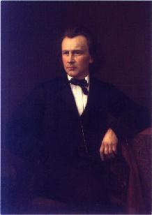
http://www.classical-composers.org/img/brahms1.jpg

- Beginning of Professional Life
  - Brahms met Schumann in 1853, aged 20
    - Brahms in 1853

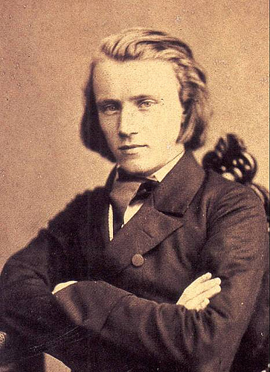
http://www.flickr.com/photos/abneypark/376844864/

    - The meeting was facilitated by the violinist/composer Joseph Joachim
    - Schumann lauded Brahms as "destined to give ideal expression to the times,” in his Neue Zeitschrift für Musik
    - Brahms maintained a strong relationship with Clara until her death
  - Brahms’ reputation was solidified with the premiere of Ein deutsches Requiem in 1868
    - Brahms settles in Vienna this year
    - We are 100 years before the birth of Mr. Johnston
    - His success here enables him to ultimately progress with finishing his first symphony
      - He had been writing for as long as 20 years
      - The premiere was conducted in 1876 by Hans von Bulow, one of the many husbands whose wives had affairs with Richard Wagner
      - This was nearly 50 years after the death of Beethoven
  - Brahms is also famous for making the earliest recording by a major composer
    - The recording was at the invitation of Thomas Edison
    - http://www.youtube.com/watch?v=BZXL3I7GPCY (2:10)

- Personal Traits (Wikipedia)
  - Fond of nature
    - Often walked in countryside
  - Kind to children
  - Brusque to adults
  - Was a regular at “The Red Hedgehog Tavern” in Vienna
  - Financially successful
    - Kept a modest apartment in Vienna
    - Gave away money to relatives
      - Helped support young musicians
  - Perfectionist
    - Felt he needed to live up to Schumann’s assessment
    - Destroyed many early works

- Later Years and Death
  - Brahms initially retired from composing in 1890 at 57
    - He ultimately ended up writing much of his greatest music, including the Clarinet Trio, Quintet and his two clarinet sonatas
      - These were for a prominent clarinetist of the time
  - Brahms

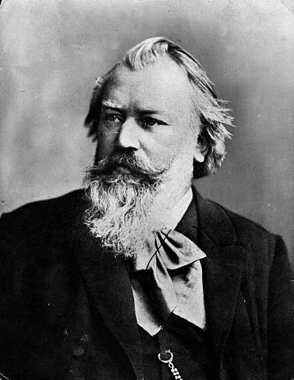
http://en.wikipedia.org/wiki/Image:JohannesBrahms.jpg

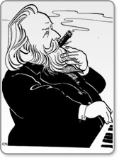
http://www.naxos.com/composerinfo/bio27097.htm
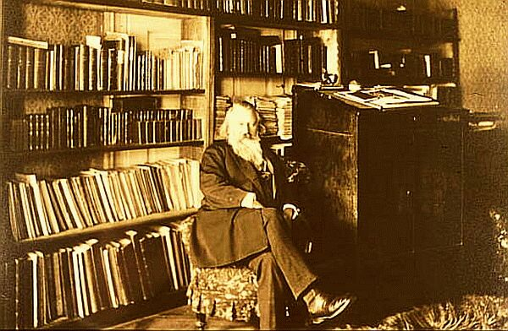
http://www.maurice-abravanel.com/brahmsburo.html

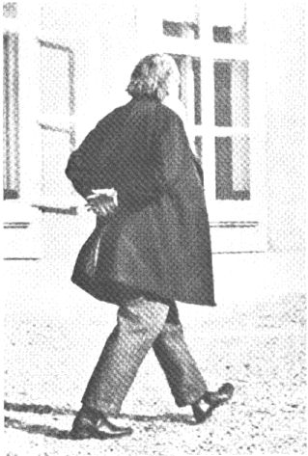
http://w3.rz-berlin.mpg.de/cmp/brahms_4.jpg

  - Brahms died of cancer (not syphilis) in 1897
  - Brahms's grave in the Zentralfriedhof (Central Cemetery), Vienna

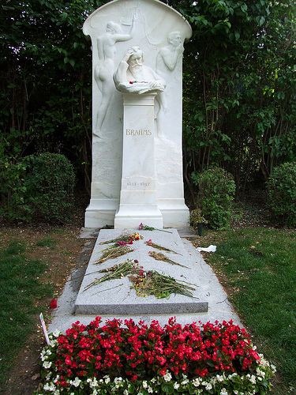
http://www.flickr.com/photos/uncle_buddha/2209162763/

Materials of Instruction:

Smart Board

Various Recordings

Summary:

Brahms was the last great German classicist. He paved the way for countless composers of different nationalities to start composing symphonies again, as most had feared comparison to Beethoven. Some would argue that he revived the symphony from certain death.

Assignment:

Read the Brahms chapter in Baker

Bibliography:

http://en.wikipedia.org/wiki/Johannes_Brahms

http://www.essentialsofmusic.com/

Suggested Reference:

History of Music, Hugh H. Miller, Barnes & Noble Books, New York. 1972

Robert L. Johnston

