Name: ______________________________ Total:____ ___/__14___

EXPERIMENTAL DESIGN
Directions: Read the following experiments and fill in the blanks that follow. For 3 and 4 answers,
there is not a control group listed in the example.
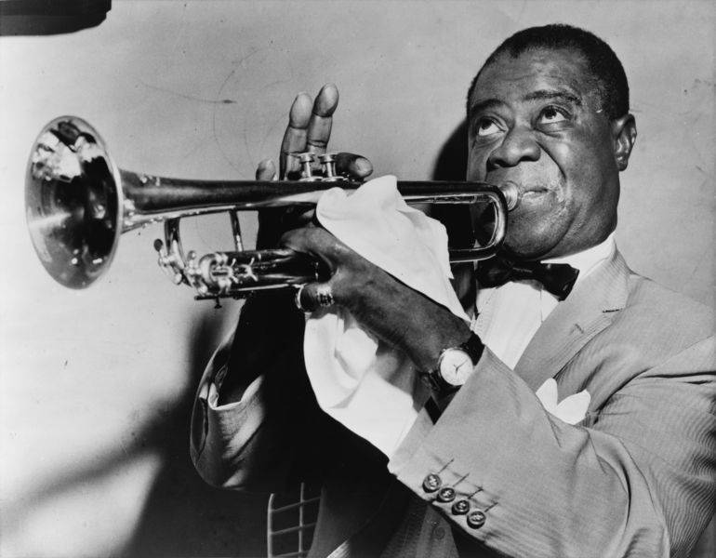
1. A study was created to test the effects of jazz on people’s sleep patterns. The hypothesis of the experiment was that if people listened to jazz music as they fall asleep, they will sleep for longer periods of time. For the experiment, 2 groups of people were created. One group was placed in a quiet room where they went to sleep and they were timed on how long they slept. The other group was placed in a room where jazz music played softly as they began to sleep and played throughout the night. As each group awoke, their sleep times were monitored.

Dependent Variable: ______________________ Control Group: ____________________________

Independent Variable: _____________________ Experimental Group: _______________________
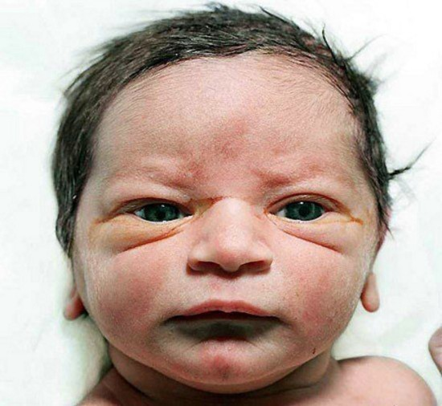
2. A study was created to test the effects of fear in children. The hypothesis of the experimenters was that if babies were exposed to fuzzy bunnies and at the same time a loud cymbal was struck close behind them, then that child would be afraid of all fuzzy things. Another group of children would be exposed to bunnies without any loud noises. The study was carried out as planned and as a result, hundreds of young children developed fear of all cute furry bunny rabbits.

Dependent Variable: ______________________ Control Group: ____________________________

Independent Variable: _____________________ Experimental Group: _______________________

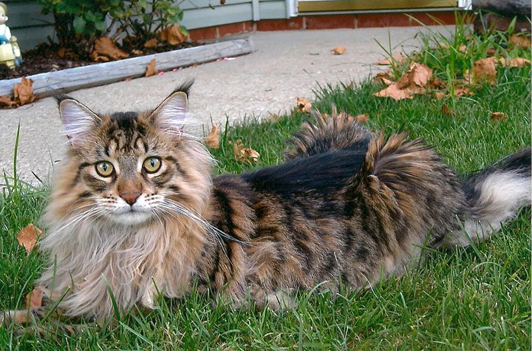
3. Shortly after Ms. Berndt’s cat, Revere, was born, Ms. Berndt realized Revere wasn’t eating enough. She went to the pet store and bought many different kinds of food and fed Revere different types every day. Each day she noted the type of food and how much Revere ate out of his dish. Eventually Revere ate a lot of the CreppyCat brand food and Ms. Berndt bought that for him from then on. Revere is the best worst cat ever.

Dependent Variable: ______________________

Independent Variable: _____________________ Experimental Group: ________________________


4. At a daycare, the staff has had problems with the children behaving badly every day. They begin to test to see how the children react if the staff gives them large amounts of candy when they are good and no candy when they are bad. The staff hopes that the incentive for the children will improve their behavior.

Dependent Variable: _______________________

Independent Variable: ______________________ Experimental Group: ________________________
Situations: Read the situation below and design an experiment.

A: John Smith has been hired by the city of Virginia Beach to investigate the recent shark attacks off the resort’s coast. He has a budget of $40,000, a 25 foot boat, and three graduate student assistants to help him. A helicopter has also been donated by a local television station, should he need one.
* * *
1. List 2 hypotheses John and his crew may have come up with for the recent shark attacks.
a. If_____________________________________, then ______________________________________
b. If_____________________________________, then ______________________________________

2. Pick one of the two hypotheses and determine the following:
a. Control Group: time of year when elephant seals are not present or another area with no elephant seals

b. Experimental Group: times/areas when/where elephant seals vary

c. Dependent Variable:________________________________

d. Independent Variable:______________________________

3. What type of data do you think John will collect (What will be the results of the experiment)?

4. What conclusions will John be able to make from the results of the experiment?

B: Suzie Q wants to know the effect of different colors of light on the growth of plants. She believes that plants can survive best in white light. She buys 5 ferns of the same species, which are all approximately the same age and height. She places one in white light, one in blue light, one in green light, one in red light and one in the closet. All of the ferns are planted in Miracle-Grow and given 20 mL of water once a day for 2 weeks. After the two weeks, Suzie observes the plants and makes measurements.

Hypothesis: If plant growth is affected by color of light, then white light will produce the most plant growth.

Independent Variable: Dependent Variable:

Control Group: Experimental Group:

What could be the controlled variables?

What types of measurements can Suzie make on the plants to determine how they did in different types of light?

KEY
John Smith has been hired by the city of Virginia Beach to investigate the recent shark attacks off the resort’s coast. He has a budget of $40,000, a 25 foot boat, and three graduate student assistants to help him. A helicopter has also been donated by a local television station, should he need one.
* * *
1. List 2 hypotheses John and his crew may have come up with for the recent shark attacks.
a. If shark attacks are related to the number of elephant seals in a certain area, then shark attacks will increase as elephant seal numbers increase.
b. If_____________________________________, then ______________________________________

2. Pick one of the two hypotheses and determine the following:
a. Control Group: time of year when elephant seals are not present or another area with no elephant seals

b. Experimental Group: times/areas when/where elephant seals vary

c. Dependent Variable: # of shark attacks

d. Independent Variable: # of elephant seals

3. What type of data do you think John will collect (What will be the results of the experiment)?
Shark attacks (distance from shore) vs number of elephant seals (mature and juvenile)

4. What conclusions will John be able to make from the results of the experiment? Various answers dependent on the hypothesis

Read the following situation and answer the following questions.

Suzie Q wants to know the effect of different colors of light on the growth of plants. She believes that plants can survive best in white light. She buys 5 ferns of the same species, which are all approximately the same age and height. She places one in white light, one in blue light, one in green light, one in red light and one in the closet. All of the ferns are planted in Miracle-Grow and given 20 mL of water once a day for 2 weeks. After the two weeks, Suzie observes the plants and makes measurements.

Hypothesis: If plant growth is affected by color of light, then white light will produce the most plant growth.

Independent Variable: type of light Dependent Variable: plant growth

Control Group: white light group, closet group Experimental Group: colored light groups

Constants (controlled variables): fertilizer, size of pot, species of fern, amount of water, length of growth time, temperature, distance of light, etc.

What types of measurements can Suzie make on the plants to determine how they did in different types of light? Mass the plant, height of plant, etc.

KEY
Directions: Read the following experiments and fill in the blanks that follow. For some answers,
there may not be a control group listed in the example, or at all.

1. A study was created to test the effects of jazz on people’s sleep patterns. The hypothesis of the experiment was that if people listened to jazz music as they fall asleep, they will sleep for longer periods of time. For the experiment, 2 groups of people were created. One group was placed in a quiet room where they went to sleep and they were timed on how long they slept. The other group was placed in a room where jazz music played softly as they began to sleep and played throughout the night. As each group awoke, their sleep times were monitored.

Dependent Variable: Sleep length Control Group: No jazz while sleeping

Independent Variable: Music Played Experimental Group: Listened to jazz while sleeping

2. A study was created to test the effects of fear in children. The hypothesis of the experimenters was that if babies were exposed to fuzzy bunnies and at the same time a loud cymbal was struck close behind them, then that child would be afraid of all fuzzy things. Another group of children would be exposed to bunnies without any loud noises. The study was carried out as planned and as a result, hundreds of young children developed fear of all cute furry bunny rabbits.

Dependent Variable: Response to bunnies Control Group: Played w/ bunnies w/ no cymbal

Independent Variable: Cymbal or no cymbal Experimental Group: Played w/ bunnies w/ cymbal

3. Shortly after Ms. Berndt’s cat, Revere, was born, Ms. Berndt realized Revere wasn’t eating enough. She went to the pet store and bought many different kinds of food and fed Revere different types every day. Each day she noted the type of food and how much Revere ate out of his dish. Eventually Revere ate a lot of the CreppyCat brand food and Ms. Berndt bought that for him from then on. Revere is the best worst cat ever.

Dependent Variable: How much Revere ate

Independent Variable: Type of cat food Experimental Group: Revere

4. At a daycare, the staff has had problems with the children behaving badly every day. They begin to test to see how the children react if the staff gives them candy when they are good and no candy when they are bad. The staff hopes that the incentive for the children will improve their behavior.

Dependent Variable: Children behavior

Independent Variable: Candy or no candy Experimental Group: Children

