Name: __________________ Date:_____ Period:____
Triangle Proofs: Test 2 REVIEW Ms. Anderle

Triangle Proofs: REVIEW

The exam will consist of…
- Fifteen 3-point multiple choice questions. These questions will both be triangle proof questions as well as review questions.
- Four 5-point review questions.
- Four 10-point triangle proofs.

1) If the conditional statement is true, what also must be true?
a) the converse of the statement.
b) the negation of the statement.
c) the contrapositive of the statement.
d) the inverse of the statement.

2) Which set of numbers can represent the lengths of sides of triangle?
a) {2, 2, 4} b) {1, 4, 3} c) {2, 3, 6} d) {5, 4, 8}

3) What is the negation of “Math is the best subject.”?
a) Math is the worst subject.
b) Math is not the best subject.
c) English is the best subject.
d) Social Studies is the best subject.

4) In which triangle do the three altitudes intersect outside the triangle?
a) obtuse triangle b) right triangle
c) acute triangle d) equilateral triangle

5) Two angles of a triangle measure 30° and 45°. What is the measure of an exterior angle of this triangle?
a) 75° b) 30° c) 60° d) 45°

6) In the accompanying diagram, AC $≅$ EC and DC $≅$ BC.
A E

B D

C
ΔADC can be proved congruent to ΔEBC by
a) HL $≅$ HL b) AAA$≅$ AAA c) SAS$≅$ SAS d) ASA$≅$ ASA

7) What way cannot be used to prove two triangles congruent?
a) SSS b) AAA c) SAS d) ASA

8) In the accompanying diagram of isosceles triangle ABC, <ACB is the vertex angle, CM ⊥ AB, and M is the midpoint of AB.
C

A M B
Which statement can not be used to justify ΔACM $≅$ ΔBCM?
a) HL $≅$ HL b)SSA$≅$ SSA c) SSS$≅$ SSS d) AAS$≅$ AAS

9) Angle A and angle B are supplementary angles. If m<A = x, which expression represents the number of degrees in angle B?
a) 180 – x b) x – 180 c) 90 – x d) x – 90

10) The diagram below shows the construction of perpendicular bisector of AB.
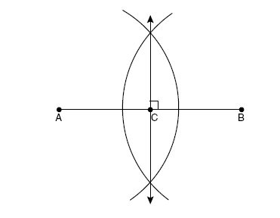
Which statement is not true?
a) CB = AC b) AC = ½ CB c) CB = 2AB d) AC + CB = AB

11) Brandon and Kevin are on a job. They decide to run 9 miles north and then 7 miles east. What is the shortest distance, to the nearest hundredth of a mile, they must travel to reach their starting point?

12) In right triangle TAR, angle A = 90°, the m<T = 73°, and TR = 18. If AR is represented by t, write an equation that can be used to find t. Then find t to the nearest tenth.

13) In a right triangle ABC, the right angle is at C and altitude CD is drawn to hypotenuse AB. If AD = 4 and DB = 8, find AC. (round to the nearest tenth if necessary).

14) Equilateral triangle MAT has a perimeter of 66. What is the length of the altitude of the triangle? (simplest radical form).

15) A B Given: AD $≅$ BE
AE $≅$ BD

C Prove: <DAE $≅$ <EBE

D E

M
16) Given: <ATM $≅$ <MHS

Prove: ΔMTH is isosceles

A S
T H

17) T H

O Given: MA $≅$ SJ
TS $≅$ HJ
TM $≅$ HA

Prove: <TMS $≅$ <HAJ

M A S J

